Command Reference: ProcessTSProduct()

Process a time series product file to produce output

Version 11.03.00, 2015-05-31

The ProcessTSProduct() command automates creation of time series data products. Products are described in time series product description (*.tsp) files, which are typically created by using the Save…Time Series Product choice in graph windows (a future enhancements may allow creation of text products from summary or table views). See the TSView Time Series Viewing Tools appendix for more information about time series products. For example, the following sequence of actions can be used to define and use time series product description files:

1. Use TSTool and interactively select time series using the main window. The time series identifiers and/or aliases will be referenced in the time series product.
2. Interactively view a graph (e.g., Results…Graph – Line) and edit its properties by right clicking on the graph and selecting the Properties choice (e.g., set titles and legend properties).
3. Save the graph as a time series product from the graph window using the Save…Time Series Product choice. Typically the product is saved in a location close to the command file. An example time series product file is as follows:

|  |
| --- |
| [Product]  ProductType = "Graph"  [SubProduct 1]  GraphType = "Line"  MainTitleString = "Streamflow (Monthly Total)"  [Data 1.1]  TSID = "08223000.DWR.Streamflow.Month~HydroBase"  [Data 1.2]  TSID = "08220500.DWR.Streamflow.Month~HydroBase" |

1. Add a ProcessTSProduct() command to the original commands to allow the product to be created automatically. Select the time series product file created in the previous step.
2. Save the commands in a file (e.g., named stations.TSTool) so that they can be run again. The command file and time series product definition files must be used consistently (e.g., the time series identifiers and directory paths must be consistent).

If the product does not appear as intended, especially for complicated products, it may be necessary to edit the file and make the following corrections:

* Specify Color or other properties so that they are explicitly set and not defaulted.
* Verify that file paths in TSID properties are valid for the machine (may need to convert absolute paths to relative paths).

Time series identifiers in the product file are used as follows:

* If the time series are in TSTool’s Results area, the time series will be used without rereading.
* Otherwise, the TSID is used to read the time series and must therefore contain enough information to locate and read the time series, such as the ~InputType~InputName information on at the end of the TSID.

If the TSAlias property is found in the product file, then the time series corresponding to the alias must be processed by a command file and be available in TSTool’s Results area.

It is also possible to create a template time series product file and use the ExpandTemplateFile() command to automate creation of large numbers of graphs, for example to create images for a website.

The following dialog is used to edit the ProcessTSProduct() command and illustrates the command syntax. The path to the file can be absolute or relative to the working directory. The Browse button can be used to select the time series product description file (if a relative path is desired, delete the leading path after the select or use the Remove Working Directory from TSP button).

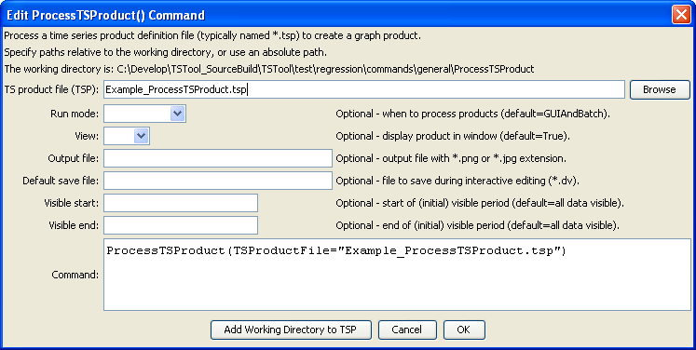

ProcessTSProduct

ProcessTSProduct() Command Editor

The command syntax is as follows:

ProcessTSProduct(Parameter=Value,…)

Command Parameters

|  |  |  |
| --- | --- | --- |
| Parameter | Description | Default |
| TSProductFile | The time series product file to process. The path to the file can be absolute or relative to the working directory. Can be specified using processor ${Property}. | None – must be specified. |
| RunMode | Indicate the run mode to process the product, one of:   * BatchOnly – indicates that the product should only be processed in batch mode. * GUIOnly – indicates that the product should only be processed when the TSTool GUI is used (useful when Preview is set to Preview). * GUIAndBatch – indicates that the product should be processed in batch and GUI mode. | None – must be specified. |
| View | Indicates whether the output should be previewed interactively, one of:   * True – display the graph. * False – do not display the graph (specify the output file instead to automate image creation). | None – must be specified. |
| OutputFile | The absolute or relative path to an output file. Use this parameter with View=False to automate image processing. If the filename ends in “jpg”, a JPEG image file will be produced. If the filename ends in “png”, a PNG file will be produced (recommended). Can be specified using processor ${Property}. | Graph file will not be created. |
| DefaultSaveFile | Used with experimental feature to enabling editing in the time series table that corresponds to a graph view. Specify the default DateValue filename to save edits. Can be specified using processor ${Property}. | Editing is disabled. |
| VisibleStart | The starting date/time to zoom for the initial (and image file) graph. Can be specified using processor ${Property}. | Full period is visible. |
| VisibleEnd | The ending date/time to zoom for the initial (and image file) graph. Can be specified using processor ${Property}. | Full period is visible. |

A sample command file to process a data product using State of Colorado HydroBase data is as follows:

|  |
| --- |
| # 08235350 - ALAMOSA RIVER ABOVE JASPER  08235350.USGS.Streamflow.Day~HydroBase  # 08236000 - ALAMOSA RIVER ABOVE TERRACE RESERVOIR  08236000.DWR.Streamflow.Day~HydroBase  # 7337 - SAGUACHE  7337.NOAA.Precip.Month~HydroBase  ProcessTSProduct(TSProductFile="Example_ProcessTSProduct.tsp") |

After using the above dialog to edit the command, the time series product can be processed from TSTool as follows:

1. Interactively load and run the command file:
   1. Open the command file, in this case containing the above commands file.
   2. Process the commands using Run All Commands. The graph will be displayed for review.
2. Load and run the command file in one step:

Use the Run…Process TSProduct File menus to select and process the product file. The time series must be in the Results area or must be specified with enough information in the product file to read the time series.

1. Run TSTool in batch mode by specifying an output file (and optionally changing the RunMode parameter to BatchOnly) using:

tstool –commands commands.TSTool

The working directory will be set to the directory for the commands file and output will be relative to that directory.