Command Reference: ReadDateValue()

Read all time series from a DateValue File

Version 11.07.03, 2015-10-17

The ReadDateValue() command reads all the time series in a DateValue file. See the DateValue Input Type Appendix for information about the file format.

The following dialog is used to edit the command and illustrates the command syntax. The path to the file can be absolute or relative to the working directory. DateValue files allow each time series to have an alias in addition to the time series identifier (TSID); however, the Alias parameter can be used to assign a new alias as the file is read.

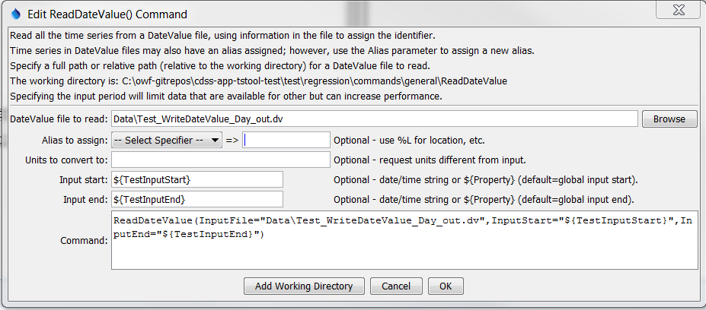

ReadDateValue

ReadDateValue() Command Editor

The command syntax is as follows:

ReadDateValue(Parameter=Value,…)

The following older command syntax is updated to the above syntax when a command file is read:

TS Alias = ReadDateValue(Parameter=Value,…)

Command Parameters

|  |  |  |
| --- | --- | --- |
| Parameter | Description | Default |
| InputFile | The name of the DateValue input file to read, surrounded by double quotes to protect whitespace and special characters. Global property values can be used with the syntax ${PropertyName}. The file can be a zip file with single compressed file. | None – must be specified. |
| Alias | The alias to assign to the time series, as a literal string or using the special formatting characters listed by the command editor. The alias is a short identifier used by other commands to locate time series for processing, as an alternative to the time series identifier (TSID). | The alias in the file will be used if present. |
| NewUnits | Units to convert data to (must be in the system/DATAUNIT configuration file under the TSTool installation folder). | Use the data units from the file. |
| InputStart | Starting date/time to read data, in precision consistent with data. Specify as a date/time string or a processor ${Property}. | Read all data. |
| InputEnd | Ending date/time to read data, in precision consistent with data. Specify as a date/time string or a processor ${Property}. | Read all data. |

A sample command file is as follows:

|  |
| --- |
| ReadDateValue(InputFile="Data\08251500.DWR.Streamflow.IRREGULAR.dv") |