Command Reference: ReadDelftFewsPiXml()

Read all time series from a Delft FEWS PI XML File

Version 11.08.01, 2016-02-14

The ReadDelftFewsPiXml() command reads all the time series in a Delft FEWS PI XML file. See the Delft FEWS Input Type Appendix for information about the file format.

The following dialog is used to edit the command and illustrates the command syntax.

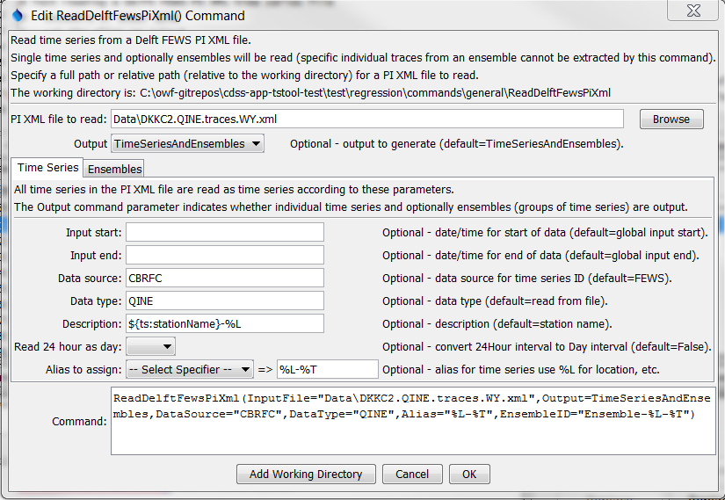

ReadDelftFewsPiXml

ReadDelftFewsPiXml() Command Editor Showing Time Series Parameters

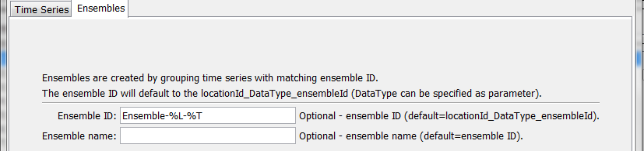

ReadDelftFewsPiXml_Ensemble

ReadDelftFewsPiXml() Command Editor Showing Ensemble Parameters

The command syntax is as follows:

ReadDelftFewsPiXml(Parameter=Value,…)

Command Parameters

| Parameter | Description | Default |
| --- | --- | --- |
| InputFile | The name of the PI XML input file to read. Global property values can be used with the syntax ${PropertyName}. The file can be a *.xml, *.zip or *.gz file with single compressed file. | None – must be specified. |
| Output | Indicate the output to be generated:   * TimeSeries – individual time series (even if in ensemble) * TimeSeriesAndEnsembles – individual time series and ensemble | TimeSeries  AndEnsembles |
| InputStart | Starting date/time to read data, in precision consistent with data. Specify as a date/time string or a processor ${Property}. | Read all data. |
| InputEnd | Ending date/time to read data, in precision consistent with data. Specify as a date/time string or a processor ${Property}. | Read all data. |
| TimeZone  Offset | The desired time zone offset for output. 0=GMT, 7=US Mountain Standard Time. | Use file time zone. |
| DataSource | Data source to use for time series identifier, for example organization that is running FEWS. Can specify with ${ts:Property} and time series % specifiers. | FEWS |
| DataType | Data type to use for time series identifier, useful because default can be long and may contain special characters. Can specify with ${ts:Property} and time series % specifiers. | <paramerId> element from PI XML file |
| Description | Time series description. Can specify with ${ts:Property} and time series % specifiers. | <stationName> element from PI XML file |
| Read24Hour  AsDay | If True, read 24Hour interval time series as Day. Hour 00 values are shifted to the previous day. | False |
| Alias | The alias to assign to the time series, as a literal string or using the special formatting characters listed by the command editor. The alias is a short identifier used by other commands to locate time series for processing, as an alternative to the time series identifier (TSID). | No alias is assigned. |
| EnsembleID | Ensemble identifier to assign to output. Can specify with ${ts:Property} and time series % specifiers. | <locationId> _DataType_ <ensembleId> |
| EnsembleName | Ensemble name to assign to output. Can specify with ${ts:Property} and time series % specifiers. | Value of EnsembleID |