Command Reference: ReadExcelWorkbook()

Read a Microsoft Excel workbook

Version 11.06.00, 2015-07-22

The ReadExcelWorkbook() command reads a Microsoft Excel workbook file (*.xls, *.xlsx, *.xlsm). The workbook is retained in memory and can be manipulated using commands that write to Excel, for example:

1. Create an Excel workbook template with desired analysis, formatting, charts, etc. Leave placeholders for data sheets. Refer to the data sheets using named ranges.
2. Read the Excel workbook template using the ReadExcelWorkbook() command.
3. Manipulate the Excel workbook using TSTool commands that write to Excel, for example WriteTableToExcel(). If the KeepOpen=False parameter is used, the original file will not be re-written. Therefore, use KeepOpen=True in combination with the following.
4. Use the CloseExcelWorkbook() command and specify WriteFile=True to force writing the Excel workbook. The NewOutputFile parameter can also be specified to write a new output file, leaving the original Excel file intact.

TSTool uses the Apache POI software (http://poi.apache.org) to read and manipulate Excel workbooks and consequently functionality is constrained by the features of that software package.

The following dialog is used to edit the command and illustrates the syntax for the command.

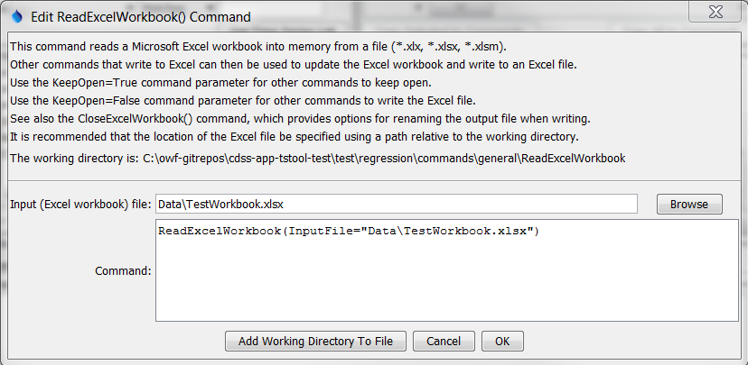

ReadExcelWorkbook

ReadExcelWorkbook() Command Editor

The command syntax is as follows:

ReadExcelWorkbook(Parameter=Value,…)

Command Parameters

| Parameter | Description | Default |
| --- | --- | --- |
| InputFile | The name of the Excel workbook file (*.xls, *.xlsx, or *.xlsm) to read, as an absolute path or relative to the command file location. Can be specified using processor ${Property}. | None – must be specified. |