Command Reference: ReadPropertiesFromFile()

Read one or more time series processor properties from a file

Version 12.00.00, 2017-03-23

The ReadPropertiesToFile() command reads the values of one or more time series processor properties from a file. The corresponding WritePropertiesToFile() command can be used to write properties to a file. Processor properties include global defaults such as InputStart, InputEnd, OutputStart, OutputEnd, OutputYearType, WorkingDir, and also user-defined properties set with the SetProperty() command. Internally, properties have a name and a value, which is of a certain type (string, integer, date/time, etc.). Examples of using the command include:

* creating tests to verify that properties are being set
* passing information from another program, such as a Python script, to TSTool
* reading persistent information from a previous use, such as the date/time that data were last downloaded from a web service

A number of property formats are supported as listed in the following table.

Property File Formats

|  |  |
| --- | --- |
| Format | Description |
| NameValue | Simple format, all properties handled as text:  PropertyName=PropertyValue  PropertyName=”Property value, quoted if necessary” |
| NameTypeValue | Same as NameValue format, with non-primitive objects treated as simple constructors:  PropertyName=PropertyValue  DateTimeProperty=DateTime(“2010-10-01 12:30”) |
| NameTypeValue  Python | Similar to the NameTypeValue format, however, objects are represented using “Pythonic” notation, to allow the file to be used directly by Python scripts:  PropertyName=”PropertyValue”  DateTimeProperty=DateTime(2010,10,1,12,30) |

The format of the file currently is not required when reading the file because the command detects the format for each property and creates an appropriate object type. The following dialog is used to edit this command and illustrates the syntax of the command.

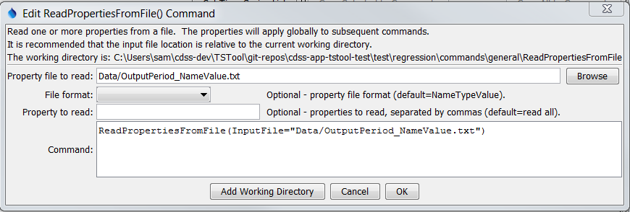

ReadPropertiesFromFile

ReadPropertiesFromFile() Command Editor

The command syntax is as follows:

ReadPropertiesFromFile(Parameter=Value,…)

Command Parameters

|  |  |  |
| --- | --- | --- |
| Parameter | Description | Default |
| InputFile | The property file to read, as an absolute path or relative to the command file. Can be specified using ${Property}. | None – must be specified. |
| FileFormat | Format of the properties file (see descriptions in the above Property File Formats table):   * NameValue * NameTypeValue * NameTypeValuePython | NameValue |
| IncludeProperty | The names of properties to read, separated by commas. Can be specified using ${Property}. | If not specified, all processor properties will be written. |