Command Reference: ReadReclamationHDB()

Read time series from a Reclamation HDB database

Version 11.10.00, 2016-03-30

This command’s documentation is now maintained as HTML – refer to the HTML version for current documentation.

The ReadReclamationHDB() command reads one or more time series from a Reclamation HDB database:

* a single “real” time series (observations)
* a single “model” time series (results from a model)
* a time series ensemble, indicated by the ensemble name, in which case each ensemble trace time series is read as a “model” time series

The primary metadata necessary to read the time series are a site data type identifier (SDI) and, if reading a model time series, a model run identifier (MRI). These values can be selected directly (from long lists), or selected through incremental selection of other data. Both options are provided for flexibility where appropriate.

See the WriteReclamationHDB() command documentation for information about writing the time series that are read by this command. See the Reclamation HDB Data Store Appendix for more information about the database features and limitations.

In all cases, the choices presented to the user cascade to allow only valid choices. For example, when a site data type identifier is selected, then only time series and ensembles are listed that have data records with the site data type identifier. This ensures that only time series with data are read.

Additional functionality includes:

* When reading hour interval data, including NHour data: regardless of the requested input period, the time series that is read will have its start and end date/time set to actual date/time. This ensures that odd offsets such as hour 1 for 3Hour data will match the actual data.

The following dialog is used to edit the command and illustrates the syntax of the command when reading “real” or “model” data using filters. This approach can be used when reading one or more time series in bulk. Where criteria should be specified in sequential order without intervening blank specifiers. This approach is useful when processing a group of time series in bulk.

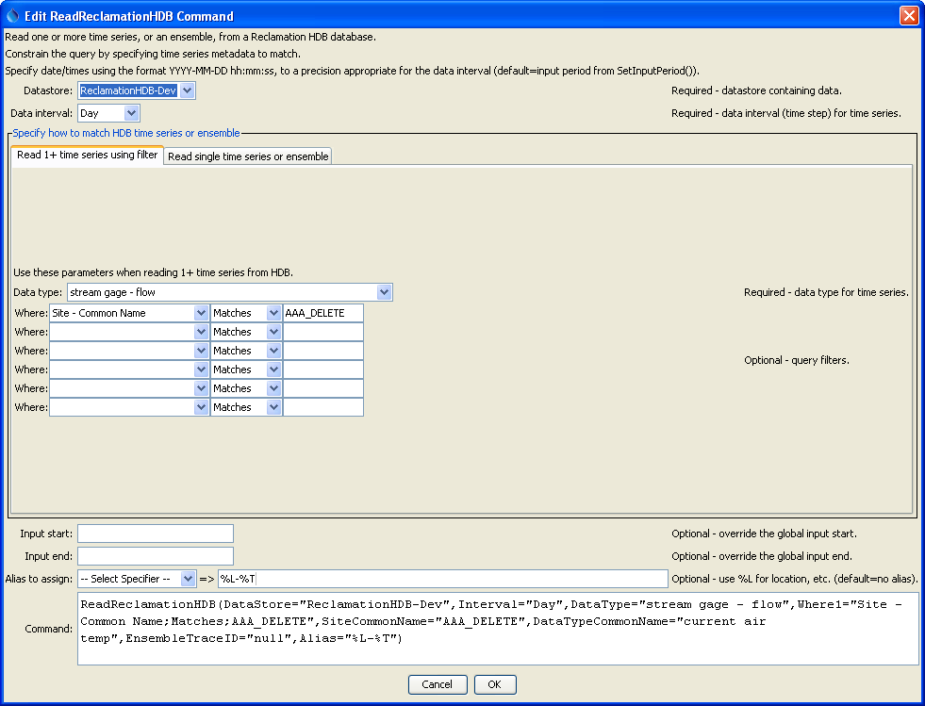

ReadReclamationHDB

ReadReclamationHDB() Command Editor When Using Filters to Read 1+ Time Series

The following figure illustrates reading a single “real” time series (note that the model parameters are not specified).

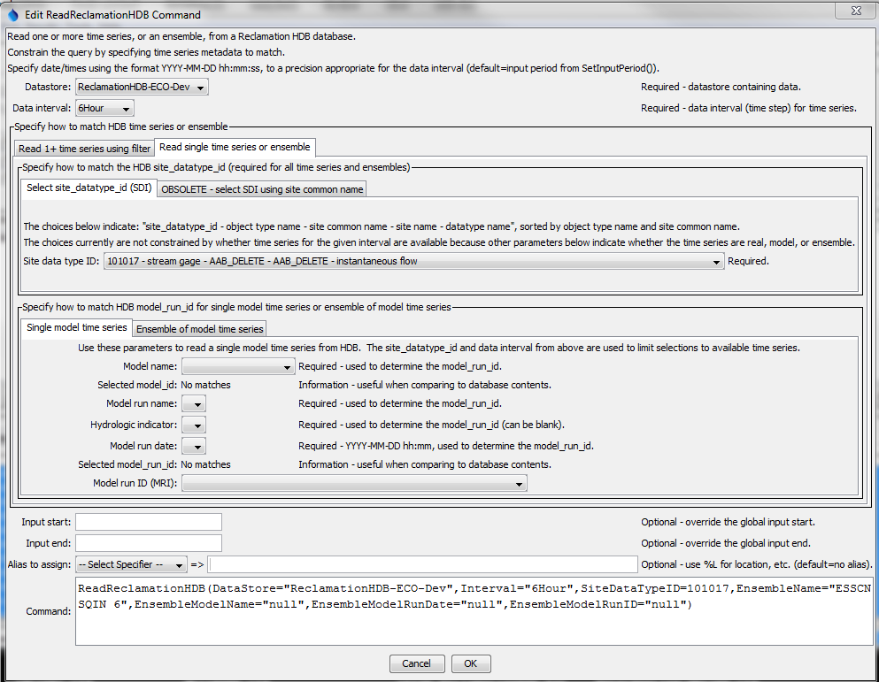

ReadReclamationHDB_Real

ReadReclamationHDB() Command Editor to Read a Single Real Time Series

The following figure illustrates reading a single “model” time series, in which case model parameters are specified in addition to the site and data type parameters. There are two ways to select the MRI:

1. Pick the MRI from the list at the bottom of the parameter section:
   1. Additional information is shown in the choice, but only the MRI is saved in the command parameter
2. Sequentially pick model-related metadata until a unique MRI is determined (multiple command parameters are saved):
   1. Model name
   2. Model run name
   3. Hydrologic indicator (may be blank)
   4. Model run date (may be blank)

The following figure illustrates both approaches, although normally one or the other would be used. Selecting an MRI directly takes precedence over the other approach.

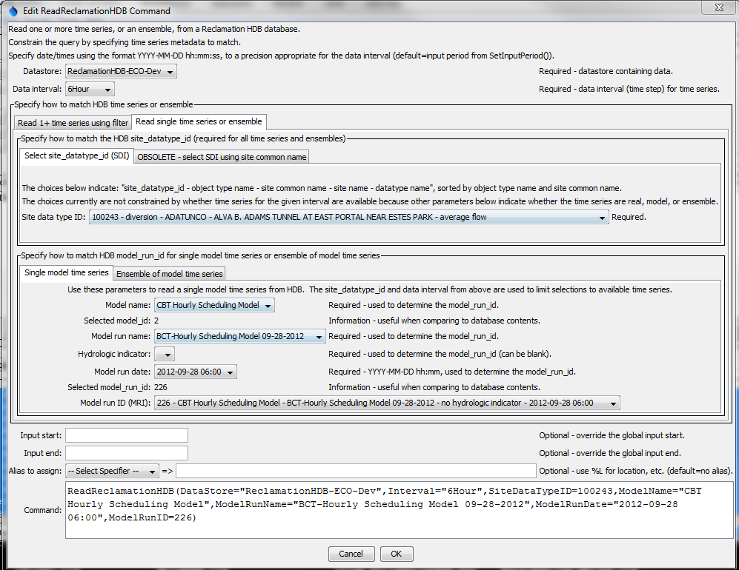

ReadReclamationHDB_Model

ReadReclamationHDB() Command Editor to Read a Single Model Time Series

The following figure illustrates reading an ensemble of “model” time series, in which case an ensemble name is specified in addition to the SDI. Ensembles are stored in HDB as follows:

Ensemble (ensemble name is unique)

Ensemble Trace(s) (trace number is unique)

Model run identifier(s) (MRI is unique)

M_* data tables

Consequently, in order to list the ensemble names for selection, the data table is checked for matching SDI, and additional queries map the data back to the ensemble data, which provide the list of ensemble names to choose from.

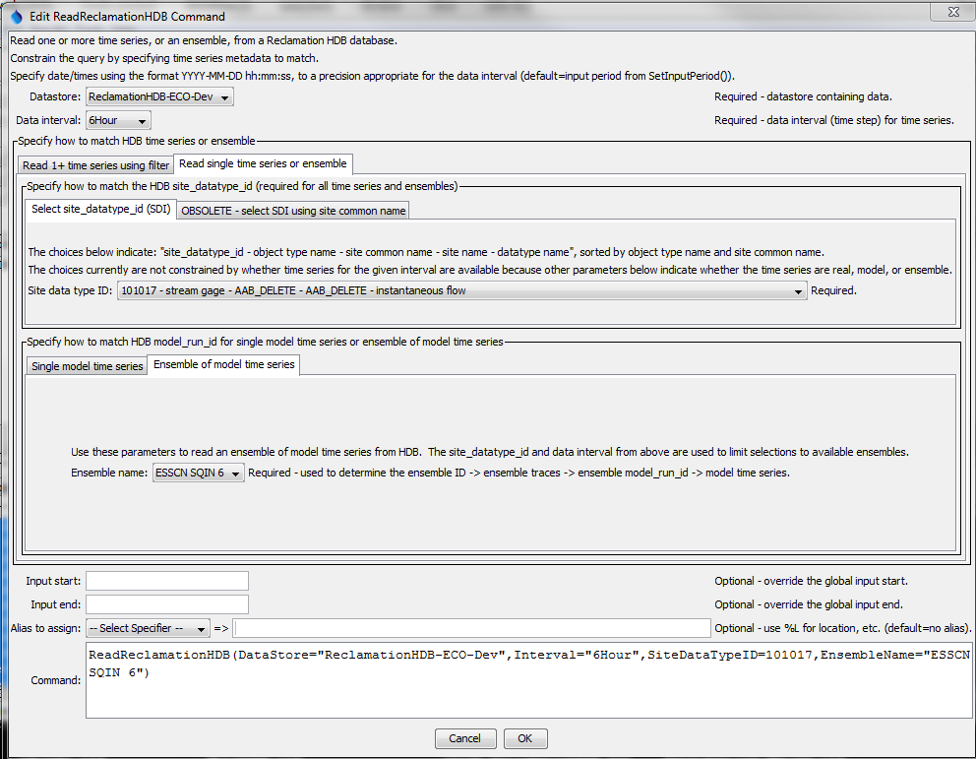

ReadReclamationHDB_Ensemble

ReadReclamationHDB() Command Editor to Read an Ensemble of Model Time Series

The command syntax is as follows:

ReadReclamationHDB(Parameter=Value,…)

Command Parameters

| Parameter | Description | Default |
| --- | --- | --- |
| DataStore | Reclamation HDB data store name indicating database from which to read time series. | None – must be specified. |
| Interval | The data interval to read (Hour, Day, Month, Year, Irregular). Irregular is used for instantaneous data and internally results in data with date/times to minute precision. | None – must be specified. |
| NHourInterval  Offset | There are cases where data may have been loaded into HDB on hours that do not properly align with expected hour offset for NHour data. For example, data in HDB for the ECAO office are saved in MST time zone but data may have been saved with a 1-hour daylight savings offset. 3Hour interval model data may be loaded on odd offsets, for example hour 1, 4, 7, 10, 13, 16, 19, and 22. In this case if extra data were loaded at other hours, TSTool does not know what data are valid and will generate an error. The offending data can be removed using a database tool, or the NHourIntervalOffset parameter can be specified to tell TSTool what data to use (in this case the offset would be 1). | Data are used as is. Checks verify that all data align as expected with NHour interval and if not an error is generated. |
|  | Use the following parameter when reading 1+ time series using filters |  |
| DataType | The data type to read as ObjectType – DataTypeCommonName. The object type is shown to help with selections. * can be specified to read all data types. | None – must be specified. |
| WhereN | The “where” clauses to be applied when querying data, which match the values in the Where fields in the TSTool main interface. The parameters should be specified as Where1, Where2, etc., with no intervening gaps in numbering. All clauses are joined as “and” and are therefore cumulative in limiting the query. The format of each parameter value is:  “Item;Operator;Value”  Where Item indicates a data field to be filtered on, Operator is the type of constraint, and Value is the value to be checked when querying. | If not specified, the query will not be limited and very large numbers of time series may result from the query (which may require a long time to perform the query). |
|  | Use the following parameters when reading a single time series or an ensemble of time series. |  |
| SiteDataTypeID | The site_datatype_id value to match the time series. Direct selection using the provided choices is preferred because the other parameters (below) are not guaranteed to be unique. |  |
| Site  CommonName | The site common name for the time series location; used with the data type common name to determine the site_datatype_id in the database. This approach is discouraged and may be removed in the future because site_common_name is not unique in HDB. | None – must be specified unless SiteDataTypeID is specified. |
| DataType  CommonName | The data type common name for the time series; used with the site common name to determine the site_datatype_id in the database. This approach is discouraged and may be removed in the future because datatype_common_name is not unique in HDB. | None – must be specified unless SiteDataTypeID is specified. |
|  | Use the following parameters when reading a single model time series. |  |
| ModelRunID | The model_run_id value to match the time series. Direct selection using the provided choices is an option to specifying the equivalent multiple parameters described below. |  |
| ModelName | The model name for the time series; used with the model run name, hydrologic indicator(s), and model run date to determine the model_run_id in the database. | None – must be specified unless ModelRunID is specified. |
| ModelRunName | The model run name for the time series; used with the model name, hydrologic indicator(s), and model run date to determine the model_run_id in the database. | None – must be specified unless ModelRunID is specified. |
| ModelRunDate | The model run date (timestamp) to use for the time series; used with the model name, model run name, and hydrologic indicator(s) to determine the model_run_id in the database. The run date should be specified using the format YYYY-MM-DD hh:mm (zero-padded with hour 0-23, minute 0-59). | None – must be specified unless ModelRunID is specified. |
| Hydrologic  Indicator | The hydrologic indicator(s) to use for the time series; used with the model name, model run name, and model run date to determine the model_run_id in the database. | None – must be specified unless ModelRunID is specified. |
|  | Use the following parameters when reading an ensemble of model time series. |  |
| EnsembleName | The name of the ensemble to read. Corresponding trace data are queried to determine model_run_id to read individual time series. | Must be specified if reading an ensemble. |
|  | The following parameters are always appropriate. |  |
| Properties | String properties to be assigned to the time series using syntax: Property1:Value1,Property2:Value2 |  |
| InputStart | Start of the period to query, specified in format YYYY-MM-DD hh:mm, with a precision appropriate for the interval. If not aligned with the time series data records for NHour data, the input start hour will be adjusted to the first interval in the day that aligns with the time series data. | Read all available data. |
| InputEnd | End of the period to query, specified in format YYYY-MM-DD hh:mm, with a precision appropriate for the interval. If not aligned with the time series data records for NHour data, the input start hour will be adjusted to the last interval in the day that aligns with the time series data. | Read all available data. |
| Alias | Indicate an alias to assign to time series, which can result in shorter identifiers for time series when referenced with other commands. | No alias is assigned. |