Command Reference: ReadTableFromDelimitedFile()

Read a table from a delimited file

Version 11.07.04, 2015-10-25

The ReadTableFromDelimitedFile() command reads a table from a comma-delimited file. Tables are used by other commands when performing lookups of information or generating summary information from processing. Table files have the following characteristics:

* Comments indicated by lines starting with # are stripped during the read.
* Extraneous lines in the file can be skipped during the read using the SkipLines parameter.
* Column headings indicated by “quoted” values in the first non-comment line will be used to assign string names to the columns. If no quoted values are present, columns will not have headings.
* Data in columns are assumed to be of consistent type (i.e., all numerical data or all text), based on rows after the header. The data type for the column will be determined automatically.
* Missing values can be indicated by blanks. However, a line ending with the delimiter may cause warnings because blank is not assumed at the end of the line (this is a software limitation that may be addressed in the future) – work around by adding an extra delimiter or ensure that the last column is not blank.
* Strings containing the delimiter should be surrounded by double quotes. This command currently does not deal with ”””text””” notation although support may be added in the future (see comma-separated-value [CSV] standards: http://en.wikipedia.org/wiki/Comma-separated_values).

The following dialog is used to edit the command and illustrates the syntax for the command.

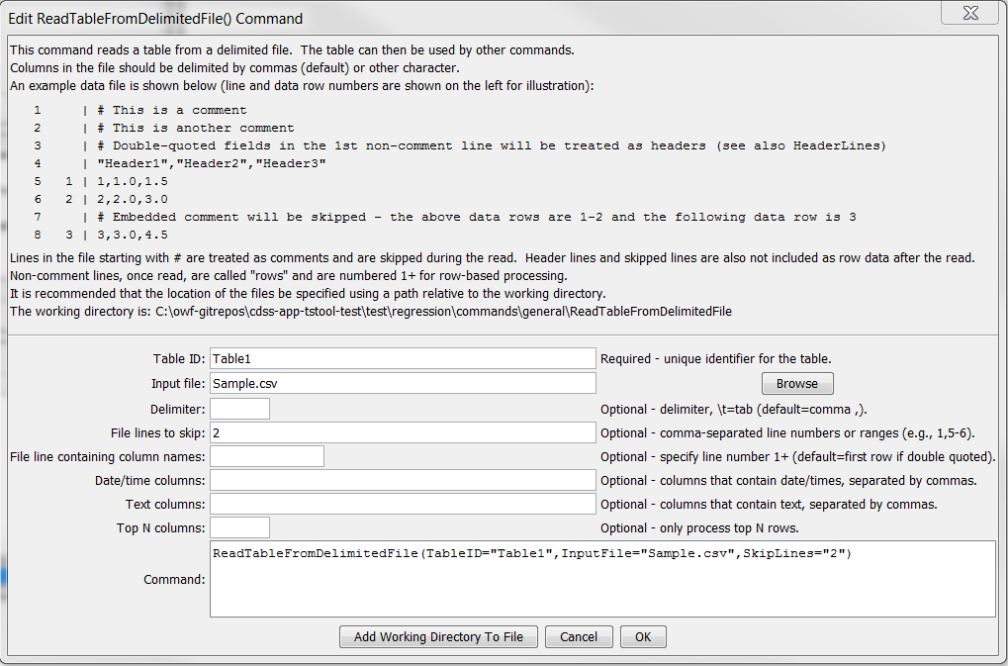

ReadTableFromDelimitedFile

ReadTableFromDelimitedFile() Command Editor

The command syntax is as follows:

ReadTableFromDelimitedFile(Parameter=Value,…)

Command Parameters

|  |  |  |
| --- | --- | --- |
| Parameter | Description | Default |
| TableID | Identifier to assign to the table that is read, which allows the table data to be used with other commands. Can be specified using processor ${Property}. | None – must be specified. |
| InputFile | The name of the file to read, as an absolute path or relative to the command file location. Can be specified using processor ${Property}. | None – must be specified. |
| Delimiter | The delimiter character between columns. Specify \t to indicate tab. | Comma. |
| SkipLines | Indicates the number of lines in the file to skip, which otherwise would interfere with reading row data. Individual row numbers and ranges can be specified, for example: 1,5-6,17 | No lines are skipped. |
| HeaderLines | Indicate the rows that include header information, which should be used for column names. Currently this should only be one row, although a range may be fully supported in the future. | If the first non-comment line contains quoted field names, they are assumed to be headers. Otherwise, no headers are read. |
| DateTime  Columns | List of comma-separated column names for columns that should be treated as containing date/time values. | Date/times default to string (text) columns. |
| TextColumns | List of comma-separated column names for columns that should be treated as containing text values. | Automatically determine column types from data. |
| Top | Specify the number of data rows to read, useful when prototyping an analysis process. | Process all rows. |

The following example command file illustrates how to read a table from a delimited file:

|  |
| --- |
| ReadTableFromDelimitedFile(TableID="Table1",  InputFile="Sample.csv",SkipRows="2") |

An excerpt from a simple delimited file is:

|  |
| --- |
| # A comment  some junk to be skipped  “Header1”,”Header2”,”Header3”  1,1.0,1.0  2,2.0,1.5  3,3.0,2.0 |

.

This page is intentionally blank.