Command Reference: ReadTimeSeries()

Read a single time series using a full time series identifier

Version 11.07.03, 2015-09-15

The ReadTimeSeries()reads a single time series using the time series identifier to uniquely identify the time series. This generalized command is useful for converting time series identifiers from the TSTool interface into read commands that assign an alias to a time series. Because the command is generic, it does not offer specific parameters that may be found in read commands for specific input types. Use the specific read commands where available for additional functionality and more specific error handling. See also the ReadTimeSeriesList() command.

The following dialog is used to edit the command and illustrates the syntax of the command.

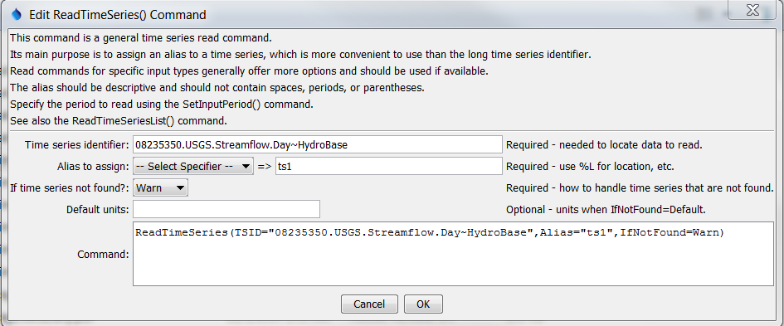

ReadTimeSeies

ReadTimeSeries() Command Editor

The command syntax is as follows:

ReadTimeSeries(Parameter=Value,…)

The following older command syntax is updated to the above syntax when a command file is read:

TS Alias = ReadTimeSeries (Parameter=Value,…)

Command Parameters

|  |  |  |
| --- | --- | --- |
| Parameter | Description | Default |
| TSID | The time series identifier of the time series to read. The identifier should include the input type (and input name, if required). See the input type appendices for examples of time series identifiers for various input types. Can be specified using ${Property} notation. | None – must be specified. |
| Alias | The alias to assign to the time series, as a literal string or using the special formatting characters listed by the command editor. The alias is a short identifier used by other commands to locate time series for processing, as an alternative to the time series identifier (TSID). | None – must be specified. |
| IfNotFound | Indicates how to handle missing time series, one of:   * Warn – generate fatal warnings and do not include in output. * Ignore – generate non-fatal warnings and do not include in output. * Default – generate non-fatal warnings and create empty time series for those that could not be found. This requires that a SetOutputPeriod() command be used before the command to define the period for default time series. | Warn |
| DefaultUnits | Default units when IfNotFound=Default. | Blank – no units. |

A sample command file to read data from the State of Colorado’s HydroBase is as follows:

|  |
| --- |
| ReadTimeSeries(TSID="08235350.USGS.Streamflow.Day~HydroBase",Alias=TS1) |