Command Reference: ReadTimeSeriesList()

Read one or more time series using location identifiers from a table

Version 11.02.00, 2015-05-18

The ReadTimeSeriesList() command reads one or more time series using location identifiers from a table, an example of which is shown below as a comma-separated value file (tables can also be read from Excel, delimited file, datastore, or other source):

|  |
| --- |
| # Example list file. Comments start with the # character.  # Column headings can be specified in the first non-comment row using quotes.  “Structure ID”,”Structure Name”  500501,Ditch 501  500502,Ditch 502  # Invalid ID (see IfNotFound parameter)  509999,Ditch 9999 |

The command typically is used when reading time series from a single source and can streamline processing in the following situations:

* A list of identifiers may have been generated from a database query
* A list of identifiers may have been extracted from a model data set

TSTool uses the location identifiers in the table with the command parameters and internally creates a list of time series identifiers. The time series are of the standard form (information in brackets is optional for basic use):

[LocationType:]Location.DataSource.DataType.Interval[.Scenario]~DataStore[~InputName]

TSTool then queries each time series using the time series identifier. See also the ReadTimeSeries() command, which performs essentially the same functionality but only reads one time series. Refer to the appendices for each datastore and file input type to understand specific time series identifier conventions.

Although it is possible to specify a datastore or input type that reads from files by also using the InputName, this may not be appropriate because the ReadTimeSeriesList() command can only specify one input file name and the file will be reopened for each time series read. Instead, read commands for specific file formats should be used because these commands typically are optimized to read multiple time series from the files. Use the SetInputPeriod() command to set the period to read.

The following dialog is used to edit the command and illustrates the syntax of the command.

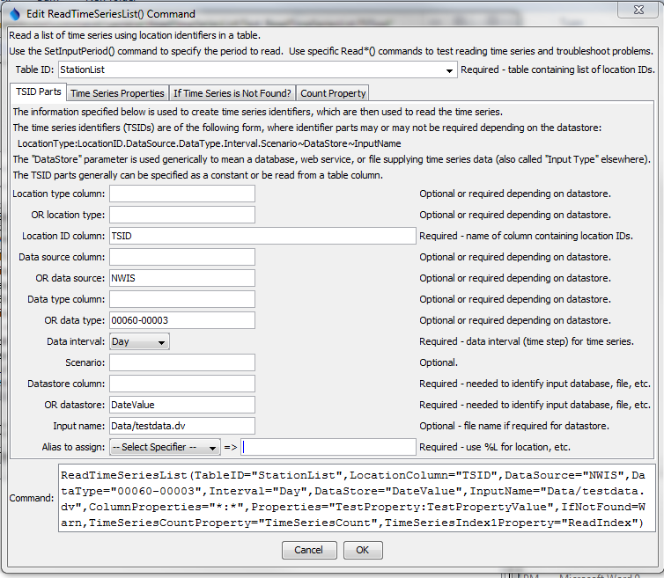

ReadTimeSeriesList

ReadTimeSeriesList() Command Editor for Main TSID Parameters

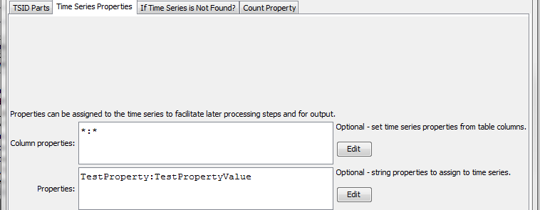

ReadTimeSeriesList_TimeSeriesProperties

ReadTimeSeriesList() Command Editor Time Series Properties Parameters

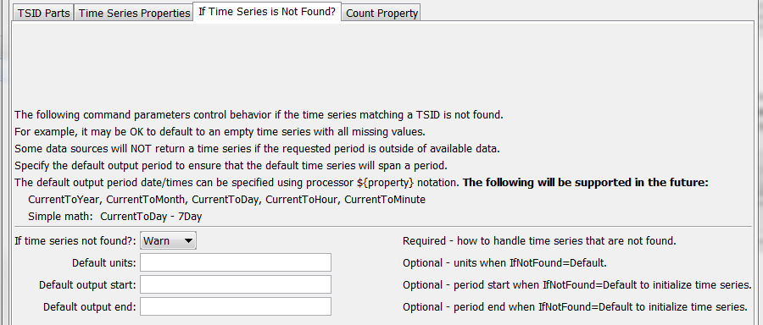

ReadTimeSeriesList_IfNotFound

ReadTimeSeriesList() Command Editor for Parameters if Time Series is not Found

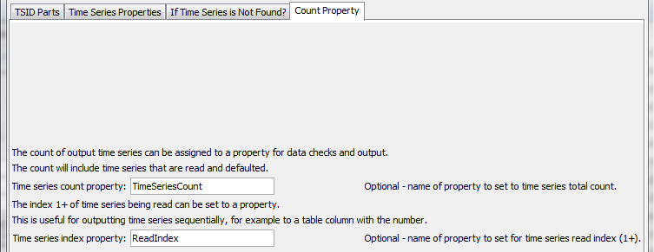

ReadTimeSeriesList_Check

ReadTimeSeriesList() Command Editor for Parameters Used in Checks

The command syntax is as follows:

ReadTimeSeriesList(Parameter=Value, …)

Command Parameters

| Parameter | Description | Default |
| --- | --- | --- |
| TableID | The identifier for the table that provides the list of location identifiers. | None – must be specified. |
| LocationType  Column | The column in the table containing the location type to use in time series identifiers. Specify LocationTypeColumn or LocationType. | May or may not be required, depending on the datastore or input type. |
| LocationType | The location type in the time series identifier. Specify LocationTypeColumn or LocationType. | May or may not be required, depending on the datastore or input type. |
| LocationColumn | The column in the table containing the location identifiers to use in time series identifiers. | None – must be specified. |
| DataSource  Column | The column in the table containing the data source to use in time series identifiers. Specify DataSourceColumn or DataSource. | May or may not be required, depending on the datastore or input type. |
| DataSource | The data source(s) in the time series identifier, separated by commas. For example, if using the State of Colorado’s HydroBase, USGS indicates that data are from the United States Geological Survey and DWR are from the Division of Water Resources. If multiple data sources are specified, each will be tried until a time series is found. This is enabled because sometimes gages change ownership. Specify DataSourceColumn or DataSource. | May or may not be required, depending on the datastore or input type |
| DataType  Column | The column in the table containing the data type to use in time series identifiers. Specify DataTypeColumn or DataType. | Data type is often required |
| DataType | The data type in the time series identifier. For example, if using the State of Colorado’s HydroBase, DivTotal is used for diversion totals. Specify DataTypeColumn or DataType. | Data type is often required |
| Interval | Data interval in the time series identifier, using standard values such as 15Minute, 6Hour, Day, Month, Year. | None – must be specified. |
| Scenario | Scenario in the time series identifier. | Usually not required. |
| DataStore | The data store (or input type) in the time series identifier. Refer to the datastore and input type appendices or the TSTool main GUI for options. | None – must be specified. |
| InputName | The input name in the time series identifier, when a file name is required. | Generally only required when reading from a file. |
| Alias | Time series alias to assign, using a combination of % specifiers and literal strings. | No alias is assigned. |
| Column  Properties | Column names and matching time series property name to set, using syntax: Column1:Property1,Column2:Property2  Specify * for the column name to set all column values as properties. Specify * for the property value to use the column name for the time series property. | No time series properties will be set from the table. |
| Properties | String properties to be assigned to the time series using syntax Property1:Value1,Property2:Value2 |  |
| IfNotFound | Indicates how to handle missing time series, one of:   * Warn – generate fatal warnings and do not include in output. * Ignore – generate non-fatal warnings and do not include in output. * Default – generate non-fatal warnings and create empty time series for those that could not be found. This requires that a SetOutputPeriod() command be used before the command to define the period for default time series. | Warn |
| DefaultUnits | Default units when IfNotFound=Default. | Blank – no units. |
| Default  OutputStart | Specify the output period start when a default time series is read, using date/time string or ${Property}. | Uses global output start. |
| Default  OutputEnd | Specify the output period start when a default time series is read, using date/time string or ${Property}. | Uses global output end. |
| TimeSeries  CountProperty | The name of the processor property to set with the count of time series processed, including read and defaulted time series. |  |
| TimeSeries  Index1Property | The name of the time series property to set with the index position (1+) for the time series read from the list, essentially a running count of read time series. |  |

A sample command file to process monthly diversion data from the State of Colorado’s HydroBase database is as follows:

|  |
| --- |
| # Read monthly diversion total from HydroBase for the structures in the list  # file. The data source is set to DWR because data source is saved in  # HydroBase.  ReadTimeSeriesList(TableID=”Diversions.csv",LocationColumn=”WDID”,  DataSource=DWR,DataType=DivTotal,Interval=Month,InputType=HydroBase,  IfNotFound=Default) |

This page is intentionally blank.