Command Reference: ReadUsgsNwisInstantaneous()

Read 1+ time series from the USGS NWIS Instantaneous Values web service

Version 11.13.00, 2017-03-07

The ReadUsgsNwisInstantaneous() command reads one or more time series from the United States Geological Survey (USGS) National Water Information System (NWIS) Instantaneous Values web service (see the UsgsNwisInstantaneous Datastore Appendix). The command provides parameters to constrain the web service query and also allows the result to be saved as an output file. For example, if WaterML is chosen as the time series format, a WaterML file can be saved and can be read later using the ReadWaterML() command. See also the WebGet() command, which also can be used to retrieve data files from the USGS website.

If WaterML is used as the data transfer format using the Format command parameter, a WaterML 1.1 XML response will be returned by the web services. WaterML 1.1 does not explicitly indicate the time series data interval (could be Irregular, could be 15Minute, etc.). Consequently the command requires that the WaterMLInterval parameter be specified. If Irregular is used for the interval, the time series will include all the values as is, which is useful for displays; however, irregular data are unwieldy for modeling and other commands will need to be used to convert to regular interval. If a regular interval is specified, then timestamps that align will be set in the time series and the WaterMLRequireDataToMatchInterval parameter controls whether warnings are generated when data don’t match. For example, this allows some flexibility to read a 15Minute time series directly if that is the published interval. These issues are being evaluated as TSTool is updated to support WaterML 2.0.

The USGS NWIS web service allows station and time series data type information to be filtered, both as a convenience and to maintain reasonable web service performance. Many of the choices that are available for limiting queries allow 0+ values to be provided. For example, specifying no requested parameter will return all available parameters for a location. Specifying a list of parameters (separated by commas) will return only the requested parameters.

USGS codes are used in order to generate a unique time series identifier (TSID). For example, the TSID data type is formed from the parameter code. The numerical codes currently are used to ensure uniqueness but in the future the string name may be allowed as an option. In order to have more human-friendly identifiers for time series, one strategy is to request only a specific parameter and then use the alias to specify a text equivalent to the numeric codes. For example, specify Parameters=00060 (for streamflow discharge) and and assign the alias with Alias=%L.Streamflow.

The following dialog is used to edit the command and illustrates the syntax. Note that some choices are provided as a convenience. However, full listing of choices (such as all the thousands of streamflow stations that are available) is not provided due to performance issues. Additional query features will be enabled as web service integration is enhanced.

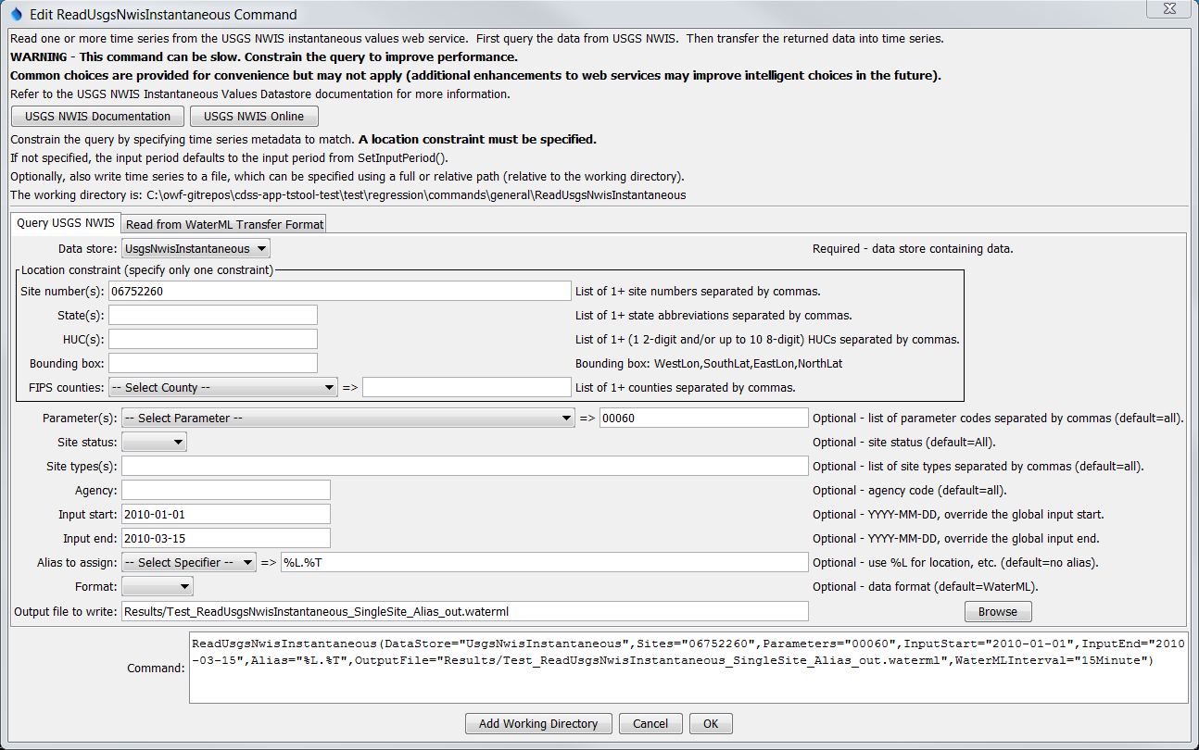

ReadUsgsNwisInstantaneous

ReadUsgsNwisInstantaneous() Command Editor

The command syntax is as follows:

ReadUsgsNwisInstantaneous(Parameter=Value,…)

Command Parameters

| Parameter | Description | Default |
| --- | --- | --- |
| Sites | A list of site numbers to read, separated by commas. Can be specified using ${Property}. | None – one of the locational parameters must be provided to constrain the query. |
| States | A list of state codes (e.g., AL), separated by commas. Can be specified using ${Property}. | None – see above. |
| HUCs | A list of hydrologic unit codes, separated by commas. See the limitations on the NWIS site for more information. Can be specified using ${Property}. | None – see above. |
| BoundingBox | A bounding box consisting of west longitude, south latitude, east longitude, and north latitude, separated by spaces. Longitudes in the western hemisphere are negative. Can be specified using ${Property}. | None – see above. |
| Counties | A list of Federal Information Processing Standards (FIPS) county codes, separated by commas. Can be specified using ${Property}. | None – see above. |
| Parameters | Data parameter codes for the stations (e.g., 00060 for stream discharge), separated by commas. Can be specified using ${Property}. | All available parameters for the sites are returned. |
| SiteStatus | Filter for stations, one of:   * All – all stations are returned * Active – only active stations are returned * Inactive – only inactive stations are returned | All |
| SiteTypes | Site types to return, separated by commas. Can be specified using ${Property}. | All available site types are returned. |
| Agency | Agency code to return (e.g., USGS). Can be specified using ${Property}. | All available agencies are returned. |
| InputStart | The start of the period to read data to 15-minute precision – specify if the period should be different from the global query period. Can be specified using ${Property}. | Use the global query period. |
| InputEnd | The end of the period to read data to 15-minute precision – specify if the period should be different from the global query period. Can be specified using ${Property}. | Use the global query period. |
| Alias | The alias to assign to the time series, as a literal string or using the special formatting characters listed by the command editor. The alias is a short identifier used by other commands to locate time series for processing, as an alternative to the time series identifier (TSID). | None – must be specified. |
| Format | The data format for output, one of:   * JSON – JavaScript Object Notation (currently used only for downloads but will not result in time series in TSTool) * RDB – tab-delimited format (also see ReadUsgsNwisRDB() command; currently used only for downloads but will not result in time series in TSTool). * WaterML – WaterML 1.1 XML format (also see the ReadWaterML() command). | WaterML |
| OutputFile | The name of the output file to create. The path to the file can be absolute or relative to the working directory. | No output file will be created. |
| WaterML  Interval | Indicate the interval for time series when Format=WaterML, necessary because the WaterML contents are ambiguous with regard to setting a data interval for instantaneous data. | Irregular |
| WaterML  RequireData  ToMatch  Interval | If true, then all timestamps read from the WaterML file must match the output time series interval specified with WaterMLInterval. This parameter can be set to false to allow reading irregular data into a 15Minute time series, for example, and saving irregular values in the time slot. | True |