Command Reference: RemoveFile()

Remove a file

Version 11.03.00, 2015-05-31

The RemoveFile() command removes a file from the file system. This command is used to remove results files before attempting to regenerate the results and is used extensively in software testing.

A failure will be generated if the file exists and cannot be removed (e.g., due to file permissions or being locked by another process).

Even read-only files may be removed by this command, depending on how the operating system and computer environment handle access permissions.

The following dialog is used to edit the command and illustrates the syntax for the command.

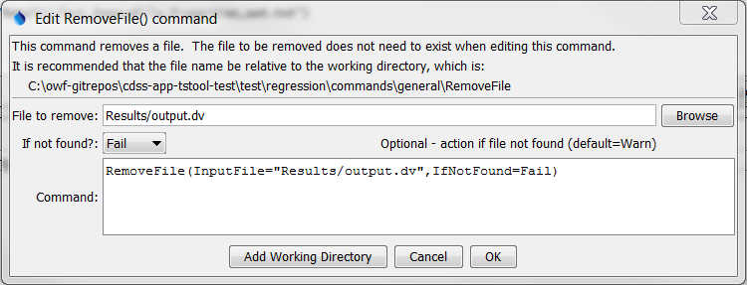

RemoveFile

RemoveFile() Command Editor

The command syntax is as follows:

RemoveFile(Parameter=Value,…)

Command Parameters

|  |  |  |
| --- | --- | --- |
| Parameter | Description | Default |
| InputFile | The name of the file to delete. Can be specified using processor ${Property}. | None – must be specified. |
| IfNotFound | Indicate action if the file is not found, one of:   * Ignore – ignore the missing file (do not warn). * Warn – generate a warning (use this if the file truly is expected and a missing file is a cause for concern). * Fail – generate a failure (use this if the file truly is expected and a missing file is a cause for concern). | Warn |

The following example command file illustrates how to remove a file:

|  |
| --- |
| RemoveFile(InputFile="Results/output.dv") |