Command Reference: ReplaceValue()

Replace time series data value(s)

Version 11.03.02, 2015-06-08

The ReplaceValue() command replaces a range of values in a time series with a constant value, sets the values to missing, or removes the values (if an irregular time series). If the missing value indicator is a number in the range, missing values also will be replaced. The time series data flag can be checked in place of or addition to checking the numerical values. This command is useful for filtering out erroneous data values. See also the CheckTimeSeries() command, which provides for a variety of checks and also allows values to be set to missing or removed.

The following dialog is used to edit the command and illustrates the syntax of the command:

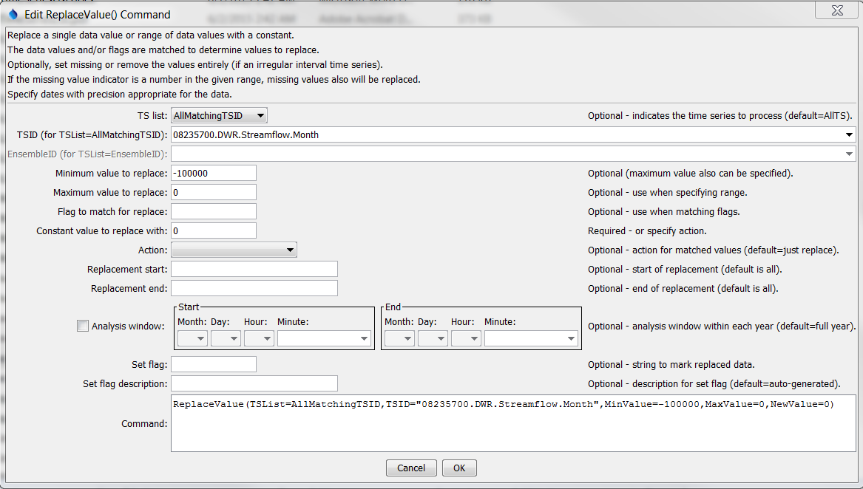

ReplaceValue

ReplaceValue() Command Editor

The command syntax is as follows:

ReplaceValue(Parameter=Value,…)

Command Parameters

| Parameter | Description | Default |
| --- | --- | --- |
| TSList | Indicates the list of time series to be processed, one of:   * AllMatchingTSID – all time series that match the TSID (single TSID or TSID with wildcards) will be processed. * AllTS – all time series before the command. * EnsembleID – all time series in the ensemble will be processed. * FirstMatchingTSID – the first time series that matches the TSID (single TSID or TSID with wildcards) will be processed. * LastMatchingTSID – the last time series that matches the TSID (single TSID or TSID with wildcards) will be processed. * SelectedTS – the time series are those selected with the SelectTimeSeries() command. | AllTS |
| TSID | The time series identifier or alias for the time series to be processed, using the * wildcard character to match multiple time series. Can be specified with processor ${Property}. | Required if TSList=*TSID. |
| EnsembleID | The ensemble to be processed, if processing an ensemble. Can be specified with processor ${Property}. | Required if TSList=EnsembleID. |
| MinValue | The minimum value to replace. | The minimum value and/or MatchFlag must be specified. |
| MaxValue | The maximum value to replace. | If not specified, only data values that exactly match the minimum value will be replaced. |
| MatchFlag | The flag to match. If specified in addition to MinValue, then the value and flag must be matched in order to perform the replacement. A case-sensitive comparison is made and the data value flag must exactly match MatchFlag. In the future additional flexibility may be added to match a substring, etc.  If Action=SetMissing, the original data flag value will remain. Specifying SetFlag will result in the original data flag being modified. | The minimum value and/or MatchFlag must be specified. |
| NewValue | The new data value. | Required, unless the Action parameter is specified. |
| Action | An additional action to take with values that are matched:   * Remove – remove the data points. This can only be specified for irregular interval time series and will be interpreted as SetMissing for regular interval time series. * SetMissing – set values to missing. | No additional action is taken and the NewValue parameter must be specified. |
| SetStart | The date/time to start filling, if other than the full time series period. Can be specified with processor ${Property}. | Check the full period. |
| SetEnd | The date/time to end filling, if other than the full time series period. Can be specified with processor ${Property}. | Check the full period. |
| AnalysisWindow  Start | The starting date/time within the calendar year to replace data. The window CANNOT cross calendar year boundaries (this may be allowed in the future). Use multiple commands if necessary. | Process each full year. |
| AnalysisWindow  End | The ending date/time within the calendar year to replace data. | Process each full year. |
| SetFlag | A string to assign to data values that are replaced. | Do not assign a string flag. |
| SetFlagDesc | Description for SetFlag, used for data products. | Auto-generate. |

A sample command file to process from the State of Colorado’s HydroBase database is as follows:

|  |
| --- |
| # 08235700 - ALAMOSA RIVER BELOW CASTLEMAN GULCH NEAR JASPER  08235700.DWR.Streamflow.Month~HydroBase  ReplaceValue(TSList=AllTS,MinValue=-100000,MaxValue=0,NewValue=0) |

This page is intentionally blank.