Command Reference: RunSql()

Run an SQL statement on a datastore

Version 10.22.00, 2013-08-26

The ReadSql() command executes a Structured Query Language (SQL) statement on the specified database datastore. This command cannot be used with web service datastores because the underlying software relies on a database to execute the SQL statement. If database datastore support is not specifically provided by TSTool, a generic datastore can be used (see the Generic Database DataStore appendix). See also the ReadTableFromDataStore(), WriteTableToDataStore(), and other commands specific to datastores. This command is useful when a database task needs to be automated in sequence with other TSTool commands. The SQL statement can be specified in the following ways:

* Specify a SQL statement as a command parameter:
  + SQL must be valid for the database (syntax may vary based on database software).
  + Use ${Property} notation to insert processor property values set with SetProperty().
  + SQL syntax is not checked for validity and therefore error messages from the database may be more difficult to interpret.
* Specify an SQL select statement in a file:
  + Similar to the above option; however, the SQL statement is read from a file.
  + Useful if the SQL statement is also used by other tools.
* Specify a procedure to run:
  + Available procedures are listed and can be selected.
  + Currently, only procedures that do not require parameters can be run.

General constraints on executing the statement are as follows:

* The table, views, and procedures being queried must be readable (some databases restrict direct access to data and require using stored procedures).
* Any SQL statement can be run; consequently, suitable authentication and permissions should be in place to protect against unintended changes to the database
* SQL syntax varies between database software so care should be take to use standard SQL if possible.
* Results from the statement currently are not displayed, although errors will be shown and added to the log file. Use the ReadTableFromDataStore() command to process statements that return a result set.

The following dialog is used to edit the command and illustrates the syntax for the command, in this case creating a database index.

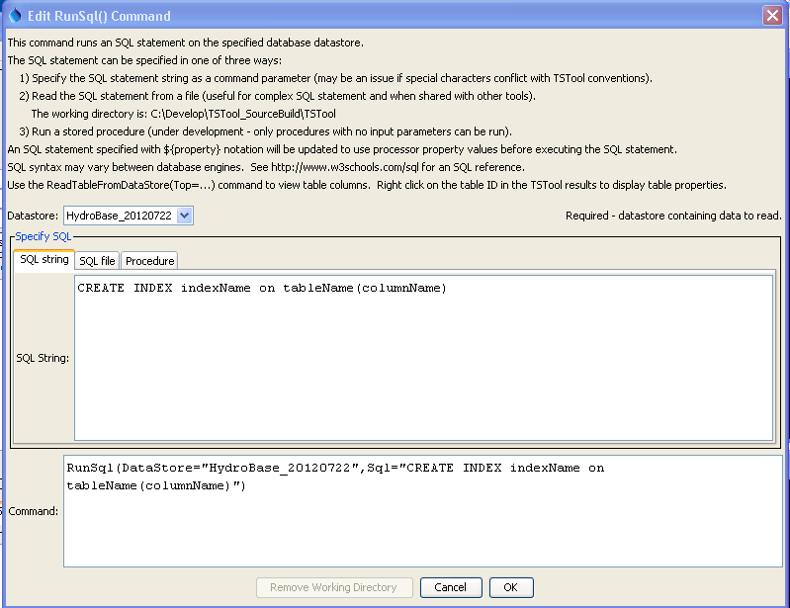

RunSql

RunSql() Command Editor

The command syntax is as follows:

RunSql(Parameter=Value,…)

Command Parameters

|  |  |  |
| --- | --- | --- |
| Parameter | Description | Default |
| DataStore | The name of a database datastore. | None – must be specified. |
| Sql | The SQL statement text that will be executed, optionally using ${Property} notation to insert processor property values. If specified, do not specify SqlFile or DataStoreProcedure. | None. |
| SqlFile | The name of the file containing an SQL statement to execute, optionally using ${Property} notation in the SQL file contents to insert processor property values. If specified, do not specify Sql or DataStoreProcedure. | None. |
| DataStore  Procedure | The name of the database procedure to run. Currently, only procedures that do not require parameters can be run. If specified, do not specify Sql or SqlFile. | None. |

This page is intentionally blank.