Command Reference: Scale()

Scale time series data values by a constant value

Version 11.03.00, 2015-05-31

The Scale() command scales each non-missing value in the specified time series. The value to use for scaling can be specified as a constant, monthly values, or special values that indicate to scale by the number of days in the month.

The following dialog is used to edit the command and illustrates the command syntax.

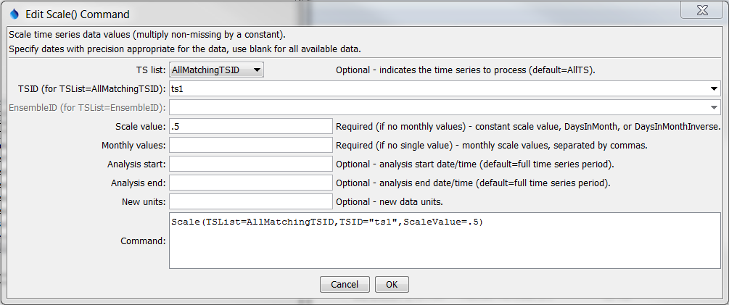

Scale

Scale() Command Editor

The command syntax is as follows:

Scale(Parameter=Value,…)

Command Parameters

| Parameter | Description | Default |
| --- | --- | --- |
| TSList | Indicates the list of time series to be processed, one of:   * AllMatchingTSID – all time series that match the TSID (single TSID or TSID with wildcards) will be modified. * AllTS – all time series before the command. * EnsembleID – all time series in the ensemble will be modified. * FirstMatchingTSID – the first time series that matches the TSID (single TSID or TSID with wildcards) will be modified. * LastMatchingTSID – the last time series that matches the TSID (single TSID or TSID with wildcards) will be modified. * SelectedTS – the time series are those selected with the SelectTimeSeries() command. | AllTS |
| TSID | The time series identifier or alias for the time series to be modified, using the * wildcard character to match multiple time series. Can be specified using processor ${Property}. | Required if TSList=*TSID |
| EnsembleID | The ensemble to be modified, if processing an ensemble. Can be specified using processor ${Property}. | Required if TSList= EnsembleID |
| ScaleValue | One of the following:   * The numerical value to scale to the time series. * DaysInMonth to indicate a scale of the number of days in the month. * DaysInMonthInverse to indicate a scale of the inverse of the number of days in the month.   Can be specified with processor ${Property}. | None – must be specified. |
| MonthValues | Monthly scale values, the fist being for January. Can be specified using processor ${Property}. | Use ScaleValue. |
| AnalysisStart | The date/time to start analyzing data. Can be specified using processor ${Property}. | Full period is analyzed. |
| AnalysisEnd | The date/time to end analyzing data. Can be specified using processor ${Property}. | Full period is analyzed. |
| NewUnits | New data units for the resulting time series. Can be specified using processor ${Property}. | Do not change the units. |

The following example scales a precipitation time series from the State of Colorado’s HydroBase by a factor of 3.5:

|  |
| --- |
| # 1458 - CENTER 4 SSW  1458.NOAA.Precip.Month~HydroBase  Scale(TSList=AllMatchingTSID,TSID="1458.NOAA.Precip.Month",ScaleValue=3.5) |

The following example scales a monthly streamflow time series with units of ACFT (volume per month) in order to convert the data to average CFS flow values (note that two scale commands are required because the DaysInMonthInverse value cannot currently be combined with a numerical value in one command). See also the ConvertDataUnits() command for simple units conversions.

|  |
| --- |
| # 06754000 - SOUTH PLATTE RIVER NEAR KERSEY  06754000.DWR.Streamflow.Month~HydroBase  Scale(TSList=AllMatchingTSID,TSID="06754000.DWR.Streamflow.Month",  ScaleValue=.5042)  Scale(TSList=AllMatchingTSID,TSID="06754000.DWR.Streamflow.Month",  ScaleValue=DaysInMonthInverse,NewUnits="CFS")  06754000.DWR.Streamflow.Month~HydroBase |