Command Reference: SelectTimeSeries()

Select time series for additional processing

Version 12.03.00, 2017-06-16

The SelectTimeSeries() command selects output time series, as if done interactively, to indicate which time series should be operated on by following commands. The command minimizes the need for the Free() command because other commands that operate on a time series list can use TSList=SelectedTS. See also the DeselectTimeSeries() command.

The following dialog is used to edit the command and illustrates the command syntax for selecting time series using the TSList parameter. This parameter provides the initial filter for the list of time series. In addition to standard TSList parameter values, the TSPosition value is specific to this command.

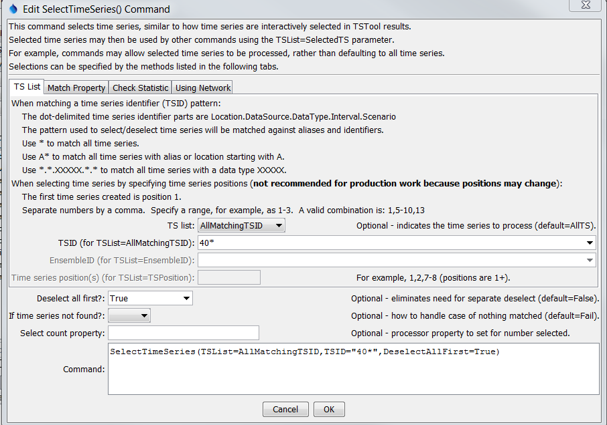

SelectTimeSeries

SelectTimeSeries() Command Editor

The following dialog illustrates how to select time series by matching a string property.

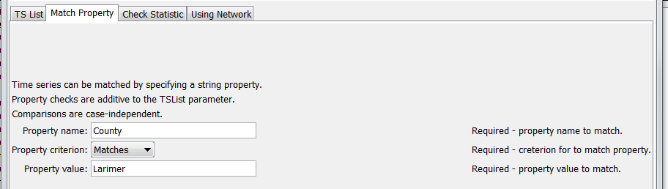

SelectTimeSeries_Property

SelectTimeSeries() Command Editor Specifying a Property to Match

The following dialog illustrates how to select time series by evaluating a time series statistic.

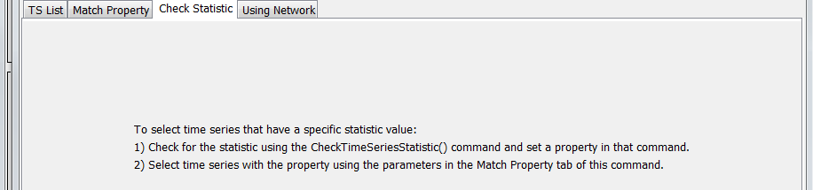

SelectTimeSeries_Statistic

SelectTimeSeries() Command Editor Specifying a Statistic to Check

The following dialog illustrates how to select time series by matching locations in a network.



SelectTimeSeries_Network

SelectTimeSeries() Command Editor Specifying Network Nodes

The command syntax is as follows:

SelectTimeSeries(Parameter=Value,…)

Command Parameters

| Parameter | Description | Default |
| --- | --- | --- |
| TSList | Indicates the list of time series to be processed, one of:   * AllMatchingTSID – all time series that match the TSID (single TSID or TSID with wildcards) will be modified. * AllTS – all time series before the command. * EnsembleID – all time series in the ensemble will be modified (see the EnsembleID parameter). * LastMatchingTSID – the last time series that matches the TSID (single TSID or TSID with wildcards) will be modified. * TSPosition – time series specified by position in the results list (see TSPosition parameter below). | AllTS |
| TSID | The time series identifier or alias for the time series to be modified, using the * wildcard character to match multiple time series. Can be specified using processor ${Property}. | Required if TSList=*TSID |
| EnsembleID | The ensemble to be modified, if processing an ensemble. Can be specified using processor ${Property}. | Required if TSList=EnsembleID |
| TSPosition | A list of time series positions (1+) in output, separated by commas. Ranges can be specified as Start-End. | Required if TSList=TSPosition |
| DeselectAllFirst | Indicate whether all time series should be deselected before selecting the specified time series: True or False. | False |
| IfNotFound | Indicate how to handle the case of no time series being matched:   * Ignore – OK if nothing selected * Warn – generate a warning message * Fail – generate a failure message | Fail |
| PropertyName | Name of user-defined property to check. A property, if specified, is additive to selections from the TSList parameter. Can be specified using processor ${Property}. |  |
| PropertyCriterion | Criterion to evaluate to determine which properties match. | Required if PropertyName is specified. |
| PropertyValue | Value to check against the property value, using criterion. Can be specified using processor ${Property}. | Required if PropertyName is specified. |
| NetworkID | The identifier for the network if selecting based on match of network node identifiers and location part of time series identifier. | Network select is not used. |
| DownstreamNodeID | The downstream node in the network to match. If preceded by a dash, don’t include the node in output. | Network select is not used. |
| UpstreamNodeIDs | Comma-separated list of upstream network node identifiers to match. If any identifier is preceded by a dash, don’t include the node in output. | If selecting from network, select all nodes upstream of the downstream node. |
| SelectCountProperty | If specified, the corresponding time series property will be set to the number of selected time series after the command is executed. This is useful in cases where following commands are wrapped in an If() command and should only be executed if the count is > 0. Also use to check for count of 0 and warn with the Message() command. Can be specified using processor ${Property}. |  |

A sample command file is as follows:

|  |
| --- |
| NewPatternTimeSeries(Alias="401234",NewTSID="401234..Precip.Day",  Description="Example data",SetStart="2000-01-01",SetEnd="2000-12-31",  Units="IN",PatternValues="0,1,3,0,0,0")  SelectTimeSeries(TSList=AllMatchingTSID,TSID="40*",DeselectAllFirst=True) |