Command Reference: SetConstant()

Set time series data to a single or monthly constant values

Version 10.26.00, 2013-12-06

The SetConstant() command sets the values of a time series to a single or monthly constant values.

The following dialog is used to edit the command and illustrates the command syntax:

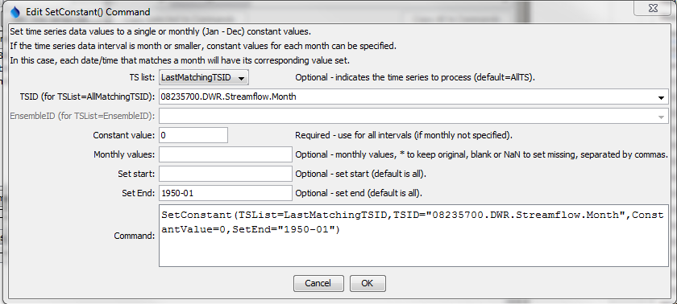

SetConstant

SetConstant() Command Editor

The command syntax is as follows:

SetConstant(Parameter=Value,…)

Command Parameters

| Parameter | Description | Default |
| --- | --- | --- |
| TSList | Indicates the list of time series to be processed, one of:   * AllMatchingTSID – all time series that match the TSID (single TSID or TSID with wildcards) will be modified. * AllTS – all time series before the command. * EnsembleID – all time series in the ensemble will be modified. * LastMatchingTSID – the last time series that matches the TSID (single TSID or TSID with wildcards) will be modified. * SelectedTS – the time series are those selected with the SelectTimeSeries() command. | AllTS |
| TSID | The time series identifier or alias for the time series to be modified, using the * wildcard character to match multiple time series. | Required if TSList=*TSID. |
| EnsembleID | The ensemble to be modified, if processing an ensemble. | Required if TSList=EnsembleID. |
| ConstantValue | The constant value to use as the data value. | None – must be specified, or specify monthly values. |
| MonthValues | Monthly values to use as the data values. Twelve values for Jan – Dec must be specified, separated by commas. * indicates to keep the original value. Blank or NaN indicates to set the value to missing. If the time series data interval is less than monthly, each date/time will be set for a specific month. | None – must be specified, or specify a constant value. |
| SetStart | The starting date/time for the data set. | Set data for the full period. |
| SetEnd | The ending date/time for the data set. | Set data for the full period. |

A sample command file to process a time series from the State of Colorado’s HydroBase is as follows (only the early period is set to zero):

|  |
| --- |
| # 08235700 - ALAMOSA RIVER BELOW CASTLEMAN GULCH NEAR JASPER  08235700.DWR.Streamflow.Month~HydroBase  SetConstant(TSList=AllMatchingTSID,TSID="08235700.DWR.Streamflow.Month",  ConstantValue=0,SetEnd="1950-01") |