Command Reference: SetDebugLevel()

Set level for debug messages

Version 11.10.00, 2016-03-31

The SetDebugLevel() command sets the debug levels for screen and log file diagnostic messages. This command can be used multiple times with different debug level (e.g., to isolate a problem). Currently the debug level applies to all components. In the future logging control may be grouped by component. Levels are not completely consistent but the following guidelines can be followed:

0 = no messages

1 = important messages generated in applications

2 = important messages generated in commands

3+ = messages generated in commands that may explain other problems

10+ = messages in processing code that may still be useful to end users

30+ = low-level messages, for example generated while reading from files or databases

The following dialog is used to edit this command and illustrates the command syntax.

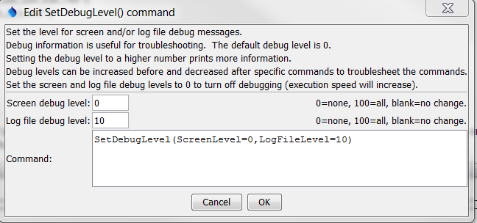

SetDebugLevel

SetDebugLevel() Command Editor

The command syntax is as follows:

SetDebugLevel(Parameter=Value,…)

Command Parameters

|  |  |  |
| --- | --- | --- |
| Parameter | Description | Default |
| ScreenLevel | The debug level for the screen (0+). | Keep previous setting. |
| LogFileLevel | The debug level for the log file (0+). | Keep previous setting. |

A sample command file is as follows:

|  |
| --- |
| SetDebugLevel(ScreenLevel=0,LogFileLevel=10) |

.