Command Reference: SetEnsembleProperty()

Set time series ensemble properties

Version 11.09.00, 2016-02-26

The SetEnsembleProperty() command sets the value of one or more time series ensemble properties. The EnsembleID property is a built-in property that has special meaning because it is used to identify the time series and cannot be changed. User-defined properties are handled as a list of properties that can be referenced by other commands using the ${tsensemble:Property} notation. Property names are case-specific.

The following dialog is used to edit this command and illustrates the syntax of the command for built-in properties.

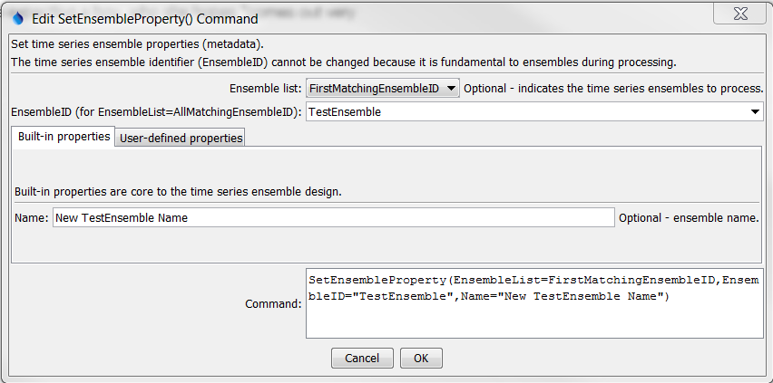

SetEnsembleProperty_Builtin

SetEnsembleProperty() Command Editor for Built-in Properties

The following dialog is used to edit this command and illustrates the syntax of the command for user-defined properties, in this case setting a property from a global processor property.

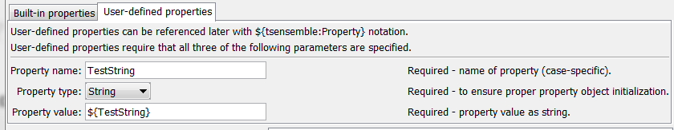

SetEnsembleProperty_User

SetProperty() Command Editor for User Properties

The command syntax is as follows:

SetTimeSeriesProperty(Parameter=Value,…)

Command Parameters

| Parameter | Description | Default |
| --- | --- | --- |
| EnsembleList | Indicates the list of time series to be processed, one of:   * AllMatchingEnsembleID – all time series ensembles that match the EnsembleID (single EnsembleID or EnsembleID with wildcards) will be modified. **Currently not enabled**. * AllEnsemble – all time series ensembles before the command. **Currently not enabled**. * EnsembleID – the matching ensemble will be modified. **Currently not enabled**. * FirstMatchingEnsembleID – the first time series ensemble that matches the EnsembleID (single EnsembleID or EnsembleID with wildcards) will be modified. * LastMatchingEnsembleID – the last time series that matches the EnsembleID (single EnsembleID or EnsembleID with wildcards) will be modified. **Currently not enabled**. | None – must be specified. |
| EnsembleID | The time series ensemble identifier for the ensemble to be modified. Can be specified using processor ${Property}. | Required if EnsembleList=  *EnsembleID. |
| Name | The ensemble name. Can be specified using processor ${Property}. | None. |
| PropertyName | Name of user-defined property. |  |
| PropertyType | Property type, to ensure proper initialization and data check. | Required if PropertyName is specified. |
| PropertyValue | Value for property as a string but adhering to the property type requirements (e.g., date as a string must match format that can be parsed). Can be specified using processor ${Property}. | Required if PropertyName is specified. |