Command Reference: SetExcelWorksheetViewProperties()

Set view properties for a worksheet in a Microsoft Excel workbook file

Version 11.08.00, 2016-01-17

The SetExcelWorksheetViewProperties() command sets view properties associated with an Excel worksheet, for example to facilitate automated creation of Excel workbooks. Additional properties will be added in the future. Currently the command can set the following properties:

* Freeze pane

TSTool uses the Apache POI software (http://poi.apache.org) to read/write the Excel file and consequently functionality is constrained by the features of that software package.

The following figures illustrate the dialog used to edit the command and the syntax for the command.

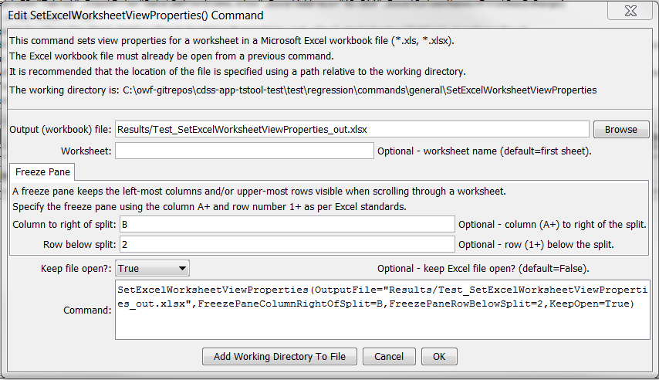

SetExcelWorksheetViewProperties

SetExcelWorksheetViewProperties() Command Editor

The command syntax is as follows:

SetExcelWorksheetViewProperties(Parameter=Value,…)

Command Parameters

| Parameter | Description | Default |
| --- | --- | --- |
| OutputFile | The name of the Excel workbook file (*.xls or *.xlsx) to write, as an absolute path or relative to the command file location. The Excel file must have been opened with a previous command. Can be specified with ${Property}. | None – must be specified. |
| Worksheet | The name of the worksheet in the workbook to set view properties. Can be specified with ${Property}. | Set properties for the first worksheet. |
| FreezePane  ColumnRight  OfSplit | The column to the right of the freeze pane split, using notation A, etc. | Columns will not be frozen. |
| FreezePane  RowBelowSplit | The row below the freeze pane split, specified as row number 1+. | Rows will not be frozen. |
| KeepOpen | Indicate whether to keep the Excel file open (True) or close after creating (False). Keeping the file open will increase performance because later commands will not need to reread the workbook. | False |