Command Reference: SetFromTS()

Set time series data using data from another time series

Version 11.03.05, 2015-06-14

The SetFromTS() command sets data in a dependent time series by transferring values from an independent time series. A period and window within the year can be specified to limit the period that is processed. See also the FillFromTS() command, which will transfer values only when the dependent time series has missing data. Only data values are transferred – time series properties will not be modified. If multiple time series or an ensemble is being processed, the number of independent time series must be one or the same number as the time series being filled.

It is also possible to use this command to transfer data between time series that have different intervals. If the independent time series has a smaller interval, then SetWindowStart and SetWindowEnd parameters should be used to specify a window to transfer – the first value in the window will be transferred. For example, when transferring all the January values from a monthly time series to a year-interval dependent time series, specify the window start and end as 01. If the transfer is from longer interval to smaller, then the values from the independent time series will be used multiple times for the dependent time series (e.g., annual value used for each month).

The following dialog is used to edit the command and illustrates the command syntax.

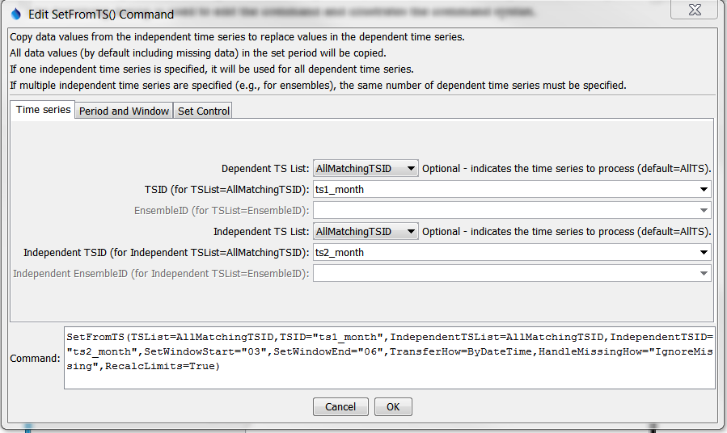

SetFromTS

SetFromTS() Command Editor for Time Series Parameters

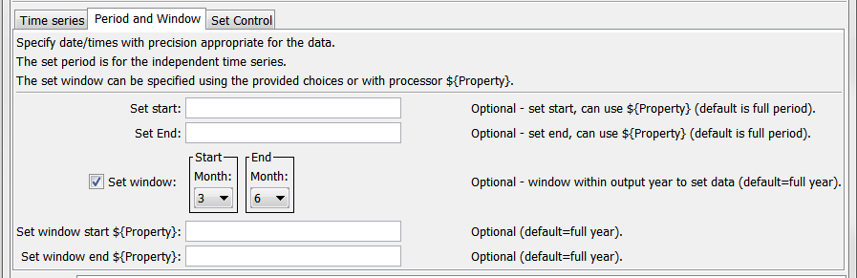

SetFromTS_Period

SetFromTS() Command Editor for Period and Window Parameters

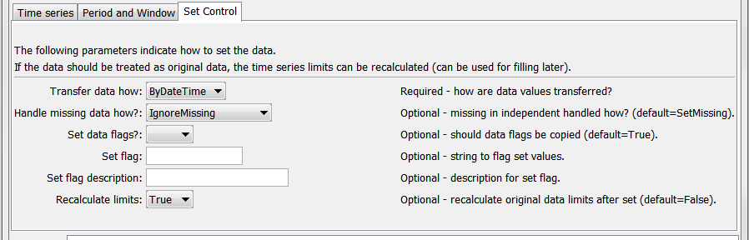

SetFromTS_Control

SetFromTS() Command Editor for Set Control Parameters

The command syntax is as follows:

SetFromTS(Parameter=Value,…)

Command Parameters

| Parameter | Description | Default |
| --- | --- | --- |
| TSList | Indicates the list of time series to be processed, one of:   * AllMatchingTSID – all time series that match the TSID (single TSID or TSID with wildcards) will be modified. * AllTS – all time series before the command. * EnsembleID – all time series in the ensemble will be modified. * FirstMatchingTSID – the first time series that matches the TSID (single TSID or TSID with wildcards) will be modified. * LastMatchingTSID – the last time series that matches the TSID (single TSID or TSID with wildcards) will be modified. * SelectedTS – the time series are those selected with the SelectTimeSeries() command. | AllTS |
| TSID | The time series identifier or alias for the time series to be modified, using the * wildcard character to match multiple time series. Can be specified using processor ${Property}. | Required when TSList=*TSID |
| EnsembleID | The ensemble to be modified, if processing an ensemble. Can be specified using processor ${Property}. | Required when TSList=EnsembleID |
| Independent  TSList | Indicates how to determine the list of independent time series (see the explanation of TSList). | AllTS |
| Independent  TSID | The time series identifier or alias for the independent time series (see the explanation of TSID). Can be specified using processor ${Property}. | Required when a IndependentTSList=  *TSID |
| Independent  EnsembleID | The ensemble identifier for the independent time series (see the explanation of EnsembleID). Can be specified using processor ${Property}. | Required when IndepndentTSList=  EnsembleID. |
| SetStart | The date/time to start setting data, if other than the full time series period. Can be specified using processor ${Property}. | Full period. |
| SetEnd | The date/time to end setting data, if other than the full time series period. Can be specified using processor ${Property}. | Full period. |
| SetWindowStart | The date/time (without year) indicating the start of the window within a year to set values in the output (dependent) time series. For example:   * mm – for monthly time series * mm-dd – for daily time series * mm-dd-hh – for hourly data   If specified using processor ${Property}, the processor property will override date/time selections. | Full year. |
| SetWindowEnd | The date/time (without year) indicating the end of the window within a year to set values in the output (dependent) time series. If specified using processor ${Property}, the processor property will override date/time selections. | Full year. |
| TransferHow | Indicates how to transfer data:   * ByDateTime – a date/time in one time series will be lined up with the other time series. * Sequentially – data from the independent will be transferred sequentially, even if the date/time does not align (used when transferring continuous data over Feb 28/29, without gaps). | None – must be specified. |
| HandleMissingHow | Indicates how to handle missing data in the independent time series:   * IgnoreMissing – missing values in the independent time series WILL NOT be transferred to the dependent time series. * SetMissing – missing values in the independent time series WILL be transferred to the dependent time series. * SetOnlyMissingValues – only the missing values in the independent time series will be transferred, useful when a separate time series has been used to insert additional missing values. | SetMissing |
| SetDataFlags | Indicates if data flags should also be transferred from the independent time series to the dependent time series. | True |
| SetFlag | String that should be used for the data flag for values that are set (overrides SetDataFlags). | No flag is set. |
| SetFlagDesc | Description that should used for the SetFlag value. | Auto-generated. |
| RecalcLimits | Available only for monthly time series. Indicate whether the original data limits for the time series should be recalculated after the setting the time series values. Setting to True is appropriate if the independent time series provides observations consistent with the original data. | False (only the values in the initial time series will be used for historical data). |

A sample command file to process data from the State of Colorado’s HydroBase is as follows:

|  |
| --- |
| # 08241000 - TRINCHERA CREEK ABOVE MOUNTAIN HOME RESERVOIR  08241000.DWR.Streamflow.Month~HydroBase  # 08240500 - TRINCHERA CREEK ABOVE TURNER'S RANCH  08240500.DWR.Streamflow.Month~HydroBase  SetFromTS(TSList=AllMatchingTSID,TSID="08241000.DWR.Streamflow.Month",  IndependentTSList=AllMatchingTSID,  IndependentTSID="08240500.DWR.Streamflow.Month",  TransferHow=ByDateTime) |