Command Reference: SetProperty()

Set a property for the time series processor

Version 11.02.00, 2015-08-20

The SetProperty() command sets the value of a property used by the time series processor. The property will be available to subsequent commands that support using ${Property} notation in parameters, for example to specify filenames more dynamically or use with If() commands. This command should not be confused with the SetTimeSeriesProperty() command, which sets a property on specific time series.

The following dialog is used to edit this command and illustrates the syntax of the command.

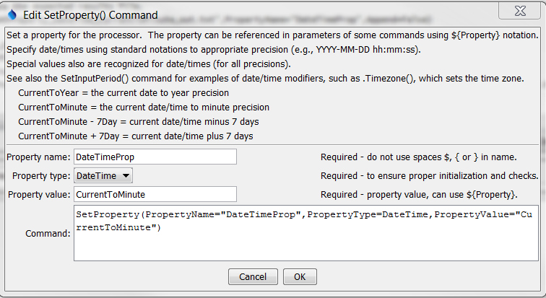

SetProperty

SetProperty() Command Editor

The command syntax is as follows:

SetProperty(Parameter=Value,…)

Command Parameters

|  |  |  |
| --- | --- | --- |
| Parameter | Description | Default |
| PropertyName | The property name. | None – must be specified. |
| PropertyType | The property type, used for validation, one of:   * Boolean – a boolean * DateTime – a date/time * Double – a floating point number * Integer – an integer * String – a string   DateTime objects can be specified with special syntax to use current time and modifiers on the DateTime. See the SetInputPeriod() command for more information. | None – must be specified. |
| PropertyValue | The value of the property, adhering to property type constraints. Date/time properties should be specified using standard formats such as “YYYY-MM-DD hh:mm:ss”, to an appropriate precision. Special date/time syntax is recognized, as shown in the above figure. Global properties can be used with the ${Property} syntax. | None – must be specified. |

A sample commands file is as follows:

|  |
| --- |
| SetProperty(PropertyName="Scenario",PropertyType=String,PropertyValue="Likely") |