Command Reference: SetPropertyFromEnsemble ()

Set a property for the time series processor using time series ensemble as input

Version 12.00.00, 2017-03-23

The SetPropertyFromEnsemble() command sets the value of a processor property, using time series ensemble properties as input. The property will be available to subsequent commands that support using ${Property} notation in parameters, for example to specify filenames more dynamically or use with If() commands. This command should not be confused with the SetEnsembleProperty() command, which sets a property on an ensemble.

The following dialog is used to edit this command and illustrates the syntax of the command.

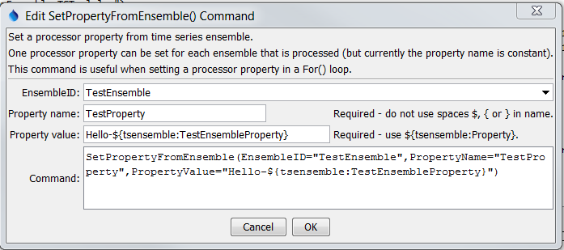

SetPropertyFromEnsemble

SetPropertyFromEnsemble() Command Editor

The command syntax is as follows:

SetPropertyFromEnsemble(Parameter=Value,…)

Command Parameters

|  |  |  |
| --- | --- | --- |
| Parameter | Description | Default |
| EnsembleID | The ensemble to be processed. Can be specified using processor ${Property}. | Required if TSList= EnsembleID |
| PropertyName | The property name to set. | None – must be specified. |
| PropertyValue | The value of the property, set using a combination of text, the time series % specifiers, ${tsensemble:Property} for custom time series ensemble properties, and ${Property}. | None – must be specified. |