Command Reference: SetPropertyFromTable()

Set a processor property using a table value

Version 11.00.00, 2015-02-28

The SetPropertyFromTable() command sets the value of a property used by the time series processor, using a table cell value. The property will be available to subsequent commands that support using ${Property} notation in parameters, for example to specify filenames more dynamically. This command is useful in cases where iteration is processing data from a table using a For() command, in which case the property can be used in other commands. Filters are used to match one or more rows. The first matched row is used to set the property.

The following dialog is used to edit this command and illustrates the syntax of the command.

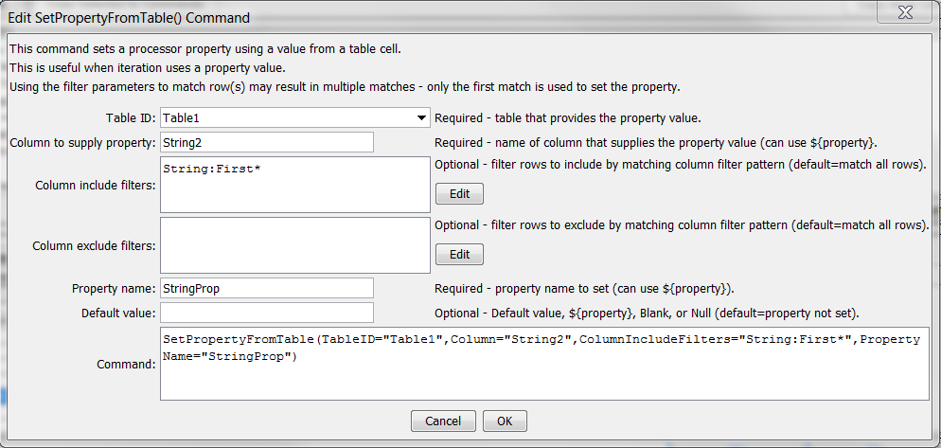

SetPropertyFromTable

SetPropertyFromTable() Command Editor

The command syntax is as follows:

SetPropertyFromTable(Parameter=Value,…)

Command Parameters

|  |  |  |
| --- | --- | --- |
| Parameter | Description | Default |
| TableID | The identifier for the table. | None – must be specified. |
| Column | The name of the column containing the value that will be used to set the processor property. | None – must be specified. |
| ColumnInclude  Filters | Filters that include rows being matched, by matching column values:  ColumnIncludeFilter1:FilterPattern1,  ColumnIncludeFilter2:FilterPattern2  Patterns can use * to indicate wildcards for matches. Only string values can be checked (other data types are converted to strings for comparison). All patterns must be matched to exclude the row. | All rows are matched. |
| ColumnExclude  Filters | Filters that exclude rows being copied, by matching column values:  ColumnExcludeFilter1:FilterPattern1,  ColumnExcludeFilter2:FilterPattern2  Patterns can use * to indicate wildcards for matches. Only string values can be checked (other data types are converted to strings for comparison). All patterns must be matched to exclude the row. | All rows are matched. |
| PropertyName | The property name to be set. | None – must be specified. |
| DefaultValue | The default value to use if no table cell is matched:   * Blank – to use a blank string * Null – to use a null value * Specified value to set to a string value. | Property is set to null. |

For example, the above command use with the following table will set StringProp=“Abba”

