Command Reference: SetPropertyFromTimeSeries()

Set a property for the time series processor using time series properties as input

Version 11.12.02, 2016-08-25

The SetPropertyFromTimeSeries() command sets the value of a processor property, using time series properties as input. The property will be available to subsequent commands that support using ${Property} notation in parameters, for example to specify filenames more dynamically or use with If() commands. This command should not be confused with the SetTimeSeriesProperty() command, which sets a property on specific time series. Parameters are provided to select the time series; however, currently, the property name cannot be dynamically changed (for example by using ${Property} for the property name).

The following dialog is used to edit this command and illustrates the syntax of the command.

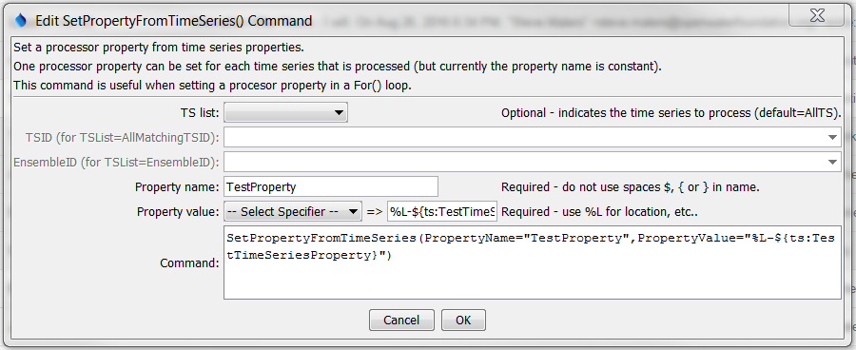

SetPropertyFromTimeSeries

SetPropertyFromTimeSeries() Command Editor

The command syntax is as follows:

SetPropertyFromTimeSeries(Parameter=Value,…)

Command Parameters

|  |  |  |
| --- | --- | --- |
| Parameter | Description | Default |
| TSList | Indicates the list of time series to be processed, one of:   * AllMatchingTSID – all time series that match the TSID (single TSID or TSID with wildcards) will be modified. * AllTS – all time series before the command. * EnsembleID – all time series in the ensemble will be modified. * FirstMatchingTSID – the first time series that matches the TSID (single TSID or TSID with wildcards) will be modified. * LastMatchingTSID – the last time series that matches the TSID (single TSID or TSID with wildcards) will be modified. * SelectedTS – the time series are those selected with the SelectTimeSeries() command. | AllTS |
| TSID | The time series identifier or alias for the time series to process, using the * wildcard character to match multiple time series. Can be specified using processor ${Property}. | Required if TSList=*TSID |
| EnsembleID | The ensemble to be modified, if processing an ensemble. Can be specified using processor ${Property}. | Required if TSList= EnsembleID |
| PropertyName | The property name. | None – must be specified. |
| PropertyValue | The value of the property, set using a combination of text, the time series % specifiers, ${ts:Property} for custom time series properties, and ${Property}. | None – must be specified. |