Command Reference: SetTableValues()

Set values in a table by first matching specific rows

Version 11.10.00, 2016-04-09

The SetTableValues() command sets values in a table. It does so by first optionally matching rows by filtering on column values (see ColumnFilters parameter), and then setting values in specified columns (see ColumnValues parameter). For example, this command can be used to set or override table values that were not included in the original data. See also the FormatTableString() and ManipulateTableString() commands.

The following dialog is used to edit the command and illustrates the syntax of the command.

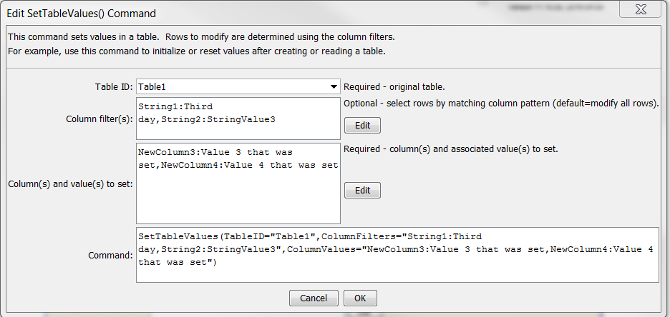

SetTableValues

SetTableValues() Command Editor

The command syntax is as follows:

SetTableValues(Parameter=Value,…)

Command Parameters

| Parameter | Description | Default |
| --- | --- | --- |
| TableID | The identifier for the table being modified. Can be specified using ${Property} notation. | None – must be specified. |
| ColumnFilters | Filters that limit the number of rows being modified, using the syntax:  FilterColumn1:FilterPattern1, FilterColumn2:FilterPattern2  Patterns can use * to indicate wildcards for matches. Only string values can be checked (other data types are converted to strings for comparison). Comparisons are case-independent. All patterns must be matched in order to match the row. The parameter can be specified using ${Property} notation. | Process all rows in the table. |
| ColumnValues | The column names and corresponding values to set using syntax:  ColumnName1:Value1, ColumnName2:Value2  The column name and value parts can be specified using ${Property} notation. | None – must be specified. |