Command Reference: SetTimeSeriesValuesFromTable()

Set time series values from a table

Version 11.02.02, 2015-05-26

The SetTimeSeriesValuesFromTable() command sets values in time series by matching the TSID and date/time in a table. Examples of use are:

* Provide data values from a table to override missing values in the time series
* Set a stream of values from a table into time series

The following dialog is used to edit the command and illustrates the syntax of the command:

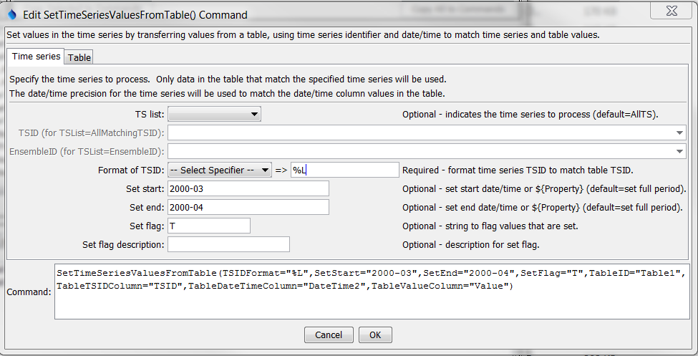

SetTimeSeriesValuesFromTable

SetTimeSeriesValuesFromTable() Command Editor Showing Time Series Parameters

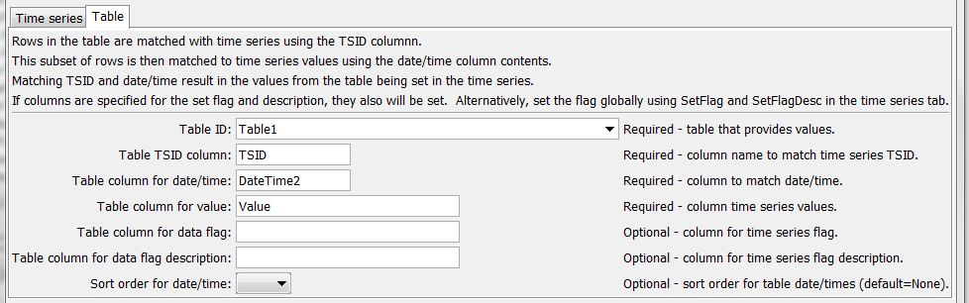

SetTimeSeriesValuesFromTable_Table

SetTimeSeriesValuesFromTable() Command Editor Showing Table Parameters

The command syntax is as follows:

SetTimeSeriesValuesFromTable(Parameter=Value,…)

Command Parameters

| Parameter | Description | Default |
| --- | --- | --- |
| TSList | Indicates the list of time series to be processed, one of:   * AllMatchingTSID – all time series that match the TSID (single TSID or TSID with wildcards) will be processes. * AllTS – all time series before the command. * EnsembleID – all time series in the ensemble will be processed. * FirstMatchingTSID – the first time series that matches the TSID (single TSID or TSID with wildcards) will be processed. * LastMatchingTSID – the last time series that matches the TSID (single TSID or TSID with wildcards) will be processed. * SelectedTS – the time series are those selected with the SelectTimeSeries() command. | AllTS |
| TSID | The time series identifier or alias for the time series to be processed, using the * wildcard character to match multiple time series. | Required if TSList=*TSID |
| EnsembleID | The ensemble to be processed, if processing an ensemble. | Required if TSList=EnsembleID |
| TSIDFormat | The specification to format the time series identifier to match the TableTSIDColumn column. | None – must be specified. |
| SetStart | The date/time to start setting values, or ${Property}. | Set the full period. |
| SetEnd | The date/time to end setting values, or ${Property}. | Set the full period. |
| SetFlag | String to flag values that are set, used for all time series. | No flag. |
| SetFlagDesc | Description for SetFlag. | Default. |
| TableID | The lookup table identifier. | None – must be specified. |
| Table  TSIDColumn | Table column name that is used to match the time series identifier for processing. | None – must be specified. |
| Table  DateTimeColumn | Table column name that is used to match the date/time for processing time series values. | None – must be specified. |
| Table  ValueColumn | Table column name for data values to be set in the time series. | None – must be specified. |
| TableSetFlag  Column | Table column name for data flags to be set in the time series, will override SetFlag. | No flags will be set. |
| TableSetFlag  DescColumn | Table column name for data flag descriptions for TableSetFlag, will override SetFlagDesc. | No flags will be set. |
| SortOrder | Indicate whether to sort the table rows by date/time. After sorting, the first matched date/time will be set in the time series. | Currently sorting is not implemented – only one value per TSID-date/time combination should be present in the table. |

This page is intentionally blank.