Command Reference: ShiftTimeByInterval()

Shift time series data by one or more time intervals

Version 11.03.00, 2015-06-01

The ShiftTimeByInterval()command shifts a time series in time. This command can be used to perform a simple shift (e.g., to shift hourly data because the Disaggregate() command did not result in data being set at the desired hours) and to perform simple routing.

The following dialog is used to edit the command and illustrates the command syntax.

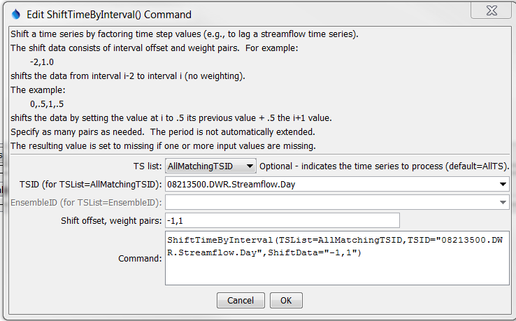

ShiftTimeByInterval

ShiftTimeByInterval() Command Editor

The command syntax is as follows:

ShiftTimeByInterval(Parameter=Value,…)

Command Parameters

| Parameter | Description | Default |
| --- | --- | --- |
| TSList | Indicates the list of time series to be processed, one of:   * AllMatchingTSID – all time series that match the TSID (single TSID or TSID with wildcards) will be modified. * AllTS – all time series before the command. * EnsembleID – all time series in the ensemble will be modified. * LastMatchingTSID – the last time series that matches the TSID (single TSID or TSID with wildcards) will be modified. * SelectedTS – the time series are those selected with the SelectTimeSeries() command. | AllTS |
| TSID | The time series identifier or alias for the time series to be modified, using the * wildcard character to match multiple time series. Can be specified using processor ${Property}. | TSID or EnsembleID must be specified if identifiers are being matched. |
| EnsembleID | The ensemble to be modified, if processing an ensemble. Can be specified using processor ${Property}. | TSID or EnsembleID must be specified if identifiers are being matched. |
| ShiftData | Interval,multiplier tuples to apply to the data to perform the shift. All values should be separated by commas. An interval of -1 indicates that the previous time step should be shifted to the current time step. If the interval is –1 and the multiplier is 1, the previous time step is shifted to the current and multiplied by 1, effectively shifting the time series by one interval. | None – at least 1 value,multiplier tuple must be specified. |

A sample command file to shift data from the State of Colorado’s HydroBase is as follows:

|  |
| --- |
| # 08213500 - RIO GRANDE RIVER AT THIRTY MILE BRIDGE NEAR CREEDE  08213500.DWR.Streamflow.Day~HydroBase  ShiftTimeByInterval(TSList=AllMatchingTSID,TSID="08213500.DWR.Streamflow.Day",  ShiftData="-1,1")  08213500.DWR.Streamflow.Day~HydroBase |

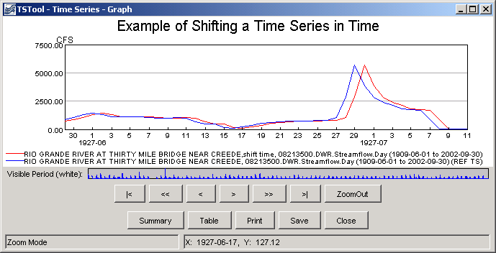

ShiftTimeByInterval_graph

Results from ShiftTimeByInterval() Command