Command Reference: SortTable()

Sort a table’s rows by sorting values in one or more columns

Version 11.03.00, 2015-05-31

The SortTable() command sorts rows in a table by sorting the values in one or more columns. The column(s) to be sorted can be of type string, integer, double, float, or date/time. Strings are sorted by ignoring case.

The following dialog is used to edit the command and illustrates the syntax of the command

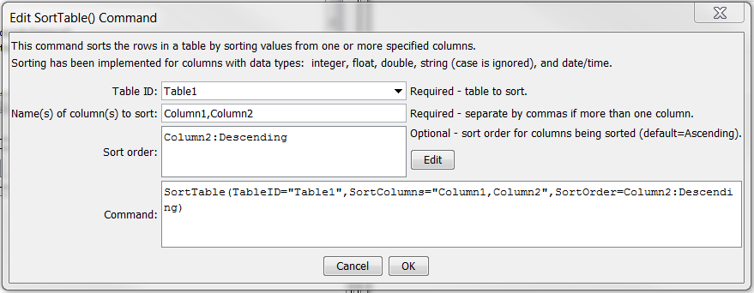

SortTable

SortTable() Command Editor

The command syntax is as follows:

SortTable(Parameter=Value,…)

Command Parameters

| Parameter | Description | Default |
| --- | --- | --- |
| TableID | The identifier for the table. Can be specified using processor ${Property}. | None – must be specified. |
| SortColumns | The names of columns to sort, separated by commas. One or more columns can be sorted. | None – must be specified. |
| SortOrder | The sort order for columns specified by SortColumns, using the syntax:  SortColumn1:Ascending,  SortColumn2:Descending  As indicated in the above example, the sort order must be specified as one of the following:   * Ascending * Descending | Ascending |

This page is intentionally blank.