Command Reference: SortTimeSeries()

Sort time series by their identifiers or properties

Version 10.31.00, 2013-07-21

This command’s documentation is now maintained as HTML – refer to the HTML version for current documentation.

The SortTimeSeries() command sorts time series based on the specified criteria:

* the time series identifier or alias
* a time series property
* a string formatted from time series properties

This command is useful for ordering time series before writing output or visualization.

The following dialog is used to edit the command and illustrates the syntax for the command.

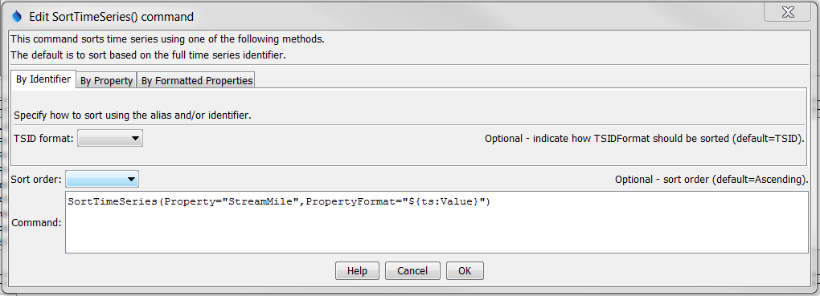

SortTimeSeries

SortTimeSeries() Command Editor Showing Parameter to Sort by TSID/Alias

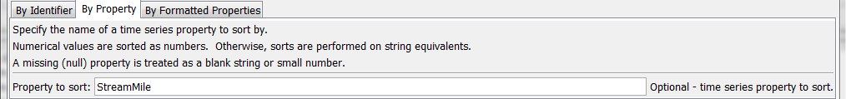

SortTimeSeries_Property

SortTimeSeries() Command Editor Showing Parameter to Sort by a Time Series Property

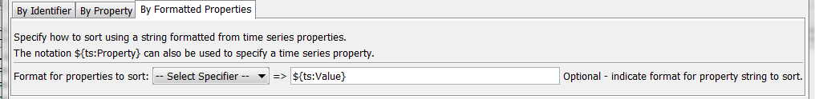

SortTimeSeries_PropertyFormat

SortTimeSeries() Command Editor Showing Parameter to Sort by Formatted Properties

The command syntax is as follows:

SortTimeSeries(Parameter=Value,…)

Command Parameters

|  |  |  |
| --- | --- | --- |
| Parameter | Description | Default |
| TSIDFormat | Sort by alias or TSID, determining the identifier for each time series as per the parameter value:   * AliasTSID – use the alias if available, and if not use the TSID * TSID – Use the TSID only (regardless of whether the alias is available) | TSID |
| Property | Sort using the values of the specified time series property. Nulls are treated as blanks if strings and very small number for integers and floating point numbers. |  |
| PropertyFormat | Sort using a string that formats one or more time series properties, indicated with:   * %-specifiers (e.g., %L for location ID) * ${ts:property} notation |  |
| SortOrder | Sort order, either Ascending or Descending. | Ascending |

A sample command file using data from the State of Colorado’s HydroBase is as follows:

|  |
| --- |
| 06756500.USGS.Streamflow.Month~HydroBase  # 06758300 - KIOWA CREEK AT BENNETT, CO.  06758300.USGS.Streamflow.Month~HydroBase  # 06758000 - KIOWA CREEK AT ELBERT, CO.  06758000.USGS.Streamflow.Month~HydroBase  # 06757600 - KIOWA CREEK AT K-79 RES, NEAR EASTONVILLE, CO.  06757600.DWR.Streamflow.Month~HydroBase  # 06758200 - KIOWA CREEK AT KIOWA, CO.  06758200.USGS.Streamflow.Month~HydroBase  # 06753400 - LONETREE CREEK AT CARR, CO.  06753400.USGS.Streamflow.Month~HydroBase  # 06753990 - LONETREE CREEK NEAR GREELEY, CO.  06753990.USGS.Streamflow.Month~HydroBase  # 06753500 - LONETREE CREEK NEAR NUNN, CO.  06753500.USGS.Streamflow.Month~HydroBase  # 06759910 - SOUTH PLATTE RIVER AT COOPER BRIDGE NEAR BALZAC  06759910.DWR.Streamflow.Month~HydroBase  # 06759500 - SOUTH PLATTE RIVER AT FORT MORGAN  06759500.USGS.Streamflow.Month~HydroBase  # 06756995 - SOUTH PLATTE RIVER AT MASTERS, CO.  06756995.USGS.Streamflow.Month~HydroBase  # 06757000 - SOUTH PLATTE RIVER AT SUBLETTE, CO.  06757000.USGS.Streamflow.Month~HydroBase  # 06754000 - SOUTH PLATTE RIVER NEAR KERSEY  06754000.DWR.Streamflow.Month~HydroBase  # 06758500 - SOUTH PLATTE RIVER NEAR WELDONA  06758500.DWR.Streamflow.Month~HydroBase  # 06758100 - WEST KIOWA CREEK AT ELBERT, CO.  06758100.USGS.Streamflow.Month~HydroBase  SortTimeSeries() |