Command Reference: SplitTableColumn()

Split a table column into multiple columns

Version 11.00.00, 2015-02-07

The SplitTableColumn() command splits a string (text) column in a table into multiple columns. Currently the only delimited string values can be split. For example, the ColumnToSplit column in the table shown in the following example can be split to produce the result in the second figure. Several options for splitting are available.

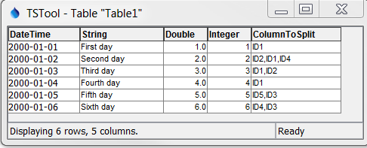

SplitTableColumn_Table1a

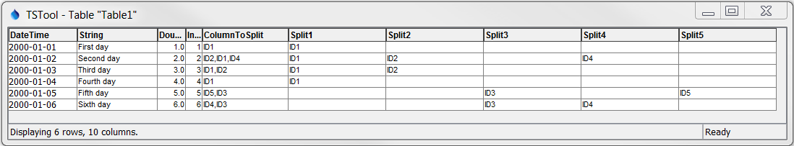

The following dialog is used to edit the command and illustrates the syntax of the command:

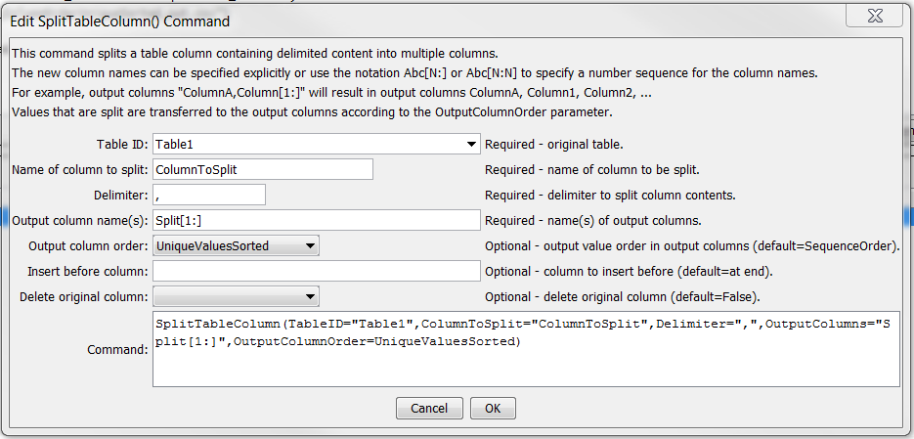

SplitTableColumn

SplitTableColumn() Command Editor

The command syntax is as follows:

SplitTableColumn(Parameter=Value,…)

Command Parameters

| Parameter | Description | Default |
| --- | --- | --- |
| TableID | The identifier for the table. | None – must be specified. |
| ColumnToSplit | The name of the table column to split. | None – must be specified. |
| Delimiter | The delimiter character for splitting the values in the split column, for example a comma. | None – must be specified. |
| OutputColumns | The names of output columns to be inserted, separated by commas. Specify literal column names or use the notation:   * [Start:End:Increment] for example [1:9:3] * [Start:End] for example [1:10] * [Start:] for example [1:]   For example, to generate output columns with names Column1, Column2, … for all necessary output columns, use: Column[1:] | None – must be specified. |
| OutputColumn  Order | The order of split values in output columns:   * SequenceOrder – split and then insert the parts sequentially in output columns * UniqueValues – create output columns for each unique value, in the order they were encountered * UniqueValuesSorted – unique values, sorted | Sequence  Order |
| InsertBefore  Column | The name of the column before which to insert the new output columns. | Append at end |
| DeleteOriginalColumn | Indicate whether the original table column should be deleted after processing: False or True. | False |