Command Reference: SplitTableRow()

Split a table row into multiple rows

Version 11.00.00, 2015-02-07

The SplitTableRow() command uses information from a table row to create a sequence of new table rows. The new rows are inserted after the original row, which optionally can be deleted from the table after processing. The following approaches are implemented:

* Use a distance measure start and end value in the row to create segmented row distances. For example, this can be used to break a streamflow reach into segments of equal length, for example “stream mile” segments as shown in the following example. The first table illustrates input and the second the table after modification (original rows are deleted). The start and end columns can be specified in any order but the output is always with the smaller value as the start.

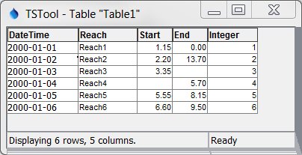

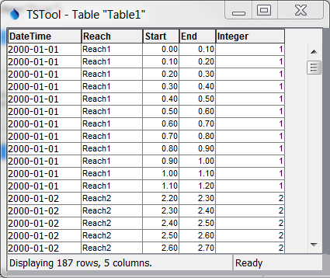

The following dialog is used to edit the command and illustrates the syntax of the command:

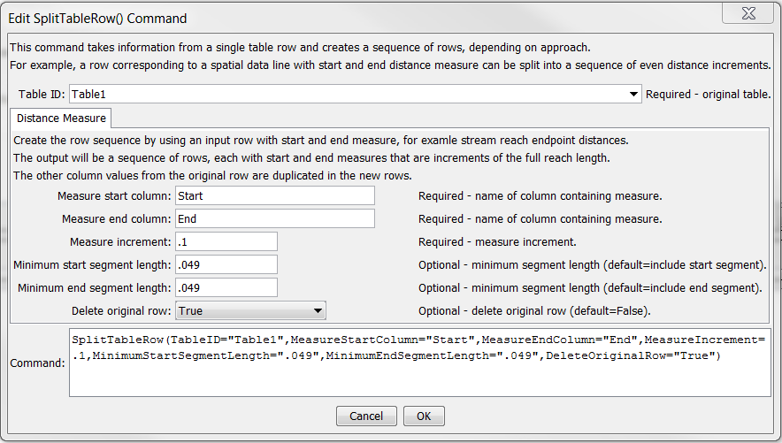

SplitTableRow

SplitTableRow() Command Editor

The command syntax is as follows:

SplitTableRow(Parameter=Value,…)

Command Parameters

| Parameter | Description | Default |
| --- | --- | --- |
| TableID | The identifier for the table. | None – must be specified. |
| MeasureStartColumn | The name of the table column for the starting measure. | None – must be specified. |
| MeasureEndColumn | The name of the table column for the ending measure. | None – must be specified. |
| MeasureIncrement | The measure increment used to split the original distance into segments (e.g., .1). | None – must be specified. |
| MinimumStartSegment  Length | The minimum length of the starting segment to include. | Include start segment. |
| MinimumEndSegment  Length | The minimum length of the ending segment to include. | Include end segment. |
| DeleteOriginalRow | Indicate whether the original table row should be deleted as False or True. Specify True if the generated sequence of rows should replace the original row. | False |