Command Reference: StartLog()

(Re)start the log file

Version 11.10.00, 2016-04-09

The StartLog() command (re)starts the log file. It is useful to insert this command as the first command in a command file, in order to persistently record the results of processing. A useful standard is to name the log file the same as the command file, with an additional .log extension, and this convention is enforced by default. A date or date/time can optionally be added to the log file name.

The following dialog is used to edit the command and illustrates the syntax for the command.

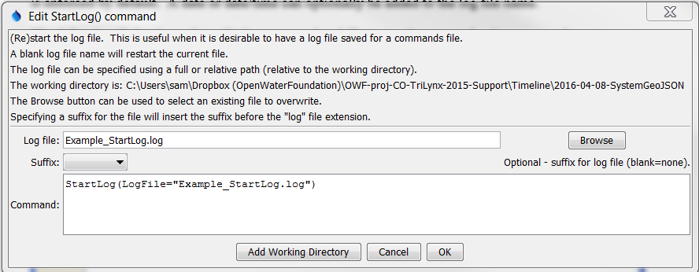

StartLog

StartLog() Command Editor

The command syntax is as follows:

StartLog(Parameter=Value,…)

Command Parameters

|  |  |  |
| --- | --- | --- |
| Parameter | Description | Default |
| LogFile | The name of the log file to write surrounded by double quotes. The extension of .log will automatically be added, if not specified. Can be specified using ${Property} notation. | If not specified, the existing file will be restarted. |
| Suffix | Indicates that a suffix will be added before the .log extension, one of:   * Date – add a date suffix of the form YYYYMMDD. * DateTime – add a date/time suffix of the form YYYYMMDD_HHMMSS.   This is useful for automatically archiving logs corresponding to commands files, to allow checking the output at a later time. However, generating date/time stamped log files can increase the amount of disk space that is used. | Do not add the suffix. |

A sample command file to process State of Colorado HydroBase data is as follows (the Add() command will generate an error because the units of the time series are incompatible):

|  |
| --- |
| StartLog(LogFile="Example_StartLog.log")  # 06753400 - LONETREE CREEK AT CARR, CO.  06753400.USGS.Streamflow.Month~HydroBase  # 1179 - BYERS 5 ENE  1179.NOAA.Precip.Month~HydroBase  Add(TSID="06753400.USGS.Streamflow.Month",AddTSList=AllTS,HandleMissingHow="IgnoreMissing") |