Command Reference: Subtract()

Subtract one or more time series from another time series

Version 11.12.00, 2016-07-14

The Subtract() command subtracts time series of the same interval. The receiving time series will have data values set to its original values minus the data values in the indicated time series. If an ensemble is being processed, another ensemble can be subtracted, a single time series can be subtracted from all time series in the ensemble, or a list of time series can be subtracted from the ensemble (the number in the list must match the number of time series in the ensemble).

This command will generate an error if the time series do not have compatible units. If the units are compatible but are not the same (e.g., IN and FT), then the units of the part will be converted to the units of the result before subtraction. Missing data in the parts can be ignored (do not set the result to missing) or can set missing values in the result. The user should consider the implications of ignoring missing data. Time series being subtracted must have the same data interval.

The following dialog is used to edit the command and illustrates the syntax of the command.

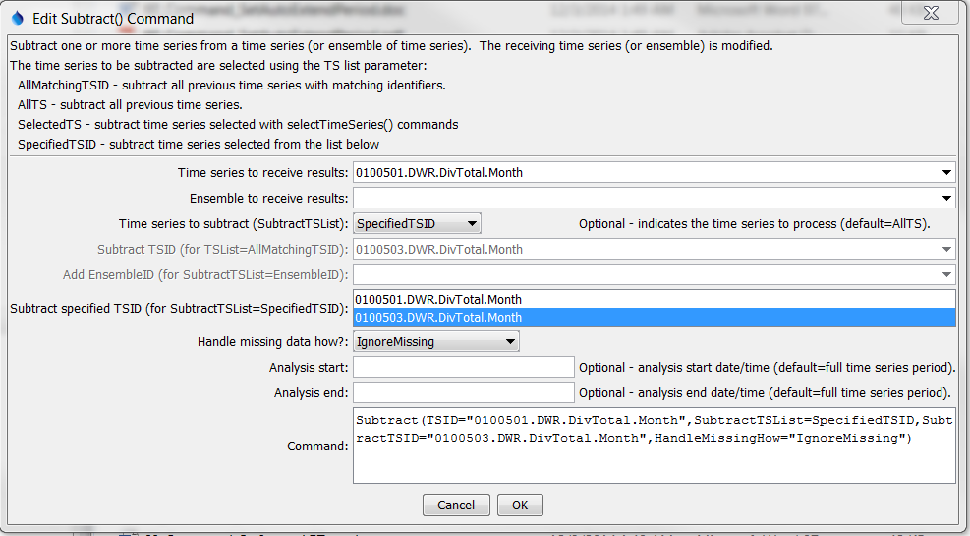

Subtract

Subtract() Command Editor

The command syntax is as follows:

Subtract(Parameter=Value,…)

Command Parameters

|  |  |  |
| --- | --- | --- |
| Parameter | Description | Default |
| TSID | The time series identifier or alias for the time series to receive the result. Can be specified using processor ${Property}. | TSID or EnsembleID must be specified. |
| EnsembleID | The ensemble to receive the result, if processing an ensemble. Can be specified using processor ${Property}. | TSID or EnsembleID must be specified. |
| Subtract  TSList | Indicates how the list of time series is specified, one of:   * AllTS – all time series before the command. * AllMatchingTSID – all time series that match the AddTSID (single TSID or TSID with wildcards) will be subtracted. * EnsembleID – the time series from ensemble will be subtracted. * LastMatchingTSID – the last time series that matches the TSID (single TSID or TSID with wildcards) will be subtracted. * SelectedTS – the time series are those selected with the SelectTimeSeries() command. * SpecifiedTSID – the specified list of time series given by the SubtractTSID parameter. **If using version 8.02.00 or earlier, use SpecifiedTS**. | AllTS (the time series receiving the sum will not be subtracted from itself) |
| SubtractTSID | If the SubtractTSList parameter is SpecifiedTSID, provide the list of time series identifiers (or alias) to subtract, separated by commas. If the SubtractTSList parameter is AllMatchingTSID, specify a single TSID or a TSID with wildcards. Can be specified using processor ${Property}. | Must be specified if TSList=  SpecifiedTSID, ignored otherwise. |
| Subtract  EnsembleID | If the EnsembleID parameter is specified, providing an ensemble ID will subtract the ensembles. Can be specified using processor ${Property}. | Use if an ensemble is being subtracted from another ensemble. |
| Handle  MissingHow | Indicates how to handle missing data in a time series:   * IgnoreMissing – create a result even if missing data are encountered in one or more time series – this option is not as rigorous as the others * SetMissingIfOtherMissing – set the result missing if any of the other time series values is missing * SetMissingIfAnyMissing – set the result missing if any time series value involved is missing | IgnoreMissing |
| AnalysisStart | The date/time to start analyzing data. Can be specified using processor ${Property}. | Full period is analyzed. |
| AnalysisEnd | The date/time to end analyzing data. Can be specified using processor ${Property}. | Full period is analyzed. |

A sample command file to subtract data from the State of Colorado’s HydroBase is as follows:

|  |
| --- |
| # 0100501 - EMPIRE DITCH  0100501.DWR.DivTotal.Month~HydroBase  # 0100503 - RIVERSIDE CANAL  0100503.DWR.DivTotal.Month~HydroBase  Subtract(TSID="0100501.DWR.DivTotal.Month",SubtractTSList=SpecifiedTSID,  SubtractTSID="0100503.DWR.DivTotal.Month",  HandleMissingHow="IgnoreMissing") |

This page is intentionally blank.