Command Reference: UnzipFile()

Unzip the contents of a zip or gzip file

Version 11.08.00, 2016-01-23

The UnzipFile() command unzips the contents of a zip (*.zip) or gzip (*.gz) file, saving to a specified output folder. Existing files will be overwritten.

The following dialog is used to edit the command and illustrates the syntax for the command.

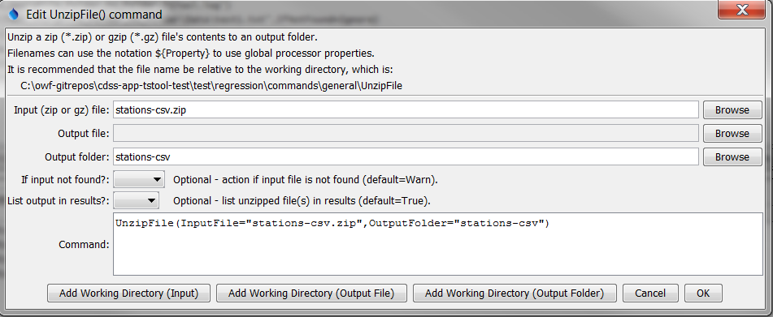

UnzipFile

UnzipFile() Command Editor

The command syntax is as follows:

UnzipFile(Parameter=Value,…)

Command Parameters

|  |  |  |
| --- | --- | --- |
| Parameter | Description | Default |
| InputFile | The name of the file to unzip. Can be specified using processor ${Property}. | None – must be specified. |
| OutputFile | The name of the output file, when the zip file contains a single file. Can be specified using processor ${Property}. This parameter is not enabled. | Output file is determined from the zip file contents. |
| OutputFolder | The name of the output folder, to receive the contents of the zip file. Can be specified using processor ${Property}. The output folder will be created if it does not already exist. | The default is the same folder as the input file. |
| IfNotFound | Indicate action if the input file is not found, one of:   * Ignore – ignore the missing file (do not warn). * Warn – generate a warning (use this if the file truly is expected and a missing file is a cause for concern). * Fail – generate a failure (use this if the file truly is expected and a missing file is a cause for concern). | Warn |
| ListInResults | Indicate whether to list unzipped output files in results (True) or not (False). It may be necessary to avoid listing for zip files with many entries. | True |