Command Reference: VariableLagK()

Lag and attenuate (route) a time series with parameters that vary by rate

Version 11.12.02, 2016-08-29

The VariableLagK() command can be used to lag and attenuate an input time series, resulting in a new time series. The command is commonly used to route an instantaneous (not mean) regular interval streamflow time series through a stretch of river (reach). For example, route 5-minute or 1-hour instantaneous streamflows measured as cubic feet per second, where the interval for data typically depends on the travel time in the reach and the analysis/modeling framework. Lag and K routing is a common routing method that combines the concepts of:

1. Lagging the inflow to simulate travel time in a reach and,
2. Attenuating the wave to simulate the storage-outflow relationship for the reach (seeFigure 1).



Figure : Lag and K Routing

At its fundamental level, the method solves the continuity equation using an approach similar to Muskingum routing (assuming that the Muskingum parameter representing wave storage is negligible). The governing equation for this routing method is given as:



where:

*Qin* = instantaneous inflow [rate] lagged appropriately,

*Qout* = instantaneous outflow [rate] lagged appropriately,

*ΔS* = change in storage in the reach [volume],

*Δt* = time difference (time series interval)

The relationship assumes an outflow-storage relationship of the form:

*S = k ⋅ Qout,*

where:

*k* = attenuation for the outflow [time].

To ensure accurate results, *k* should be larger or equal to *Δt/2.* For discrete time steps these relationships translate into:



where: *I1* and *I2* are the lagged inflows into the reach at the previous and current time step, respectively,

*O1* and *O2* are the outflows out of the reach at the previous and current time step, respectively,

*S1* is the storage within the reach at the previous time step, defined as *S1* = *k⋅O1*, and

*Δt* is the time difference between the two time steps (time series interval)

Values for Lag and K can usually be established by comparing routed flows to downstream observations. Alternatively, the Lag can be estimated using the reach length and wave speed in the reach. Without any other information, K can be set to Lag/2.

The above discussion applies where the Lag and K parameters are single values (as implemented in the LagK() command). However, there are cases where the values vary by flow, which is handled by this command. The approach that is implemented is an adaptation of that described in National Weather Service River Forecast System LAG/K documentation:

* <http://www.nws.noaa.gov/oh/hrl/nwsrfs/users_manual/part2/_pdf/24lagk.pdf>
* http://www.nws.noaa.gov/ohd/hrl/nwsrfs/users_manual/part5/_pdf/533lagk.pdf

## VariableLagK States

States can be saved to a table during analysis using the StateSaveDateTime and StateSaveInterval parameters, as long as state table parameters are also provided. States are saved at any date/time of processing that match the requested save date/time. State values in the state table are saved as a JSON string, as illustrated in the following example (line breaks inserted for readability):

{

"lagInterval": "3Hour",

"units": "CMS",

"currentLaggedInflow": "1.0",

"currentOutflow": ".4966",

"currentStorage": "11.92",

"qtLag": [ 0.0, 1.0, 11.93 ]

}

The following table explains the meaning of the states:

VariableLagK States

| Parameter | Description | Default |
| --- | --- | --- |
| currentLaggedInflow | The lagged inflow corresponding to the state save date/time. | 0 |
| currentOutflow | The outflow corresponding to the state save date/time. | 0 |
| currentStorage | The storage corresponding to the state save date/time. | 0 |
| lagInterval | The interval between qtLag values, which matches the input time series interval. This interval can be used as a check to confirm that states that were saved can be used later. | Assumed to be data interval for input time series. |
| qtLag | An array of QT lagged flows, where the last value corresponds to the save date/time and the first value is earliest in time. The number of values depends on the largest lag value from input. If specified with the InitialQTLag parameter the values will be positioned at the end of the internal array, with zeros filling earliest values if necessary. | 0 for all values |
| units | Data units for states, which can be used to check against VariableLagK command that is attempting to use the states. | Assumed to be consistent with input time series. |

The saved states can then be used to restart the analysis, as follows:

* **Output period** – The output period used to create the output time series is defined by the OutputStart and OutputEnd parameters. If not specified, the full time series period (or global output period) is used.
* **Date/time for initial states** – The date/time corresponding to OutputStart is used to retrieve states that have been previously saved to the state table.
* **Initialize states** – States are initialized for the algorithm as follows:
  + If the state table should be used to initialize states (InitializeStatesFromTable=True), get the initial states from the state table by matching the StateTableObjectID, OutputStart, and TableStateNameColumn (for example state name of VariableLagK).
  + If no states have been saved in the state table, then the initial values will be set to the values from parameters InitialLaggedInflow, InitialOutflow, InitialStorage, and InitialQTLag.
  + If no initial states are specified, the values will default to zero. This will cause a start-up condition that will converge to accurate routed output after several intervals.

The following dialog is used to edit the command and illustrates the syntax for the command:

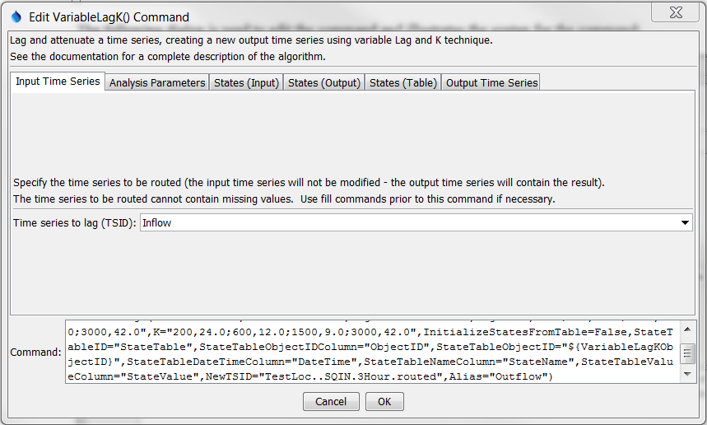

ViriableLagK

VariableLagK() Command Editor Showing Input Time Series Parameter

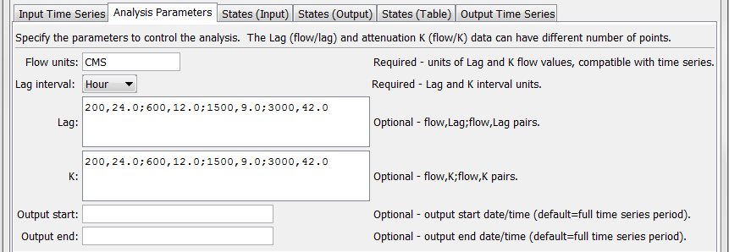

ViriableLagK_Analysis

VariableLagK() Command Editor Showing Analysis Parameters

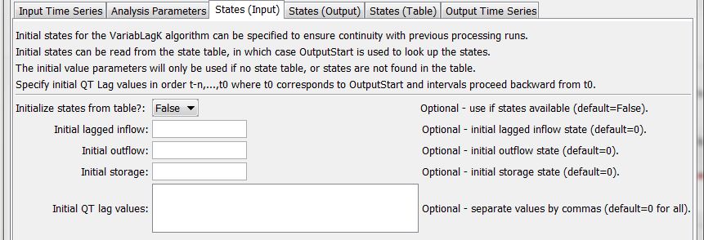

ViriableLagK_StatesInput

VariableLagK() Command Editor Showing Input State Parameters

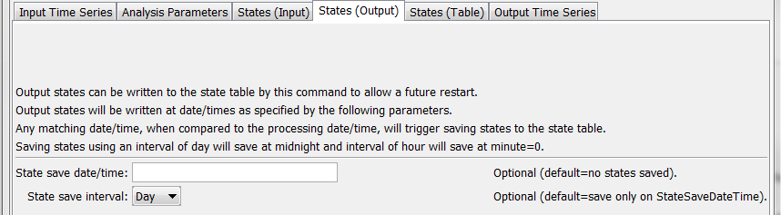

ViriableLagK_StatesOutput

VariableLagK() Command Editor Showing Output State Parameters

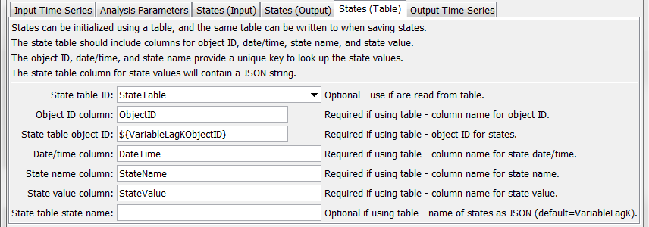

ViriableLagK_StatesTable

VariableLagK() Command Editor Showing State Table Parameters

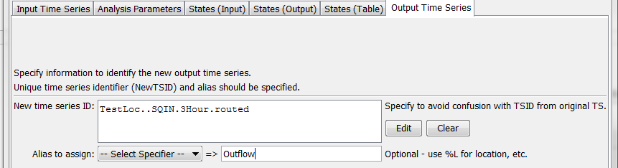

ViriableLagK_Output

VariableLagK() Command Editor Showing Output Parameters

The command syntax is as follows:

VariableLagK(Parameter=Value,…)

Command Parameters

| Parameter | Description | Default |
| --- | --- | --- |
| TSID | Identifier or alias for the time series to be routed. It is assumed that this series describes an instantaneous flow. Due to the lagging, the first data values required for the computation of *O2* are not available within this time series and are therefore set to values set in the InflowStates parameter. Can be specified with ${Property}. | None – must be specified. |
| FlowUnits | The units of the flow data specified in the Lag and K tables. These units must be compatible with the time series units. The table values will be converted to the time series units if the units are not the same. Can be specified with ${Property}. | None – must be specified. |
| LagInterval | The base interval for the time data specified in the Lag and K tables. The interval must be compatible with the time series base interval. The table values will be converted to the time series time interval if the intervals are not the same. For example, table data specified in Hour base interval will be converted to Minute if the time series being routed contains NMinute data. | None – must be specified. |
| Lag | Flow value and lag time pairs to control routing. The units of the data values are as specified by the FlowUnits parameter (see above). The units of the lag are time as specified by the LagInterval parameter. The Lag value is not required to be evenly divisible by the time step interval; values in the time series between time steps will be linearly interpolated. Can be specified with ${Property}. Use commas and semi-colons to separate values, for example:  100.0,10;200.0,20 | None – must be specified. |
| K | Flow value and K time pairs to control routing. The attenuation factor K is applied to the wave. The units of K are time as specified by the LagInterval parameter. Can be specified with ${Property}. Use commas and semi-colons to separate values, for example:  100.0,5;200.0,10 | None – must be specified. |
| OutputStart | The starting date/time for the output time series. States will be initialized relative to this date/time, which is referred to as *t0*. Can be specified with ${Property}. | Full input time series period is processed. |
| OutputEnd | The ending date/time for the output time series. Can be specified with ${Property}. | Full input time series period is processed. |
| Initialize  StatesFromTable | Indicate whether to initialize states from the state table:   * False – do not attempt to initialize states from the state table, in which case the following parameters are used to initialize, if specified * True – attempt to initialize states from the state table and if states are not found, use the following parameters to initialize, if specified | False |
| Initial  LaggedInflow | Initial state value for lagged inflow. Can be specified using ${Property}. | 0 |
| InitialOutflow | Initial state value for outflow. Can be specified using ${Property}. | 0 |
| InitialStorage | Initial state value for storage. Can be specified using ${Property}. | 0 |
| InitialQTLag | Comma-delimited list of initial QT Lag array values. The order of the values is earliest to latest. The array can specify up to (Lag/multiplier) + 1 values (1 is for bounding end point). For example, a 10 minute time series data interval with a LAG of 30 must be provided with 30/10 + 1 = 4 inflow state values. Specifying values that are not consistent with the Lag and K parameters will result in oscillation. Can be specified with ${Property}. | 0 for all values. |
| StateTableID | The table identifier for the state table. Can be specified using ${Property}. | Default states are used. |
| StateTable  ObjectIDColumn | State table column name for object ID, used to the computation unit with states. For example, the object ID might be a stream reach identifier or location. Can be specified with ${Property}. | Required for table. |
| StateTable  ObjectID | The object identifier, used to match the row in the state table. Can be specified with ${Property}. | Required for table. |
| StateTable  DateTimeColumn | State table column containing state date/time. Can be specified with ${Property}. | Required for table. |
| StateTable  NameColumn | State table column containing state name. Can be specified with ${Property}. | Required for table. |
| StateTable  ValueColumn | State table column containing state value. Can be specified with ${Property}. | Required for table. |
| StateTable  StateName | Name of the state in the StateTableNameColumn for states, used to match rows. The text should match that of the VariableLagK States section above. Can be specified with ${Property}. | VariableLagK |
| NewTSID | Identifier for the new (routed) time series. This is required to ensure that the internal identifier for the time series is unique and accurate for the data. The interval of the identifier must be the same as for the time series specified by TSID. Can be specified with ${Property}. | None – must be specified. |
| Alias | The alias that will be assigned to the new time series, which can use ${Property} and ${ts:Property}. | No alias will be assigned. |

A sample command file is as follows (commands to read time series are omitted):

|  |
| --- |
| # Test routing at 3 hour interval  StartLog(LogFile="Results/Test_VariableLagK_3hr.TSTool.log")  # Read NWSCard input file  ReadNwsCard(InputFile="Data\3HR_INPUT.SQIN",Alias=”Inflow”)  #  # Route using the same routing parameters used in the mcp3 input deck  # (metric units: Lag(hrs) K(hrs) Q(cms)  # Lag  # K  # 24.0 200.0 12.0 600.00 9.0 1500.0 42.0 3000.0  # 24.0 200.0 12.0 600.00 9.0 1500.0 42.0 3000.0  #  NewTable(TableID="StateTable",  Columns="ObjectID,string;DateTime,datetime;StateName;string;StateValue;string")  SetProperty(PropertyName="VariableLagKObjectID",PropertyType=String,  PropertyValue="TestSegment")  VariableLagK(TSID="Inflow",FlowUnits="CMS",LagInterval="Hour",  Lag="200,24.0;600,12.0;1500,9.0;3000,42.0",  K="200,24.0;600,12.0;1500,9.0;3000,42.0",InitializeStatesFromTable=False,  StateTableID="StateTable",StateTableObjectIDColumn="ObjectID",  StateTableObjectID="${VariableLagKObjectID}",StateTableDateTimeColumn="DateTime",  StateTableNameColumn="StateName",StateTableValueColumn="StateValue",  NewTSID="TestLoc..SQIN.3Hour.routed",Alias="Outflow") |

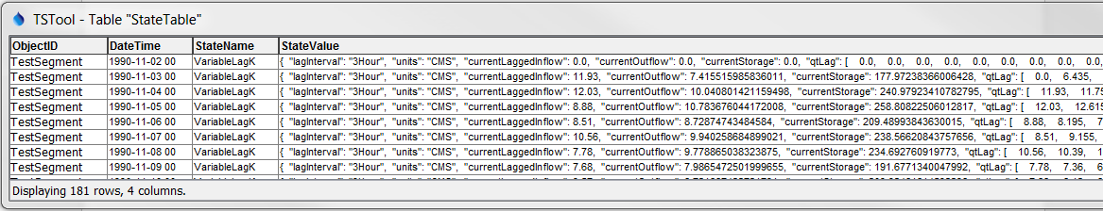

ViriableLagK_StateTable_Out

Output State Table