Command Reference: Wait()

Wait a specified time before continuing

Version 11.00.00, 2015-02-14

The Wait() command waits a specified time before continuing. Examples of use include:

* Testing to simulate slow datastores.
* Waiting for an external process to finish. Functionality will be added in the future to wait for a file to exist or not exist.

The following dialog is used to edit this command and illustrates the command syntax.

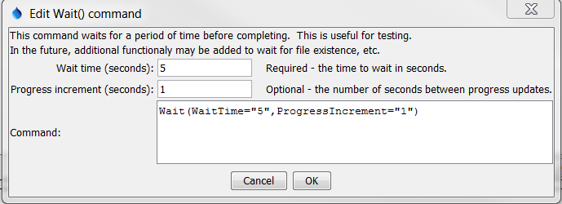

Wait

Wait() Command Editor

The command syntax is as follows:

Wait(Parameter=Value,…)

Command Parameters

|  |  |  |
| --- | --- | --- |
| Parameter | Description | Default |
| WaitTime | The number of seconds to wait. | None – must be specified. |
| ProgressIncrement | The number of seconds between progress updates in the main TSTool progress indicator. | WaitTime divided by ten. |

This page is intentionally blank.