Command Reference: WriteCheckFile()

Write a check file containing a summary of data/processing problems

Version 11.09.00, 2016-02-24

The WriteCheckFile() command summarizes the results of command processing warning/failure messages in a “check file”. This file is useful for reviewing results and for quality control. The check file is essentially a persistent record of any problems that occurred during processing organized by commands, whereas a full log file contains a sequential list of processing.

The following dialog is used to edit the command and illustrates the syntax for the command.

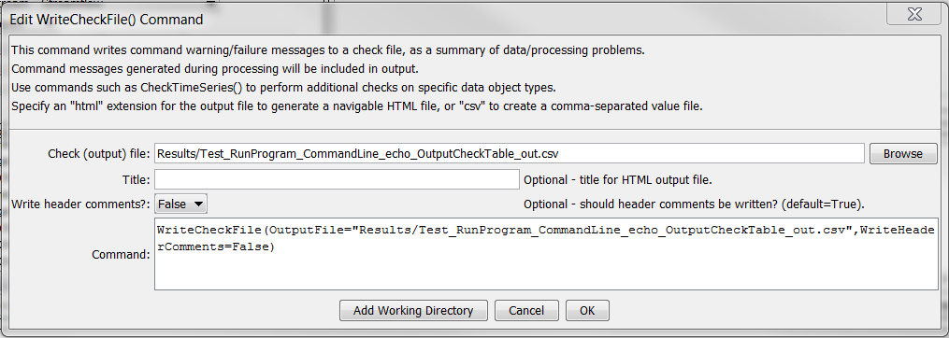

WriteCheckFile

WriteCheckFile() Command Editor

The command syntax is as follows:

WriteCheckFile(Parameter=Value,…)

Command Parameters

| Parameter | Description | Default |
| --- | --- | --- |
| OutputFile | The name of the check file to create. A path relative to the command file containing this command can be specified. Can be specified using ${Property}.  Specify a filename with .html extension to generate an HTML file or .csv to generate a comma-separated value file suitable for use with Excel. The HTML file will contain more information and include navigation links. | None – must be specified. |
| Title | Title to use for HTML output file. Can be specified using ${Property}. | Automatically generated. |
| WriteHeaderComments | Indicate whether to write header comments at the top of the output file as False or True. These are standard comments indicating creator, date, etc. The comments may not be desirable for a csv file read by another program, for example. | True |