Command Reference: WriteDateValue()

Write time series to a DateValue format file

Version 11.03.03, 2015-06-10

The WriteDateValue() command writes time series to the specified DateValue format file. See the DateValue Input Type Appendix for more information about the file format. The time series being written must have the same data interval – use the TSList parameter to select appropriate time series. The following dialog is used to edit the command and illustrates the syntax of the command.

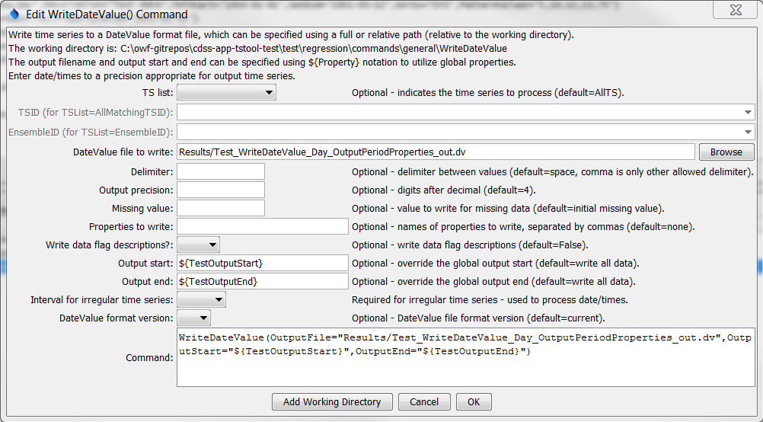

WriteDateValue

WriteDateValue() Command Editor

The command syntax is as follows:

WriteDateValue(Parameter=Value,…)

Command Parameters

| Parameter | Description | Default |
| --- | --- | --- |
| TSList | Indicates the list of time series to be processed:   * AllMatchingTSID – all time series that match the TSID (single TSID or TSID with wildcards) will be processed. * AllTS – all time series before the command. * EnsembleID – all time series in the ensemble will be processed. * FirstMatchingTSID – the first time series that matches the TSID (single TSID or TSID with wildcards) will be processed. * LastMatchingTSID – the last time series that matches the TSID (single TSID or TSID with wildcards) will be processed. * SelectedTS – the time series are those selected with the SelectTimeSeries() command. | AllTS |
| TSID | The time series identifier or alias for the time series to be processed, using the * wildcard character to match multiple time series. Can be specified using processor ${Property}. | Required if TSList=*TSID. |
| EnsembleID | The ensemble to be processed, if processing an ensemble. Can be specified using processor ${Property}. | Required if TSList= EnsembleID. |
| OutputFile | The DateValue output file. The path to the file can be absolute or relative to the working directory (command file location). Can be specified using processor ${Property}. | None – must be specified. |
| Delimiter | The delimiter character to use between data values. Comma is the only other allowed value other than the default space and is recommended for irregular time series, which are output as blanks when date/times don’t align with other time series. | Space. |
| Precision | The number of digits after the decimal for numerical output. | 4 (in the future may default based on data type) |
| MissingValue | The value to write to the file to indicate a missing value in the time series. | As initialized when reading the time series or creating a new time series, typically -999, NaN, etc. |
| Include  Properties | A list of time series property names to write, separated by commas, as of Version=1.6. | None. |
| WriteDataFlag  Descriptions | Indicate whether data flag descriptions should be written using True or False, as of Version=1.6. | False |
| OutputStart | The date/time for the start of the output as a date/time string or ${Property}. | Use the global output period. |
| OutputEnd | The date/time for the end of the output as a date/time string or ${Property}. | Use the global output period. |
| Irregular  Interval | The interval (e.g., Day) used when writing irregular time series, to indicate the precision of date/times. This may be necessary when it is not possible to automatically determine the date/time precision. The date/time precision to format output is assumed to be Minute if unknown; however, specifying the irregular interval will inform the data processing. | Determined from the period start date/time of each time series, defaulting to Minute where the date/time precision is set to “irregular” (unknown). |
| Version | Version of the file to write. See the DateValue Input Type appendix for information. | Current version. |