Command Reference: WriteDelimitedFile()

Write time series to a delimited file

Version 11.13.00, 2017-03-08

The WriteDelimitedFile() command writes time series to the specified delimited file, for example a comma-separated-value (CSV) file. The following constraints apply to this command:

* The time series being written must have the same data interval – use the TSList parameter to select appropriate time series.
* Only one irregular time series can be written because functionality has not yet been added to properly handle all date/times found in multiple time series. The output period is adjusted to ensure that actual endpoints found in the time series are used to bound output.
* The first row in the file contains column headings, which often are used by other software to identify the column:
  + By default, no character will be used to surround headings.
  + The HeadingSurround parameter can be used to specify a character to surround each heading.
  + If HeadingSurround matches a character in a column heading, the character will be removed from the column heading.
* Precision for data values and missing value for output can be specified.

The following dialog is used to edit the command and illustrates the syntax of the command.

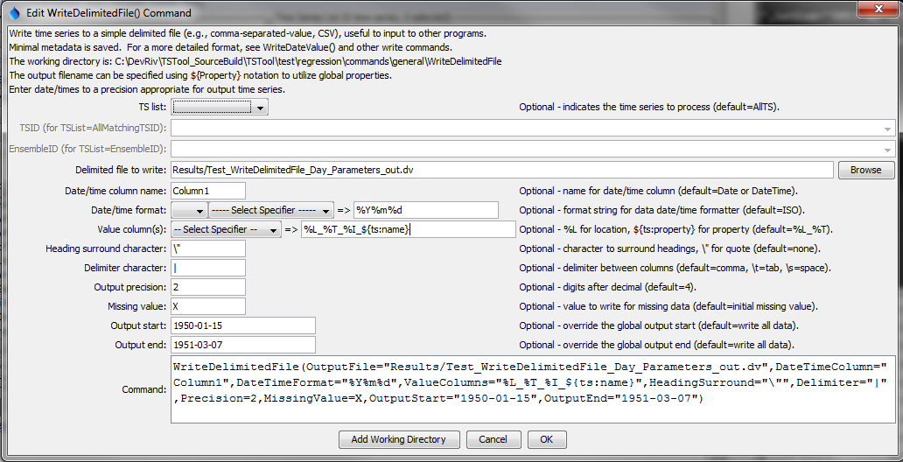

WriteDelimitedFile

WriteDelimitedFile() Command Editor

The command syntax is as follows:

WriteDelimitedFile(Parameter=Value,…)

Command Parameters

| Parameter | Description | Default |
| --- | --- | --- |
| TSList | Indicates the list of time series to be processed, one of:   * AllMatchingTSID – all time series that match the TSID (single TSID or TSID with wildcards) will be processed. * AllTS – all time series before the command. * EnsembleID – all time series in the ensemble will be processed. * FirstMatchingTSID – the first time series that matches the TSID (single TSID or TSID with wildcards) will be processed. * LastMatchingTSID – the last time series that matches the TSID (single TSID or TSID with wildcards) will be processed. * SelectedTS – the time series are those selected with the SelectTimeSeries() command. | AllTS |
| TSID | The time series identifier or alias for the time series to be processed, using the * wildcard character to match multiple time series. Can be specified using processor ${Property}. | Required if TSList=*TSID. |
| EnsembleID | The ensemble to be processed, if processing an ensemble. Can be specified using processor ${Property}. | Required if TSList= EnsembleID. |
| OutputFile | The delimited output file. The path to the file can be absolute or relative to the working directory (command file location). Global properties can be used to specify the filename, using the ${Property} syntax. | None – must be specified. |
| DateTime  Column | The name of the column for the date/time. | Date if day, month, or year interval, DateTime otherwise. |
| DateTime  FormatterType | Specify the date/time formatter type, which indicates the syntax for DateTimeFormat. Currently, only C is supported, corresponding to the C programming language strftime() function, which is also used by other software (see Linux date command). | C |
| DateTime  Format | The format used to expand the date/time corresponding to each time series data value. The format string can contain literal strings and specifiers supported by the DateTimeFormatterType. |  |
| ValueColumns | The name(s) of the column(s) corresponding to each time series, to use for the values. Specify with % formatters, ${ts:property} and ${property}. In the future a parameter may be added to more specifically define the column names. If the column name contains the HeadingSurround character, occurrences of the character will be removed. | %L_%T |
| Heading  Surround | Character that is used to surround column headings. Specify a double quote using \”. | No surrounding character. |
| Delimiter | The delimiter character to use between data values. Specify \t for tab and \s for space. | Space. |
| Precision | The number of digits after the decimal for numerical output. | 4 (in the future may default based on data type) |
| MissingValue | The value to write to the file to indicate a missing value in the time series. This will override the value initialized when the time series is read or created (typically -999, NaN or another value). Specify Blank to output a blank. | Time series missing value. |
| OutputStart | The date/time for the start of the output. Can be specified using processor ${Property}. | Use the global output period. |
| OutputEnd | The date/time for the end of the output. Can be specified using processor ${Property}. | Use the global output period. |

This page is intentionally blank.