Command Reference: WritePropertiesToFile()

Write one or more time series processor properties to a file

Version 11.02.03, 2015-05-27

The WritePropertiesToFile() command writes the value of one or more time series processor properties to a file (this command replaces the older WriteProperty() command, which is being phased out). The ReadPropertiesFromFile() command can be used to read properties from a file. Processor properties include global defaults such as InputStart, InputEnd, OutputStart, OutputEnd, OutputYearType, WorkingDir, and also user-defined properties set with SetProperty() and other commands. Internally, properties have a name and a value, which is of a certain type (Boolean, string, integer, date/time, etc.). Examples of using the command include:

* creating tests to verify that properties are being set
* passing information from TSTool to another program, such as a Python script
* storing persistent information for later use, such as the date/time that data were last downloaded from a web service

A number of property formats are supported as listed in the following table.

Property File Formats

|  |  |
| --- | --- |
| Format | Description |
| NameValue | Simple format, all properties handled as text:  PropertyName=PropertyValue  PropertyName=”Property value, quoted if necessary” |
| NameTypeValue | Same as NameValue format, with non-primitive objects treated as simple constructors:  PropertyName=PropertyValue  DateTimeProperty=DateTime(“2010-10-01 12:30”) |
| NameTypeValue  Python | Similar to the NameTypeValue format, however, objects are represented using “Pythonic” notation, to allow the file to be used directly by Python scripts:  PropertyName=”PropertyValue”  DateTimeProperty=DateTime(2010,10,1,12,30) |

The following dialog is used to edit this command and illustrates the syntax of the command.

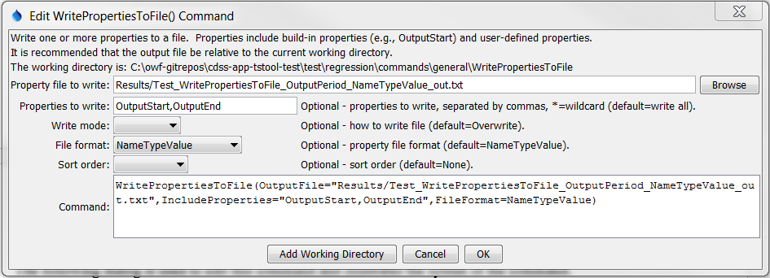

WritePropertiesToFile

WritePropertiesToFile() Command Editor

The command syntax is as follows:

WritePropertiesToFile(Parameter=Value,…)

Command Parameters

|  |  |  |
| --- | --- | --- |
| Parameter | Description | Default |
| OutputFile | The property file to write, as an absolute path or relative to the command file. | None – must be specified. |
| IncludeProperties | The names of properties to write, separated by commas. The * wildcard can be used to indicate multiple properties. | If not specified, all processor properties will be written. |
| WriteMode | Indicates how the file should be written:   * Append – append the properties to the file without checking for matches (create the file if it does not exist) * Overwrite – overwrite the properties file * Update – update the properties in the file by first checking for matching property names (which will be updated) and then appending unmatched properties (**not yet implemented**) | Overwrite |
| FileFormat | Format of the properties file (see descriptions in the above Property File Formats table):   * NameValue * NameTypeValue * NameTypeValuePython | NameValue |
| SortOrder | The order to sort properties:   * Ascending * Descending * None | None – order depends on order in processor. |