Command Reference: WriteReclamationHDB()

Write time series to a Reclamation HDB database

Version 11.09.02, 2016-03-13

This command’s documentation is now maintained as HTML – refer to the HTML version for current documentation.

The WriteReclamationHDB() command writes time series to a Reclamation HDB database:

* a single “real” time series (observations)
* a single “model” time series (results from a model)
* a time series ensemble, indicated by the ensemble name, in which case each ensemble trace time series is read as a “model” time series

See the ReadReclamationHDB() command documentation for information about reading the time series that are written by this command. See the Reclamation HDB Data Store Appendix for more information about the database features and limitations. Command functionality includes:

* **Time series metadata/new time series:**
  + In general, the command will not define new sites, data types, site datatype identifier (SDI) combinations, models or other fundamental data. It is expected that such data have previously been defined in the database.
  + New real time series can be written by selecting the appropriate SDI.
  + New (non-ensemble) model time series can be specified by selecting a model run information and if appropriate a new run date.
  + New ensembles and corresponding trace time series can be defined by specifying ensemble name, trace number, and model run date using the NewEnsembleName and NewEnsembleModelRunDate command parameters.
* **Date/time handling**:
  + TSTool uniformly uses the time at the end of the recorded interval for data values (instantaneous time or end of interval for mean and accumulated values), whereas HDB uses the time at the beginning of the recorded interval for hourly data. See the ReclamationHDB Datastore appendix for more information.
  + Writing NHour data uses WRITE_TO_HDB procedure where the SAMPLE_END_DATETIME is set to the TSTool date/time and SAMPLE_DATE_TIME is set the TSTool date/time minus NHour. Currently the procedure always stores the difference as one hour but this is being evaluated.
  + Writing other than NHour data uses the WRITE_TO_HDB procedure with SAMPLE_DATE_TIME passed as the same value as the TSTool date/time.
* **Updating time series records:**
  + Time series data records for an existing time series will be updated if previously written. The values in the write period are not removed before writing. It would be useful to have the ability to write null or a missing value in the database.
* **Missing data**:
  + Missing data currently are not written. By convention missing values in HDB are simply not included in the database. Currently the command will not delete previous records if the new value at a date/time is missing. It would be useful to have the ability to clear the time series values in the write period before inserting the new values. This would ensure that the data are current.
* **Data units**:
  + Data units in the time series are not checked against data units in the database because the units in TSTool data may originally have come from various sources that do not use the same units abbreviations as HDB. It is the user’s responsibility to ensure that time series that are being written have units that are compatible with HDB.
* **Data flags**:
  + Data flags from the time series are not written to the database. The ValidationFlag, OverwriteFlag, and DataFlags parameters are provided to specify HDB flags. Additional capability may be added in the future.
* **Time zone**:
  + Time zone can be indicated in TSTool time series by including in the start and end date/time information; however, time zones can be difficult to standardize when data comes from different sources. The default time zone for HDB is configured for the Reclamation office that uses the database. To ensure proper data loading, the TimeZone command parameter, which indicates the time zone for the time series data, is required as of TSTool 11.09.02 (it was optional prior to this version). If the time zone for the data are different from the database, the HDB WRITE_TO_HDB stored procedure will adjust the data in the database to store as the database time zone. It is the user’s responsibility to verify that the correct time zone is being provided to the WriteReclamationHDB command. It is strongly recommended that standard time be used for time series data and if possible use the same time zone as the database. A daylight savings time zone such as MDT or PDT could be used for a time series period that is entirely in that zone; however, switching between standard and daylight savings time in time series leads to confusion.
* **HDB data table**:
  + The time series interval is used to determine the HDB time series table to write, with irregular data being written as instantaneous data with date/time precision to minute.
  + TSTool treats year-interval data generically and does not manage water year (or other types of years) in special fashion, other than when processing data into year interval time series. Water year data can be saved in year interval data but currently there is no way to write to the water-year tables in HDB.
* **HDB database procedure**:
  + The HDB WRITE_TO_HDB stored procedure is used to write individual time series data records:
    - The time series is written to a model time series table if model parameters are specified.
    - The model run date, for single time series and ensembles, is truncated to minutes in time series identifiers and for query purposes.
  + When writing ensembles, the HDB procedure ENSEMBLE.GET_TSTOOL_ENSEMBLE_MRI is used to determine the model run identifier corresponding to model time series and then the WRITE_TO_HDB procedure (above) is used to write data records:
    - The ensemble name is determined from the EnsembleName parameter (or NewEsembleName parameter if creating a new ensemble) – existing names can be selected or a new name can be specified
    - The trace number is determined from the EnsembleTrace command parameter, and will result in the trace being taken from specific time series properties. Currently this must be an integer but in the future string trace identifiers may be supported (TSTool uses string identifiers internally).
    - The model name is determined from the EnsembleModelName parameter. Model names consistent with non-ensemble model time series are used.
    - The model run date is determined from the EnsembleModelRunDate parameter (or NewEnsembleModelRunDate parameter if writing data for a new run date). If specified then the P_IS_RUNDATE_KEY procedure parameter is set to Y, if not specified it is set to N). Consequently, ensemble time series can be written with or without a model run date.

The following dialog is used to edit the command and illustrates the syntax of the command when writing “real” data, in which case model information in the lower panel are not specified. Currently the site_name and site_common_name are not required to be unique in HDB and therefore specifying the unique site_datatype_id (SDI) is the only way to ensure that the proper time series is being selected.

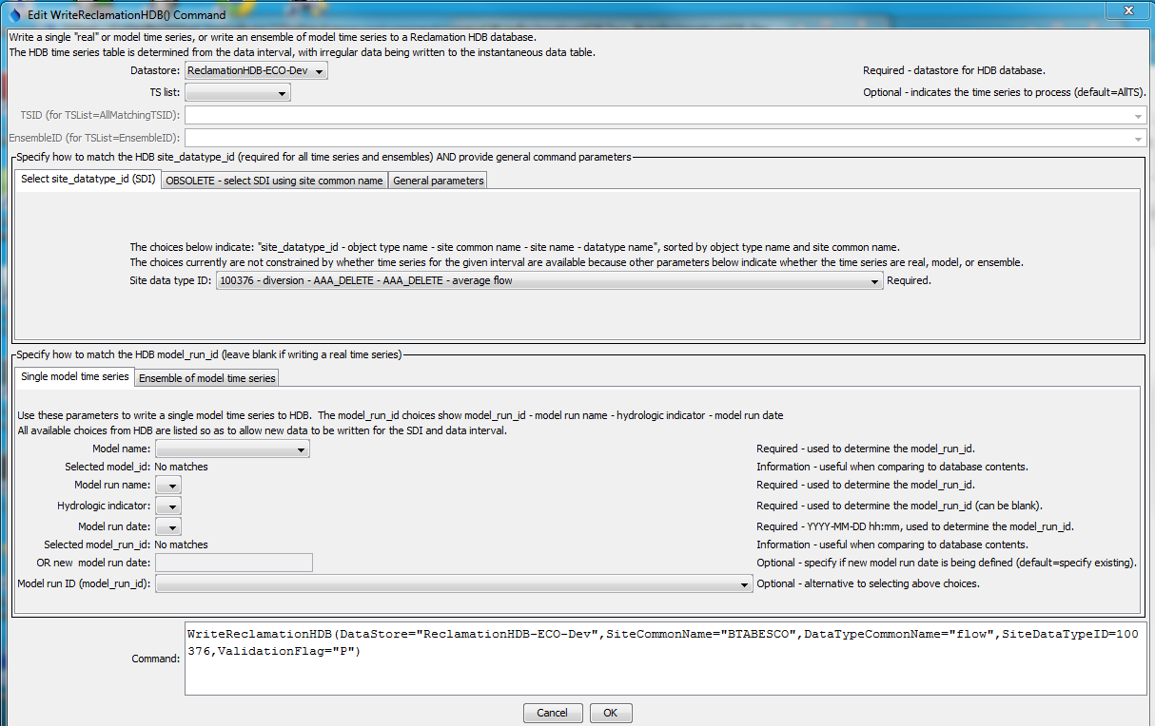

WriteReclamationHDB

WriteReclamationHDB() Command Editor for “Real” Time Series

The following figure illustrates general command parameters.

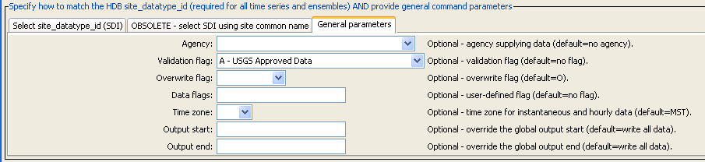

WriteReclamationHDB_General

WriteReclamationHDB() Command Editor for General Parameters

The following figure illustrates the syntax of the command when writing “model” data for a single time series, in which case the model parameters are specified via the Single model time series tab. The model run identifier can be specified in one of two ways:

1. Select the MRI from the list at the bottom of the dialog
2. Select the MRI by specifying multiple values that result in a unique MRI:
   1. Model name
   2. Model run name
   3. Hydrologic indicator (can be blank)
   4. Run date (can be blank) – currently a new run date cannot be specified

The example in the following shows parameter values for both methods for illustration; however, the directly selected ModelRunID will be used in this case.

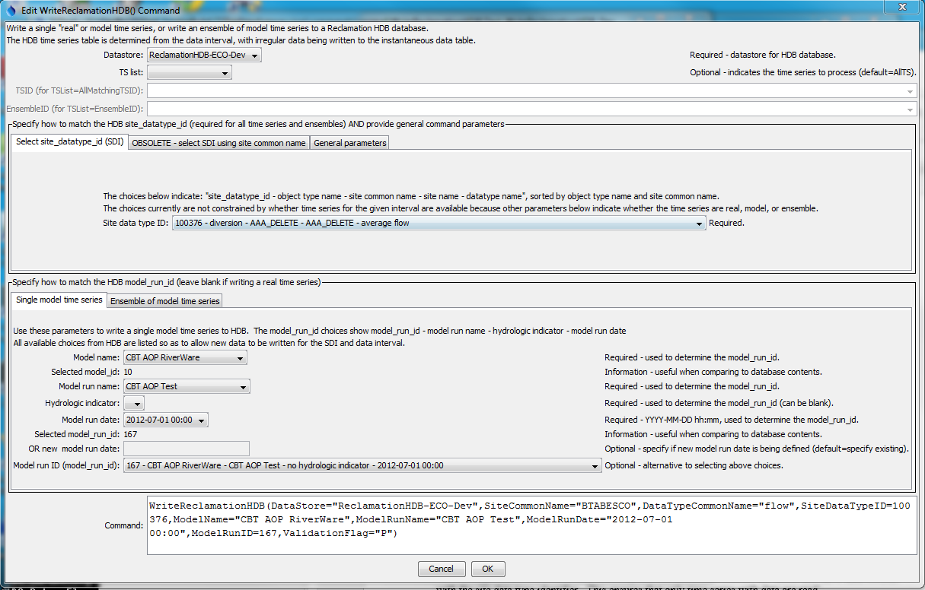

WriteReclamationHD_Model

WriteReclamationHDB() Command Editor for Single Model Time Series

The following figure illustrates the syntax of the command when writing an ensemble of model time series, in which case ensemble and related model parameters are specified via the Ensemble of model time series tab. The TSTool ensemble to write is specified with the TSList=EnsembleID and EnsembleID parameters. In the following example a new ensemble is being written. The time series trace number and model run date are both taken from the ensemble time series properties when the command is run.

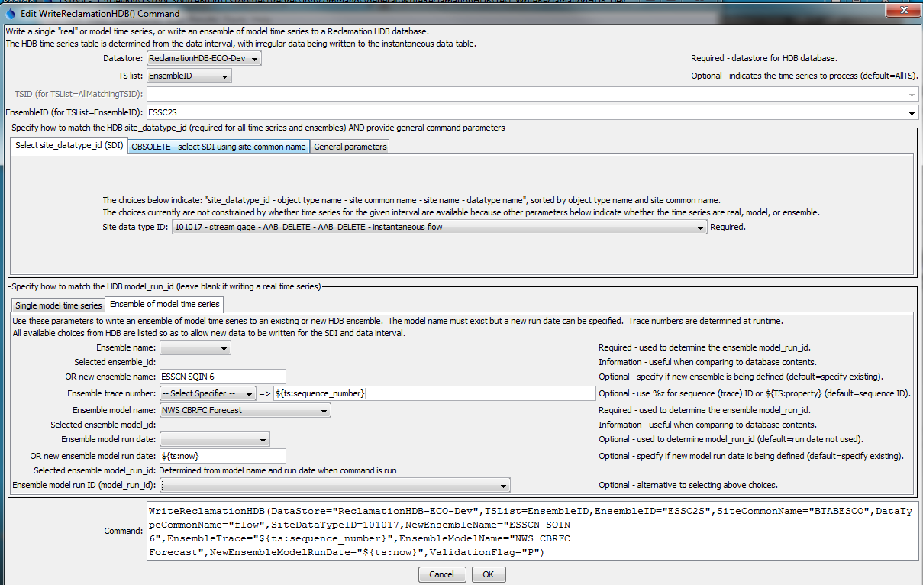

WriteReclamationHD_Ensemble

WriteReclamationHDB() Command Editor for Ensemble of Model Time Series

The command syntax is as follows:

WriteReclamationHDB(Parameter=Value,…)

Command Parameters

| Parameter | Description | Default |
| --- | --- | --- |
| DataStore | The identifier for the ReclamationHDB data store to use for the database. | None – must be specified. |
| TSList | Indicates the list of time series to be processed, one of:   * AllMatchingTSID – all time series that match the TSID (single TSID or TSID with wildcards) will be processed. * AllTS – all time series before the command. * EnsembleID – all time series in the ensemble will be processed. * FirstMatchingTSID – the first time series that matches the TSID (single TSID or TSID with wildcards) will be processed. * LastMatchingTSID – the last time series that matches the TSID (single TSID or TSID with wildcards) will be processed. * SelectedTS – the time series are those selected with the SelectTimeSeries() command. | AllTS |
| TSID | The time series identifier or alias for the time series to be processed, using the * wildcard character to match multiple time series. | Required if TSList=*TSID. |
| EnsembleID | The identifier for the TSTool ensemble to be processed, if processing an ensemble, not to be confused with the Ensemble* parameters below that match HDB data. | Required if TSList= EnsembleID. |
| SiteDataTypeID | The site_datatype_id value to match the time series. If specified, the value will be used instead of the site_datatype_id determined from SiteCommonName and DataTypeCommonName. |  |
| Site  CommonName | The site common name for the time series location; used with the data type common name to determine the site_datatype_id in the database. Because SiteCommonName is not guaranteed to be unique, the SiteDataTypeID should be specified instead. | None – must be specified unless SiteDataTypeID is specified. |
| DataType  CommonName | The data type common name for the time series; used with the site common name to determine the site_datatype_id in the database. Because DataTypeCommonName is not guaranteed to be unique without additional information such as HDB object type, the SiteDataTypeID should be specified instead. | None – must be specified unless SiteDataTypeID is specified. |
|  | Use the following parameters when writing a single model time series. |  |
| ModelName | The model name for the time series; used with the model run name, hydrologic indicator(s), and model run date to determine the model_run_id in the database. | None – must be specified unless ModelRunID is specified. |
| ModelRunName | The model run name for the time series; used with the model name, hydrologic indicator(s), and model run date to determine the model_run_id in the database. | None – must be specified unless ModelRunID is specified. |
| Hydrologic  Indicator | The hydrologic indicator(s) to use for the time series; used with the model name, model run name, and model run date to determine the model_run_id in the database. The hydrologic indicate can be blank. | None – must be specified unless ModelRunID is specified. |
| ModelRunDate | The model run date (timestamp) to use for the time series; used with the model name, model run name, and hydrologic indicator(s) to determine the model_run_id in the database. The run date should be specified using the format YYYY-MM-DD hh:mm (zero-padded with hour 0-23, minute 0-59). Run dates in HDB include seconds, but this information is ignored when matching time series. | None – must be specified unless ModelRunID is specified. |
| NewModelRunDate | If specified, the new model run date will be used instead of the ModelRunDate. This parameter is currently not implemented. | Use ModelRunDate. |
| ModelRunID | The model_run_id value to match the time series. If specified, the value will be used instead of the model_run_id determined from ModelName, ModelRunName, HydrologicIndicator, and ModelRunDate (or NewModelRunDate). |  |
|  | Use the following parameters when writing an ensemble of model time series. |  |
| EnsembleName | The name of the ensemble to write. The TSList=EnsembleID and EnsembleID parameters also should be specified. | Must be specified if writing an ensemble. |
| NewEnsembleName | If specified, the new ensemble name will be used instead of the EnsembleName. See EnsembleTrace notes below for options to format the new ensemble name. | EnsembleName |
| EnsembleModelName | The model name corresponding to the ensemble. | Must be specified if writing an ensemble. |
| EnsembleTrace | Indicate how to identify time series trace identifiers:   * %z – use standard time series properties to format the ensemble trace ID (see command editor for format characters). %z indicates the sequence identifier from an ensemble trace time series. * ${TS:property} – format the trace identifier from time series properties (e.g., properties read from original ensemble data) * ${property} – format the trace identifier from time series processor (global) properties (e.g., properties set with the SetProperty() command)   The HDB GET_TSTOOL_ENSEMBLE_MRI procedure currently requires the identifier to be an integer – additional options for identifying traces may be added in the future. | The time series sequence number (equivalent to the %z formatting string) |
| EnsembleModel  RunDate | When writing an ensemble, an existing model run date for the ensemble, specified using format:   * YYYY-MM-DD hh:mm (zero-padded with hour 0-23)   The model time series associated with the existing run will be overwritten. |  |
| NewEnsembleModel  RunDate | When writing an ensemble, the new model run date for the ensemble, specified using format:   * YYYY-MM-DD hh:mm (zero-padded with hour 0-23) * ${ts:property} – use a run date from a time series property, truncated to minute * ${property} – format the new model run date identifier from time series processor (global) properties (e.g., properties set with the SetProperty() command) | If not specified, the ensemble identifier in HDB will not include the model run date. |
|  | The following parameters are always appropriate. |  |
| Agency | The agency abbreviation (e.g., USBR) for data records written to the database. | No agency is indicated in database. |
| Validation  Flag | HDB validation flag. Only uppercase characters are supported. | No flag is used. |
| OverwriteFlag | HDB overwrite flag. | Overwrite (enforced by HDB stored procedure).. |
| DataFlags | User-defined flags, up to 20 characters. | No flags are used. |
| TimeZone | Three-letter time zone abbreviation for the time series data records written to the database, consistent with HDB time zones. Specifying helps ensure that the timestamp on time series data is properly handled. It is recommended that time series data use a standard time zone and not daylight savings time. | None – must be specified. |
| OutputStart | The date/time for the start of the output. If not aligned with the time series data records for NHour data, the output start hour will be adjusted to the first interval in the day that aligns with the time series data. | Use the global output period. |
| OutputEnd | The date/time for the end of the output. If not aligned with the time series data records for NHour data, the output end hour will be adjusted to the last interval in the day that aligns with the time series data. | Use the global output period. |
| EnsembleIDProperty | Processor property name to set to the HDB ensemble ID that is written, useful for testing purposes. |  |