Command Reference: WriteRiverWare()

Write time series to a RiverWare format file

Version 11.08.00, 2016-01-14

The WriteRiverWare() command writes one time series to the specified RiverWare format file. See the RiverWare Input Type Appendix for more information about the file format.

The following dialog is used to edit the command and illustrates the syntax of the command.

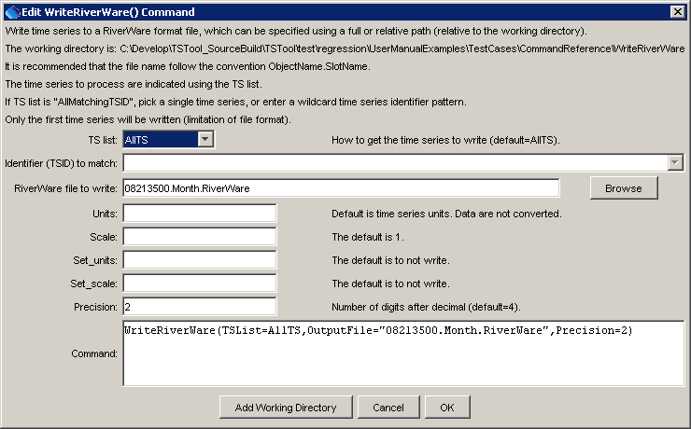

WriteRiverWare

WriteRiverWare() Command Editor

The command syntax is as follows:

WriteRiverWare(Parameter=Value, …)

Command Parameters

|  |  |  |
| --- | --- | --- |
| Parameter | Description | Default |
| TSList | Indicate how to determine the list of time series to process (only first one is written), one of:   * AllMatchingTSID – process time series that have identifiers matching the TSID parameter. * AllTS – process all the time series. * SelectedTS – process the time series that are selected (see SelectTimeSeries()). | None – must be specified. |
| TSID | Used if TSList=AllMatchingTSID to indicate the time series identifier or alias for the time series to be filled. Specify * to match all time series or use a wildcard for one or more identifier parts. Can be specified with ${Property} notation. | Required if TSList=  AllMatchingTSID. |
| OutputFile | The RiverWare file to write. The path to the file can be absolute or relative to the working directory. The Browse button can be used to select the file to write (if a relative path is desired, delete the leading path after the select). Can be specified with ${Property} notation. | None – must be specified. |
| Units | The data units to be output. Specify units that are recognized by RiverWare – the units are not actually converted but the new units string is used in the output file. | Use the units in the time series. |
| Scale | See the RiverWare Input Type Appendix. | 1 |
| Set_units | See the RiverWare Input Type Appendix. | Set_units are not output. |
| Set_scale | See the RiverWare Input Type Appendix. | Set_scale are not output. |
| Precision | The number of digits after the decimal to write. | 4 |

A sample command file to write data from the State of Colorado’s HydroBase is as follows:

|  |
| --- |
| # 08213500 - RIO GRANDE RIVER AT THIRTY MILE BRIDGE NEAR CREEDE  08213500.DWR.Streamflow.Month~HydroBase  WriteRiverWare(TSList=AllTS,OutputFile="08213500.Month.RiverWare",Precision=2) |