Command Reference: WriteSummary()

Write time series to a summary format file

Version 11.11.00, 2016-05-25

The WriteSummary() command writes time series to a summary report file, as text or HMTL. The format of the file is a default for the data interval. The total/average column in reports (if output) is based on the units – a parameter may be added in the future to allow more flexibility.

The following dialog is used to edit the command and illustrates the syntax of the command.

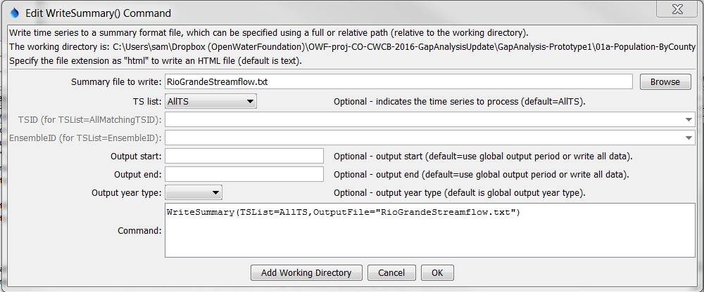

WriteSummary

WriteSummary() Command Editor

The command syntax is as follows:

WriteSummary(Parameter=Value,…)

Command Parameters

|  |  |  |
| --- | --- | --- |
| Parameter | Description | Default |
| OutputFile | The summary file. The path to the file can be absolute or relative to the working directory (command file location). Specifying a filename with an “html” extension will result in HTML output, which is color-coded for missing values and has notes for flagged values. Can be specified using ${Property}. | None – must be specified. |
| TSList | Indicates the list of time series to be processed, one of:   * AllMatchingTSID – all time series that match the TSID (single TSID or TSID with wildcards) will be processed. * AllTS – all time series before the command. * EnsembleID – all time series in the ensemble will be processed. * FirstMatchingTSID – the first time series that matches the TSID (single TSID or TSID with wildcards) will be processed. * LastMatchingTSID – the last time series that matches the TSID (single TSID or TSID with wildcards) will be processed. * SelectedTS – the time series are those selected with the SelectTimeSeries() command. | AllTS |
| TSID | The time series identifier or alias for the time series to be processed, using the * wildcard character to match multiple time series. Can be specified using ${Property}. | Required if TSList=*TSID. |
| EnsembleID | The ensemble to be processed, if processing an ensemble. Can be specified using ${Property}. | Required if TSList= EnsembleID. |
| OutputStart | The date/time for the start of the output. Can be specified using ${Property}. | Use the global output period. |
| OutputEnd | The date/time for the end of the output. Can be specified using ${Property}. | Use the global output period. |
| Output  YearType | The output year type, in particular for formatting monthly and daily time series. | Calendar |

A sample command file to process data from the State of Colorado’s HydroBase is as follows:

|  |
| --- |
| SetOutputPeriod(OutputStart="1950-01",OutputEnd="2002-12")  # 08213500 - RIO GRANDE RIVER AT THIRTY MILE BRIDGE NEAR CREEDE  08213500.DWR.Streamflow.Month~HydroBase  # 08217000 - RIO GRANDE AT WASON, BELOW CREEDE, CO.  08217000.USGS.Streamflow.Month~HydroBase  WriteSummary(TSList=AllTS,OutputFile="RioGrandeStreamflow.txt",TSList="AllTS") |