Command Reference: WriteTableToDelimitedFile()

Write a table to a delimited file

Version 11.13.00, 2017-01-19

The WriteTableToDelimitedFile() command writes a table to a delimited file. Currently only the comma is supported as the delimiter. This command is the analog to the ReadTableFromDelimitedFile() command. It can be used to provide tabular data to other programs, such as spreadsheet programs and geographic information systems.

The default is to write a standard file header using comment lines that start with the # character. If available, column names will be written in double quotes as the first non-comment row. Formatting for cell values is limited and the default precision of floating point numbers may include too many digits – this will be addressed in future updates.

The following dialog is used to edit the command and illustrates the syntax for the command.

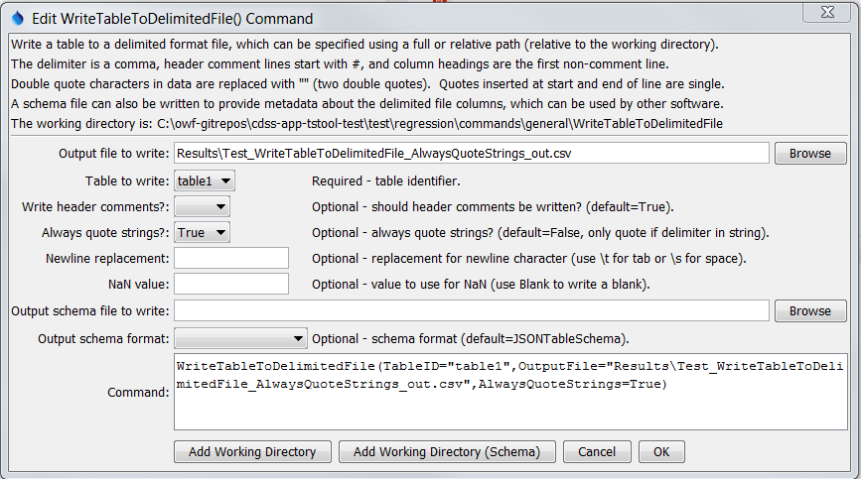

WriteTableToDelimitedFile

WriteTableToDelimitedFile() Command Editor

The command syntax is as follows:

WriteTableToDelimitedFile(Parameter=Value,…)

Command Parameters

|  |  |  |
| --- | --- | --- |
| Parameter | Description | Default |
| TableID | Identifier for the table to write. Can be specified using processor ${Property}. | None – must be specified. |
| OutputFile | The name of the file to write, as an absolute path or relative to the command file location. Can be specified using processor ${Property}. | None – must be specified. |
| WriteHeader  Comments | Indicates whether to write the header comments, True or False. Some programs, such as Esri’s ArcGIS do not handle delimited files with comments. | True |
| AlwaysQuote  Strings | Indicates whether values in string columns should always be surrounded by double quotes:   * False – only quote strings that contain the delimiter * True – always quote strings   An example of using AlwaysQuoteStrings=True is to quote identifiers that have a leading zero (e.g., 01234567). Not quoting may cause the values to be interpreted as integers when read from the delimited file. | False |
| Newline  Replacement | The string to replace newlines in string values, necessary to prevent unexpected line breaks in output rows. In order to handle newlines from various systems, the following patterns are replaced in sequence:   * \r\n * \n * \r   The following special parameter values are recognized:   * \t – replace newline with tab * \s – replace newline with space | Do not replace newlines (file format may be unusable because of unexpected line breaks). |
| NaNValue | The value to write for NaN data values. Specify Blank to write a blank (empty string). | NaN |
| OutputSchema  File | Name of schema file to write, useful to help other software understand contents of the delimited file. See the OutputSchemaFormat parameter. | Do not create schema file. |
| OutputSchema  Format | Schema format, one of the following, output is limited but will be expanded in the future:   * JSONTableSchema – see <http://specs.frictionlessdata.io/json-table-schema> * GoogleBigQuery – see <https://cloud.google.com/bigquery/docs/reference/rest/v2/tables> | JSONTable  Schema |