Command Reference: WriteTableToExcel()

Write a table to a Microsoft Excel workbook file

Version 10.29.00, 2014-05-05

**This command is under development.**

The WriteTableToExcel() command writes a table to a worksheet in a Microsoft Excel workbook file. A contiguous block of cells (rectangle) must be specified in one of the following ways to receive the table:

* Specify the upper-left cell in a range of cells using Excel address notation (e.g., A1)
* Specify a range of cells using Excel address notation (e.g., A1:D10)
* Specify the name of an Excel named range.
* Specify a table name (essentially a named range).

TSTool uses the Apache POI software, version 3.9 (http://poi.apache.org) to read/write the Excel file and consequently functionality is constrained by the features of that software package.

The following are limitations of this command:

* Currently only the upper-left cell is utilized but in the future the range may be used to limit output.
* Cell data types are determined from the table columns being written. In the future a parameter may be provided to allow option of using original Excel formatting.

The following figures illustrate the dialog used to edit the command and the syntax for the command.

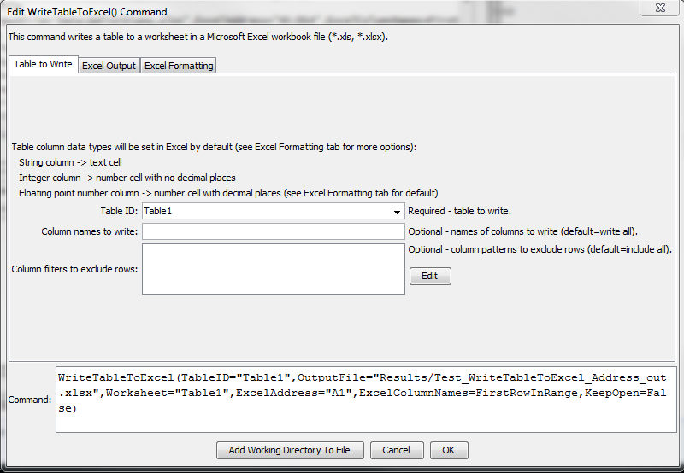

WriteTableToExcel

WriteTableToExcel() Command Editor

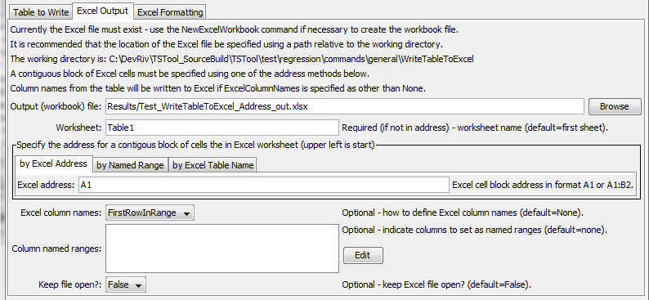

WriteTableToExcel_Excel

WriteTableToExcel() Command Editor for Excel Output Parameters

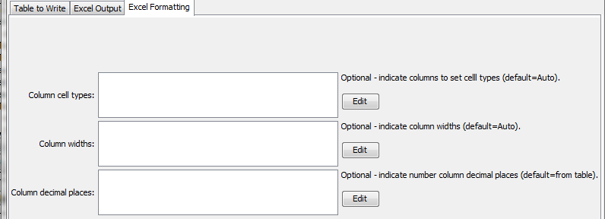

WriteTableToExcel_Excel

WriteTableToExcel() Command Editor for Excel Formatting Parameters

The command syntax is as follows:

WriteTableToExcel(Parameter=Value,…)

Command Parameters

| Parameter | Description | Default |
| --- | --- | --- |
| TableID | Identifier for table to write. | None – must be specified. |
| IncludeColumns | Names of columns in table to write. | Write all columns. |
| ColumnExclude  Filters | Indicate table column names and pattern to use to exclude rows. For example, exclude rows with blanks in columns. The format of the parameter is:  ColumnName1:Pattern1,  ColumnName2:Pattern2,…  where patterns can contain * to match a substring. | Include all rows. |
| OutputFile | The name of the Excel workbook file (*.xls or *.xlsx) to write, as an absolute path or relative to the command file location. If the Excel file does not exist it will be created. | None – must be specified. |
| Worksheet | The name of the worksheet in the workbook to write. If the worksheet does not exist it will be created. | Write to the first worksheet. |
| ExcelAddress | Indicates the block of cells to write, using Excel address notation (e.g., A1:D10). | Must specify address using one of available address parameters. |
| ExcelNamedRange | Indicates the block of cells to write, using an Excel named range. | Must specify address using one of available address parameters. |
| ExcelTableName | Indicates the block of cells to write, using an Excel named range. | Must specify address using one of available address parameters. |
| ExcelColumn  Names | Indicate how to determine the column names for the Excel table (in order to not overwrite with data rows), one of:   * FirstRowInRange – column names are written to the first row in the Excel address range * None – column names are not written * RowBeforeRange – column names are written to the row before the Excel address range | None |
| ColumnNamedRanges | The map of column names to named ranges, useful when the column of values is used as choices in Excel data validation. | No named ranges will be defined. |
| KeepOpen | Indicate whether to keep the Excel file open (True) or close after creating (False). Keeping the file open will increase performance because later commands will not need to reread the workbook. Make sure to close the file in the last Excel command. | False |
| ColumnCellTypes | Column names and corresponding cell types using notation: ColumnName1:CellType1,ColumnName2:CellType2. Column name can be Default to set the default for all output columns. Supported cell types are:   * Auto – determine cell type from table column * Text – Excel text cell | Auto |
| ColumnWidths | Column names and corresponding widths using notation: ColumnName1:Width1,ColumnName2:Width2. Column name can be Default to set the default for all output columns. Supported width values are:   * Auto – determine width from table contents * N – number of 1/256 of character widths (maximum is 256*256) | Default column with determined by Excel. |
| ColumnDecimal  Places | Column names and corresponding number of decimal places, for floating point numbers, using notation: ColumnName1:Num1,ColumnName2:Num2. | Determine from table column precision, or 6 if unable to determine from table. |