Command Reference: WriteTableToGeoJSON()

Write a table to a GeoJSON file

Version 11.08.00, 2016-01-21

The WriteTableToGeoJSON() command writes a table to a GeoJSON file, which is a spatial data format that can be viewed in geographic information system (GIS) software and other visualization tools. See:

http://geojson.org/geojson-spec.html

The table must include columns for longitude and latitude or a column containing Well Known Text (WKT) geometry strings. See:

http://en.wikipedia.org/wiki/Well-known_text

Currently only point and polygon data can be processed but in the future support for well-known text for other geometry types will be added. A future enhancement of this command will allow the geometry feature data to be read from other spatial formats.

The following dialog is used to edit the command and illustrates the command syntax for point data in separate columns.

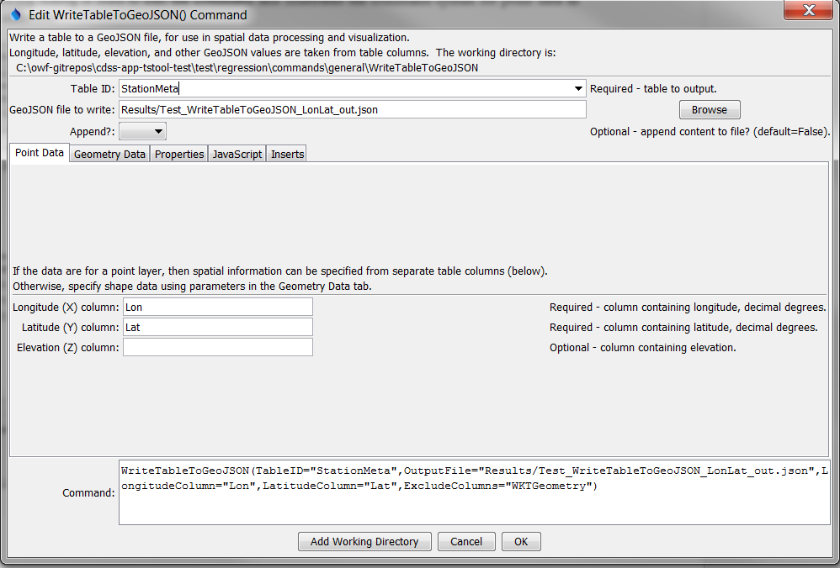

WriteTableToGeoJSON

WriteTableToGeoJSON() Command Editor for Point Data Parameters

The following figure illustrates the command syntax for layers specified with a geometry data column.

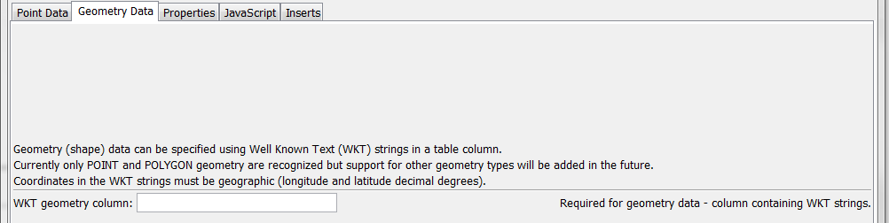

WriteTableToGeoJSON_WKTGeometry

WriteTableToGeoJSON() Command Editor for Geometry Data Parameters

The following figure illustrates the command syntax for specifying table columns to include as properties in the GeoJSON output.

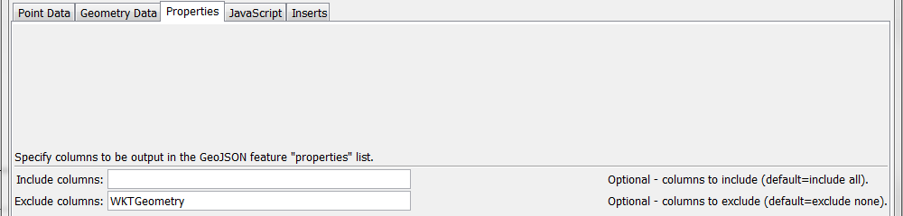

WriteTableToGeoJSON_Properties

WriteTableToGeoJSON() Command Editor for Property Parameters

The following figure illustrates the command syntax for specifying the JavaScript variable for the output object.

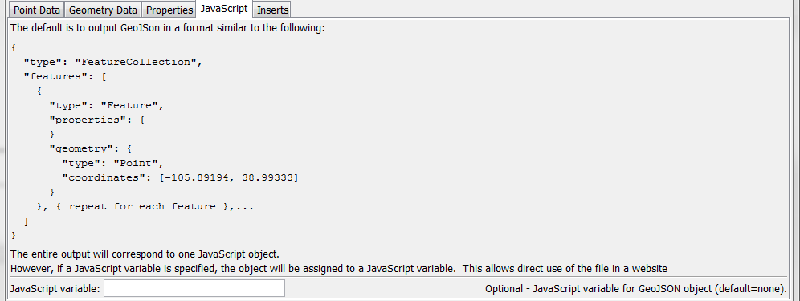

WriteTableToGeoJSON_JavaScript

WriteTableToGeoJSON() Command Editor for JavaScript Parameters

The following figure illustrates the command syntax for specifying inserts before and after the GeoJSON content.

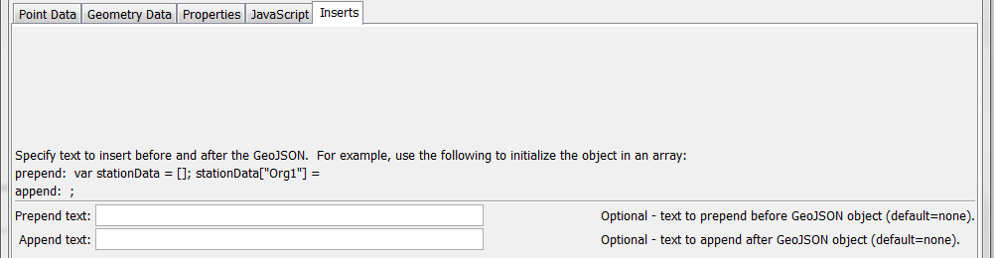

WriteTableToGeoJSON_Inserts

WriteTableToGeoJSON() Command Editor for Text Insert Parameters

The command syntax is as follows:

WriteTableToGeoJSON(Parameter=Value,…)

Command Parameters

| Parameter | Description | Default |
| --- | --- | --- |
| TableID | Identifier for the table to write. Can be specified using ${Property} notation. | None – must be specified. |
| OutputFile | The name of the GeoJSON file to write, as an absolute path or relative to the command file location. Can be specified using ${Property} notation. | None – must be specified. |
| Append | Indicate whether to append the GeoJSON content to the output file, True or False. | False |
| Longitude  Column | The name of the table column that contains longitude. | None – must be specified. |
| Latitude  Column | The name of the table column that contains latitude. | None – must be specified. |
| Elevation  Column | The name of the table column that contains elevation. | Elevation is omitted. |
| WKTGeometry  Column | The name of the table column that contains Well Known Text (WKT) geometry strings. |  |
| IncludeColumns | List of column-separated table column names to include as feature properties. | Include all columns. |
| ExcludeColumns | List of column-separated table column names to exclude as feature properties. | Exclude no columns. |
| JavaScriptVar | Name of JavaScript variable to assign object to in output. This parameter will be ignored if PrependText or AppendText are specified. | Output GeoJSON object surrounded by { }. |
| PrependText | Provide text to insert before the GeoJSON object, for example to provide custom JavaScript. Can be specified using ${Property} notation. | No insert. |
| AppendText | Provide text to append after the GeoJSON object, for example to provide custom JavaScript. Can be specified using ${Property} notation. |  |

The following example illustrates a CSV table that specifies WKT for points (see WKTGeometry column):

"ID","ID_text","Lon","Lat","Name","WKTGeometry"

50263,050263,-105.891940,38.993330,ANTERO RSVR,"POINT (-105.891940 38.993330)"

50454,050454,-105.476670,39.404720,BAILEY,"POINT (-105.476670 39.404720)"

50848,050848,-105.266670,39.991940,BOULDER,"POINT (-105.266670 39.991940)"

The following example illustrates a CSV table that specifies WKT for polygons:

"ID","ID_text","Lon","Lat","Name","WKTGeometry"

50263,050263,-105.891940,38.993330,ANTERO RSVR,"POLYGON (-105.891940 38.993330,-106 39,-106 37.5)"

50454,050454,-105.476670,39.404720,BAILEY,"POLYGON (-105.476670 39.404720, -104 39, -103 37.5)"