Command Reference: WriteTableToKml()

Write a table to a KML file

Version 10.26.00, 2013-12-01

The WriteTableToDelimitedFile() command writes a table to a Keyhole Markup Language (KML) file (see: <https://developers.google.com/kml/documentation/topicsinkml>). The table must include columns for longitude and latitude or a column containing Well Known Text (WKT) geometry strings. Currently only point data can be processed but in the future support for well-known text for various geometry types will be added.

The following dialog is used to edit the command and illustrates the command syntax for general parameters.

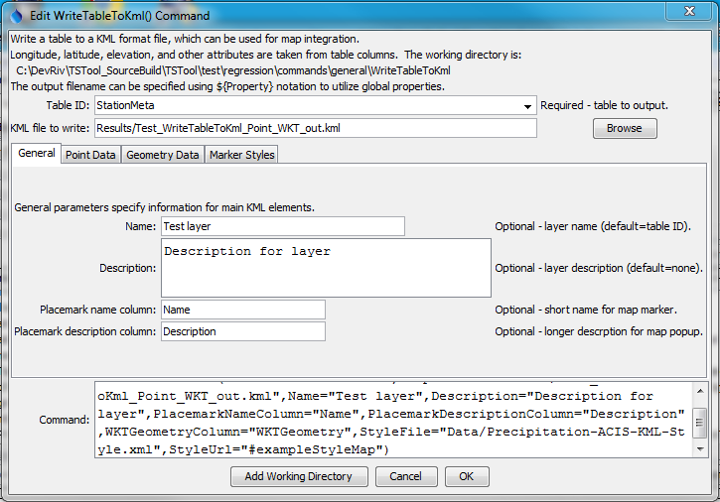

WriteTableToKml

WriteTableToKml() Command Editor for General Parameters

The following figure illustrates the command syntax for point data in separate columns.

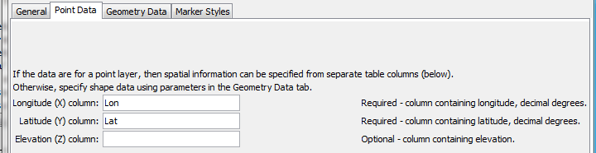

WriteTableToKml_Point

WriteTableToKml() Command Editor for Point Data Parameters

The following figure illustrates the command syntax for layers specified with a geometry data column.

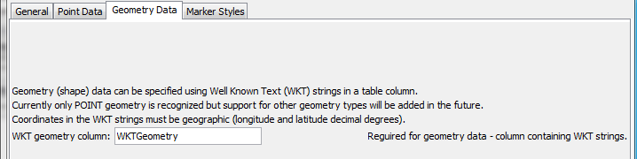

WriteTableToKml_Geometry

WriteTableToKml() Command Editor for Geometry Data Parameters

The following figure illustrates the command syntax for marker style parameters.

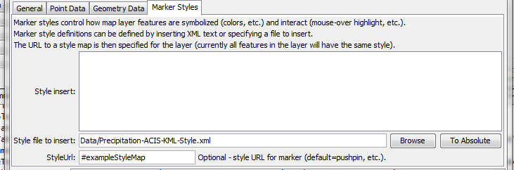

WriteTableToKml_Styles

WriteTableToKml() Command Editor for Marker Style Parameters

The command syntax is as follows:

WriteTableToKml(Parameter=Value,…)

Command Parameters

| Parameter | Description | Default |
| --- | --- | --- |
| TableID | Identifier for the table to write. | None – must be specified. |
| OutputFile | The name of the KML file to write, as an absolute path or relative to the command file location. | None – must be specified. |
| Name | The name of the layer, corresponding to the <name> KML element. | Table ID. |
| Description | The description for the layer, corresponding to the <description> KML element. The text can contain HTML markup. | Blank |
| Placemark  NameColumn | The name of the table column that contains placemark names, corresponding to the KML <Placemark><name> element. | Blank |
| Placemark  Description  Column | The name of the table column that contains placemark descriptions, corresponding to the KML <Placemark><description> element. The description text in the table can contain HTML markup. | Blank |
| Longitude  Column | The name of the table column that contains longitude, corresponding to the KML <Point><coordinates> element. | None – must be specified. |
| Latitude  Column | The name of the table column that contains latitude, corresponding to the KML <Point><coordinates> element. | None – must be specified. |
| Elevation  Column | The name of the table column that contains elevation, corresponding to the KML <Point><coordinates> element. | Elevation of 0 is assumed. |
| WKTGeometry  Column | The name of the table column that contains Well Known Text (WKT) geometry strings. |  |
| StyleInsert | Text containing <Style> and <StyleMap> element text, which will be inserted in the KML file. | No styles. |
| StyleFile | Similar to StyleInsert; however, the style information to be inserted is read from the specified file. |  |
| StyleUrl | Specifies the <StyleMap> element to use for each placemark in the layer. For example, specify as #myStyleMap to match a style map included in the KML file with the StyleInsert or StyleFile parameter. | Default KML style. |

The following is an example of a style insert file (refer to KML reference documentation for explanation):

<Style id="highlightPlacemark">

<IconStyle>

<Icon>

<href>http://maps.google.com/mapfiles/kml/paddle/red-stars.png</href>

</Icon>

</IconStyle>

</Style>

<Style id="normalPlacemark">

<IconStyle>

<Icon>

<href>http://maps.google.com/mapfiles/kml/paddle/wht-blank.png</href>

</Icon>

</IconStyle>

</Style>

<StyleMap id="exampleStyleMap">

<Pair>

<key>normal</key>

<styleUrl>#normalPlacemark</styleUrl>

</Pair>

<Pair>

<key>highlight</key>

<styleUrl>#highlightPlacemark</styleUrl>

</Pair>

</StyleMap>

The following is an example of the resulting KML file:

<?xml version="1.0" encoding="UTF-8"?>

<kml xmlns="http://www.opengis.net/kml/2.2">

<Document>

<name>Test layer</name>

<description>Description for layer</description>

<Style> …. Omitted … see example above

</Style>

<StyleMap> … Omitted … see example above

</SyleMap>

<Placemark>

<name>ANTERO RSVR</name>

<description>Description: ANTERO RSVR</description>

<styleUrl>#exampleStyleMap</styleUrl>

<Point>

<coordinates>-105.89194,38.99333,0</coordinates>

</Point>

</Placemark>

<Placemark>

<name>BAILEY</name>

<description>Description: BAILEY</description>

<styleUrl>#exampleStyleMap</styleUrl>

<Point>

<coordinates>-105.47667,39.40472,0</coordinates>

</Point>

</Placemark>

</Document>

</kml>