Command Reference: WriteTimeSeriesPropertiesToFile()

Write one or more time series properties to a file

Version 11.02.00, 2015-05-16

The WriteTimeSeriesPropertiesToFile() command writes the value of time series properties to a file. This command should not be confused with the WritePropertiesToFile() command, which writes processor properties. This command is useful for testing whether properties are being set. It can also be used to pass information from TSTool to another program. A number of property formats are supported as listed in the following table.

Property File Formats

|  |  |
| --- | --- |
| Format | Description |
| NameValue | Simple format, all properties handled as text:  PropertyName=PropertyValue  PropertyName=”Property value, quoted if necessary” |
| NameTypeValue | Same as NameValue format, with non-primitive objects treated as simple constructors:  PropertyName=PropertyValue  DateTimeProperty=DateTime(“2010-10-01 12:30”) |
| NameTypeValue  Python | Similar to the NameTypeValue format, however, objects are represented using “Pythonic” notation, to allow the file to be used directly by Python scripts:  PropertyName=”PropertyValue”  DateTimeProperty=DateTime(2010,10,1,12,30) |

The following dialog is used to edit this command and illustrates the syntax of the command.

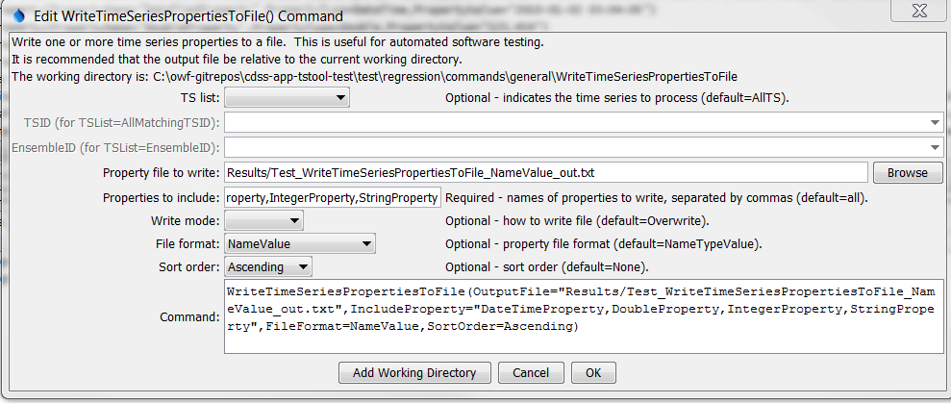

WriteTimeSeriesPropertiesToFile

WriteTimeSeriesPropertiesToFile() Command Editor

The command syntax is as follows:

WriteTimeSeriesPropertiesToFile(Parameter=Value,…)

Command Parameters

|  |  |  |
| --- | --- | --- |
| Parameter | Description | Default |
| TSList | Indicates the list of time series to be processed, one of:   * AllMatchingTSID – all time series that match the TSID (single TSID or TSID with wildcards) will be modified. * AllTS – all time series before the command. * EnsembleID – all time series in the ensemble will be modified. * FirstMatchingTSID – the first time series that matches the TSID (single TSID or TSID with wildcards) will be modified. * LastMatchingTSID – the last time series that matches the TSID (single TSID or TSID with wildcards) will be modified. * SelectedTS – the time series are those selected with the SelectTimeSeries() command. | AllTS |
| TSID | The time series identifier or alias for the time series to process, using the * wildcard character to match multiple time series. | Required when TSList=*TSID |
| EnsembleID | The ensemble to be processed, if processing an ensemble. | Required when TSList= EnsembleID. |
| OutputFile | The property file to write, as an absolute path or relative to the command file. | None – must be specified. |
| Include  Properties | The names of time series properties to write, separated by commas. The * wildcard can be used to indicate multiple properties. Currently only user-defined properties are written. | If not specified, all time series properties will be written. |
| WriteMode | Indicates how the file should be written:   * Append – append the time series properties to the file without checking for matches (create the file if it does not exist) * Overwrite – overwrite the properties file * Update – update the properties in the file by first checking for matching property names (which will be updated) and then appending unmatched properties (**not yet implemented**) | Overwrite |
| FileFormat | Format of the properties file (see descriptions in the above Property File Formats table):   * NameValue * NameTypeValue * NameTypeValuePython | NameValue |
| SortOrder | The order to sort properties:   * Ascending * Descending * None | None – order depends on order in processor. |