Command Reference: WriteTimeSeriesToExcel()

Write one or more time series to a Microsoft Excel workbook file

Version 11.03.07, 2015-06-24

The WriteTimeSeriesToExcel() command writes one or more time series to an Excel workbook. The following functionality is provided:

* Time series are written in columns (see WriteTimeSeriesToExcelBlock() for alternate formatting options).
* The worksheet and position in worksheet can be specified.
* The output can be created or appended.
* Separate columns can be written for date/time, date, and/or time. Currently date/time values are written as strings but Excel date objects will be enabled in the future.
* Cell comments can be formatted using data flags and other time series properties.

TSTool uses the Apache POI software, version 3.9 (http://poi.apache.org) to read/write the Excel file and consequently functionality is constrained by the features of that software package.

The following figures illustrate the dialog used to edit the command and the syntax for the command.

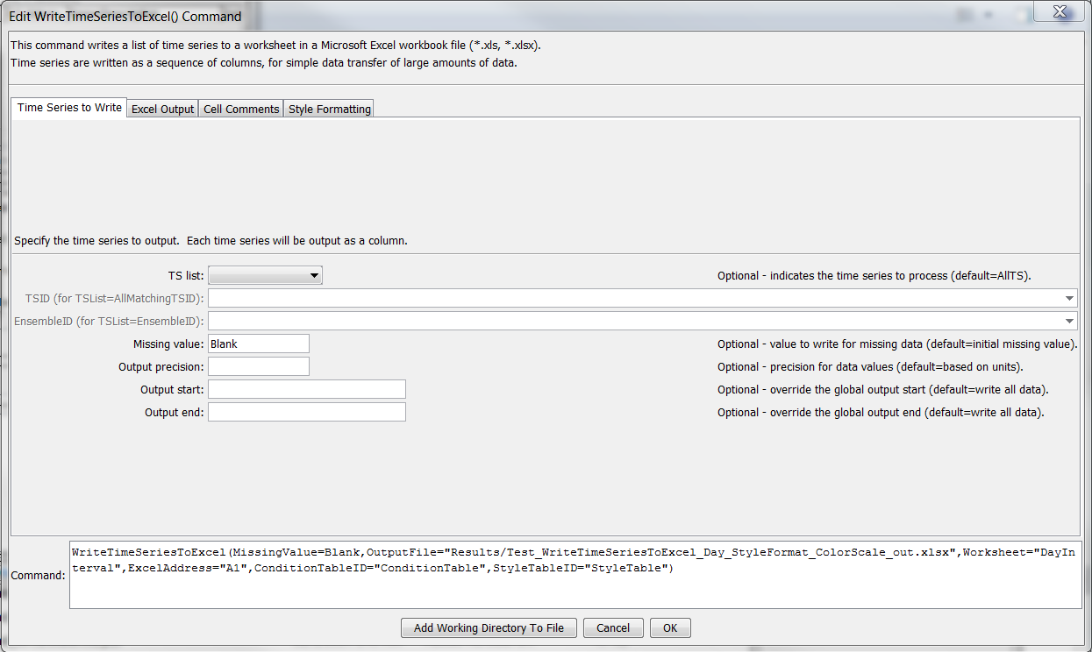

WriteTimeSeriesToExcel

WriteTimeSeriesToExcel() Command Editor

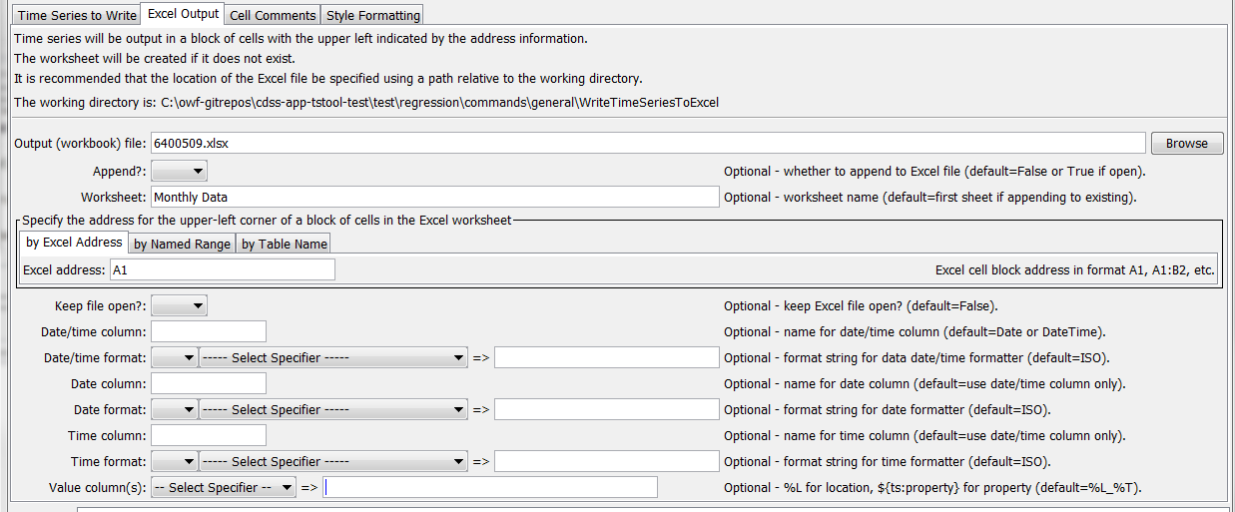

WriteTimeSeriesToExcel_ExcelOutput

WriteTimeSeriesToExcel() Command Editor for Excel Output Parameters

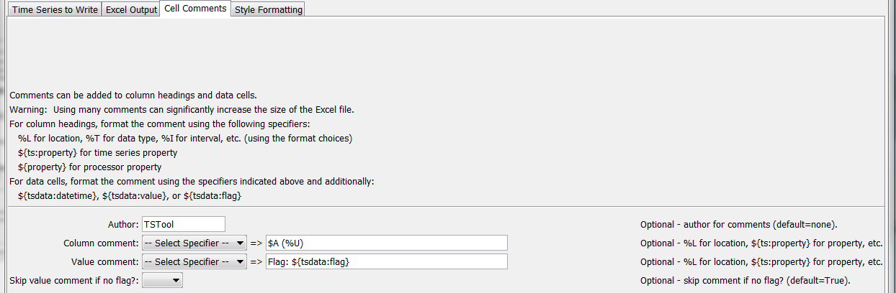

WriteTimeSeriesToExcel_CellComments

WriteTimeSeriesToExcel() Command Editor for Cell Comments Parameters

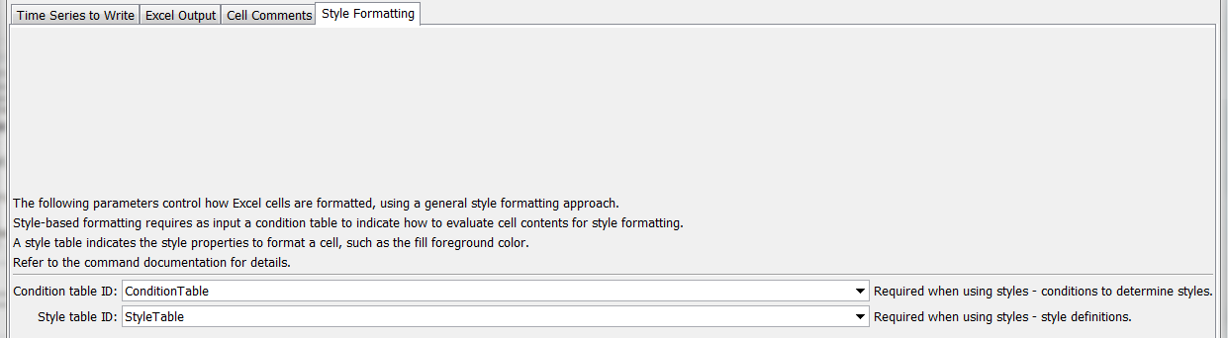

WriteTimeSeriesToExcel_StyleFormat

WriteTimeSeriesToExcel() Command Editor for Style Formatting Parameters

The command syntax is as follows:

WriteTimeSeriesToExcel(Parameter=Value,…)

Command Parameters

| Parameter | Description | Default |
| --- | --- | --- |
| TSList | Indicates the list of time series to be processed, one of:   * AllMatchingTSID – all time series that match the TSID (single TSID or TSID with wildcards) will be processed. * AllTS – all time series before the command. * EnsembleID – all time series in the ensemble will be processed. * FirstMatchingTSID – the first time series that matches the TSID (single TSID or TSID with wildcards) will be processed. * LastMatchingTSID – the last time series that matches the TSID (single TSID or TSID with wildcards) will be processed. * SelectedTS – the time series are those selected with the SelectTimeSeries() command. | AllTS |
| TSID | The time series identifier or alias for the time series to be processed, using the * wildcard character to match multiple time series. Can be specified using processor ${Property}. | Required if TSList=*TSID. |
| EnsembleID | The ensemble to be processed, if processing an ensemble. Can be specified using processor ${Property}. | Required if TSList= EnsembleID. |
| MissingValue | Value to write to Excel for missing data values. | Original missing value. |
| Precision | The number of digits after the decimal for data values. | Determine from units. |
| OutputStart | The date/time for the start of the output. Can be specified using processor ${Property}. | Use the global output period. |
| OutputEnd | The date/time for the end of the output. Can be specified using processor ${Property}. | Use the global output period. |
| OutputFile | The name of the Excel workbook file (*.xls or *.xlsx) to write, as an absolute path or relative to the command file location. If the Excel file does not exist it will be created. Can be specified using processor ${Property}. | None – must be specified. |
| Append | Indicate whether the sheet being written should appended to an existing workbook. | False – create a new workbook. |
| Worksheet | The name of the worksheet in the workbook to write. If the worksheet does not exist it will be created. Can be specified using processor ${Property}. | Write to the first worksheet. |
| ExcelAddress | Indicates the block of cells to write, using Excel address notation (e.g., A1:D10). | Must specify address using one of available address parameters. |
| ExcelNamedRange | Indicates the block of cells to write, using an Excel named range. | Must specify address using one of available address parameters. |
| ExcelTableName | Indicates the block of cells to write, using an Excel named range. | Must specify address using one of available address parameters. |
| KeepOpen | Indicate whether to keep the Excel file open (True) or close after creating (False). Keeping the file open will increase performance because later commands will not need to reread the workbook. Make sure to close the file in the last Excel command. | False |
| DateTime  Column | The name of the column for the date/time. | Date if day, month, or year interval, DateTime otherwise. |
| DateTime  FormatterType | Specify the date/time formatter type, which indicates the syntax for DateTimeFormat. Currently, only C is supported, corresponding to the C programming language strftime() function, which is also used by other software (see Linux date command). | C |
| DateTime  Format | The format used to expand the date/time corresponding to each time series data value. The format string can contain literal strings and specifiers supported by the DateTimeFormatterType. |  |
| DateColumn | The name of the column for the date, if date and time need to be in separate columns. | Date |
| Date  FormatterType | Specify the date/time formatter type, which indicates the syntax for DateFormat. Currently, only C is supported, corresponding to the C programming language strftime() function, which is also used by other software (see Linux date command). | C |
| DateFormat | The format used to expand the date/time corresponding to each time series data value. The format string can contain literal strings and specifiers supported by the DateFormatterType. |  |
| TimeColumn | The name of the column for the time, if date and time need to be in separate columns. | Time |
| Time  FormatterType | Specify the date/time formatter type, which indicates the syntax for TimeFormat. Currently, only C is supported, corresponding to the C programming language strftime() function, which is also used by other software (see Linux date command). | C |
| TimeFormat | The format used to expand the date/time corresponding to each time series data value. The format string can contain literal strings and specifiers supported by the TimeFormatterType. |  |
| ValueColumns | The name(s) of the column(s) corresponding to each time series, to use for the values. Specify with % formatters, ${ts:property} and ${property}. In the future a parameter may be added to more specifically define the column names. | %L_%T |
| Author | Name to use in comments for author. | No author |
| ColumnComment | A string to format for column heading comments for each time series. See ValueColumns for formatting options. | No comments. |
| ValueComment | See ValueColumns for formatting options. The string ${tsdata:flag} can also be specified to include the data flag for the cell. | No comments. |
| SkipValueComment  IfNoFlag | Indicate whether the ValueComment should be skipped if the data flag for a cell is blank. | True |
| Condition  TableID | Identifier for condition table (see below). Can be specified using processor ${Property}. | Style formatting is not used. |
| StyleTableID | Identifier for style table (see below). Can be specified using processor ${Property}. | Style formatting is not used. |

Excel cell formatting consists of number formatting, cell colors, cell width, etc. The Style Formatting tab provides general formatting capabilities for data cells. Consider the following data table, where the goal is to write the TSTool time series to Excel and format cells to indicate specific conditions of interest. Note that this approach is implemented in a similar way for the WriteTableToExcel() command.

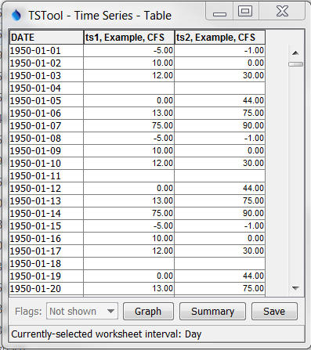

WriteTimeSeriesToExcel_DataTable

Data Table used with WriteTimeSeriesToExcel() Command Style Formatting

To configure style-based formatting, a style table is defined listing properties for formatting a cell. This table can be defined as a CSV file, Excel worksheet or other format and read into TSTool using a suitable command. The following figure illustrates a basic style table, which can be shared among commands.

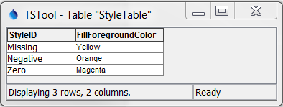

WriteTableToExcel_StyleTable

Style Table used with WriteTimeSeriesToExcel() Command Style Formatting

The following style table columns are recognized. The default values for cell style properties not listed in the table are those provided by Excel.

Recognized Style Table Columns

| Column Name | Description | Default |
| --- | --- | --- |
| StyleID | An identifier for the style, which is used in the format table below. | None – must be specified. |
| FillForegroundColor | The foreground fill color as a named color (e.g., “Red”), RGB triplet (255,255,255), or hex color 0xFFFFFF. The following named colors are recognized: black, blue, cyan, darkgray, gray, green, lightgray, magenta, none, orange, pink, red, white, yellow. | No fill color. |
| FillPattern | Fill pattern for cells using FillForegroundColor and FillBackgroundColor. | **Currently always defaults to solid.** |

The format table indicates how the styles are used for columns and cell values, as shown in the following example, which indicates that any columns with names starting with “ts” should be processed to evaluate for missing and negative values.

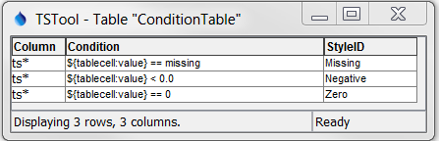

WriteTableToExcel_FormatTable

Condition Table used with WriteTimeSeriesToExcel() Command for Style Formatting

For the above style and format tables, the column names must be specified as shown. The Condition column recognizes the following specifiers:

* ${tsdata:value} – the time series data value
* ${tsdata:flag} – the time series flag

Values on the left and right of the operator must be separated with spaces to facilitate parsing the condition. The Condition column recognizes the following operators:

Format Table Condition Operators

| Operator | Description |
| --- | --- |
| < | Less than. |
| <= | Less than or equal to. |
| == | Equal to. Specify the right-side value as missing to check for missing. |
| != | Not equal to. Specify the right-side value as missing to check for missing. |
| > | Greater than. |
| >= | Greater than or equal to. |
| contains | Specify for string values to check for substring (case-independent). |

Multiple conditions can be specified by using AND (surrounded by a single space) between conditions.

The following figure illustrates the output from the above example.

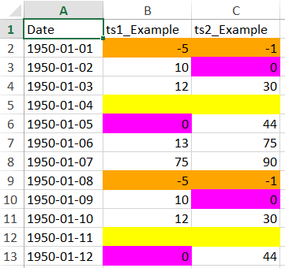

WriteTimeSeriesToExcel_Output

WriteTimeSeriesToExcel() Command Example Output for Style Formatting

The following example illustrates using multiple conditions to implement a color scale.

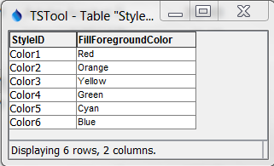

WriteTableToExcel_StyleTable2

Style Table used with WriteTimeSeriesToExcel() Command for Style Formatting and a Color Scale

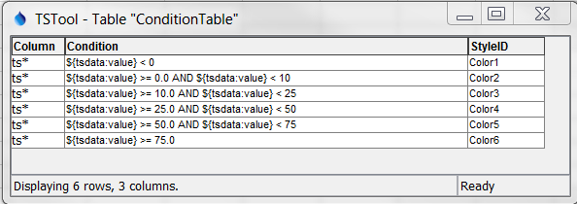

WriteTableToExcel_ConditionTable2

Condition Table used with WriteTimeSeriesToExcel() Command for Style Formatting and a Color Scale

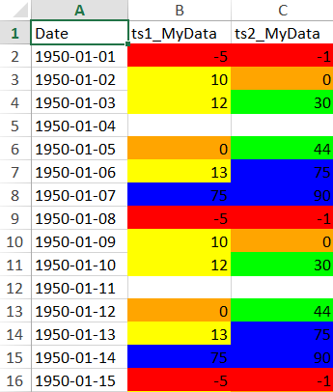

WriteTimeSeriesToExcel_Output2

WriteTimeSeriesToExcel() Command Example Output for Style Formatting