Command Reference: WriteTimeSeriesToExcelBlock()

Write 1+ time series to a Microsoft Excel workbook file using block layout

Version 11.07.03, 2015-09-06

**This command is under development.**

The WriteTimeSeriesToExcelBlock() command writes one or more time series to an Excel workbook with output being in block layout. The following functionality is provided:

* Time series are written in blocks (see WriteTimeSeriesToExcel() for simple column output).
* The worksheet and position in worksheet can be specified.
* The output can be created or appended.
* Options are provided to select how the blocks of data are oriented. For example, for monthly time series rows may contain years of data and columns may contain months of data.

TSTool uses the Apache POI software (http://poi.apache.org) to read/write the Excel file and consequently functionality is constrained by the features of that software package.

The following figures illustrate the dialog used to edit the command and the syntax for the command.

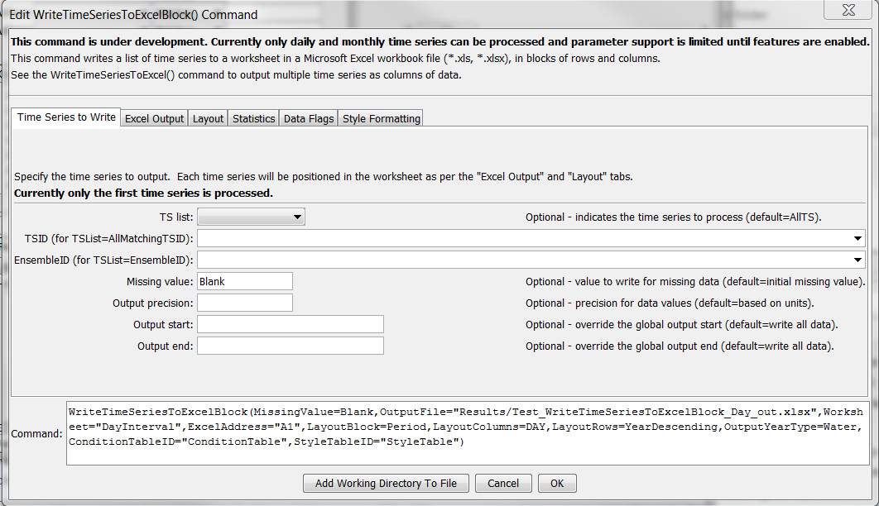

WriteTimeSeriesToExcelBlock_TimeSeries

WriteTimeSeriesToExcelBlock() Command Editor for Time Series Parameters

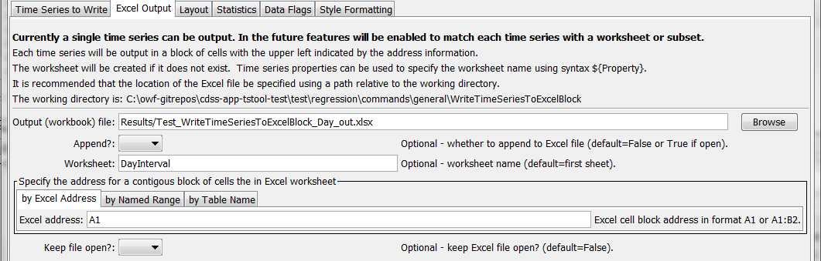

WriteTimeSeriesToExcelBlock_ExcelOutput

WriteTimeSeriesToExcel() Command Editor for Excel Output Parameters

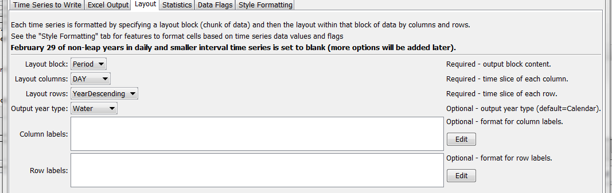

WriteTimeSeriesToExcelFormatted_Layout

WriteTimeSeriesToExcel() Command Editor for Layout Parameters

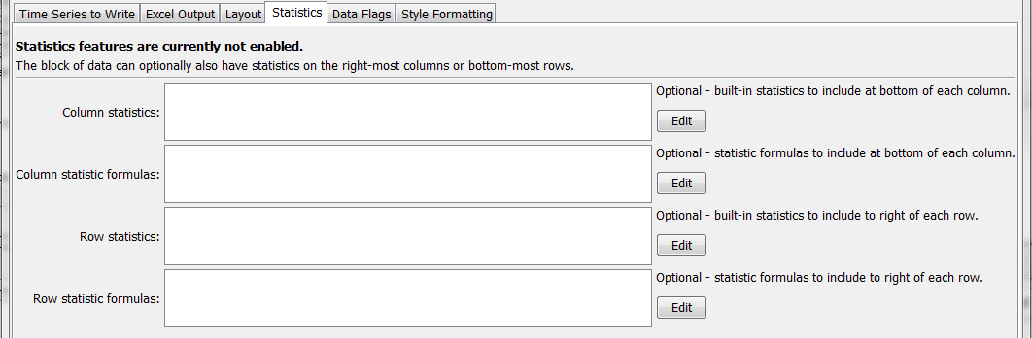

WriteTimeSeriesToExcelBlock_Statistics

WriteTimeSeriesToExcel() Command Editor for Statistics Parameters

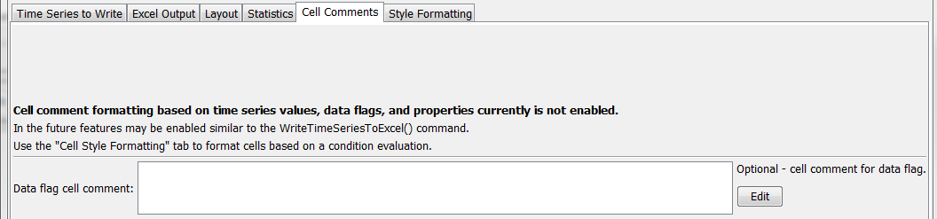

WriteTimeSeriesToExcelBlock_DataFlags

WriteTimeSeriesToExcel() Command Editor for Data Flag Parameters

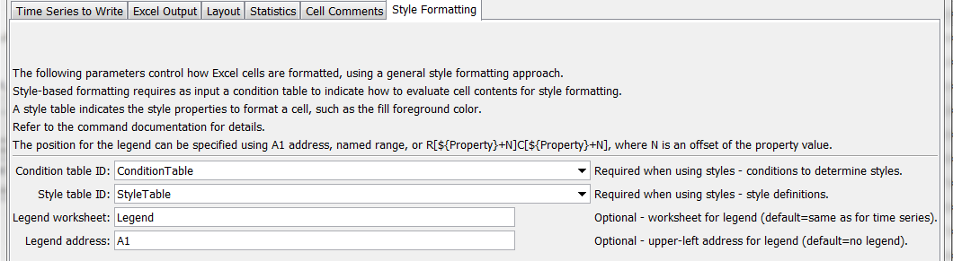

WriteTimeSeriesToExcelBlock_Style

WriteTimeSeriesToExcel() Command Editor for Style Formatting Parameters

The command syntax is as follows:

WriteTimeSeriesToExcelBlock(Parameter=Value,…)

Command Parameters

| Parameter | Description | Default |
| --- | --- | --- |
| TSList | Indicates the list of time series to be processed, one of:   * AllMatchingTSID – all time series that match the TSID (single TSID or TSID with wildcards) will be processed. * AllTS – all time series before the command. * EnsembleID – all time series in the ensemble will be processed. * FirstMatchingTSID – the first time series that matches the TSID (single TSID or TSID with wildcards) will be processed. * LastMatchingTSID – the last time series that matches the TSID (single TSID or TSID with wildcards) will be processed. * SelectedTS – the time series are those selected with the SelectTimeSeries() command. | AllTS |
| TSID | The time series identifier or alias for the time series to be processed, using the * wildcard character to match multiple time series. Can be specified with processor ${Property}. | Required if TSList=*TSID. |
| EnsembleID | The ensemble to be processed, if processing an ensemble. Can be specified with processor ${Property}. | Required if TSList= EnsembleID. |
| MissingValue | Value to write to Excel for missing data values, can be literal Blank to output blank cell. | Original missing value. |
| Precision | The number of digits after the decimal for data values. | Determine from units. |
| OutputStart | The date/time for the start of the output. Can be specified with processor ${Property}. | Use the global output period. |
| OutputEnd | The date/time for the end of the output. Can be specified with processor ${Property}. | Use the global output period. |
| OutputFile | The name of the Excel workbook file (*.xls or *.xlsx) to write, as an absolute path or relative to the command file location. If the Excel file does not exist it will be created. Can be specified with processor ${Property}. | None – must be specified. |
| Append | Indicate whether the sheet being written should appended to an existing workbook. | False – create a new workbook. |
| Worksheet | The name of the worksheet in the workbook to write. If the worksheet does not exist it will be created. Can be specified with processor ${Property}. | Write to the first worksheet. |
| ExcelAddress | Indicates the block of cells to write, using Excel address notation (e.g., A1:D10). | Must specify address using one of available address parameters. |
| Excel  NamedRange | Indicates the block of cells to write, using an Excel named range. | Must specify address using one of available address parameters. |
| Excel  TableName | Indicates the block of cells to write, using an Excel named range. | Must specify address using one of available address parameters. |
| KeepOpen | Indicate whether to keep the Excel file open (True) or close after creating (False). Keeping the file open will increase performance because later commands will not need to reread the workbook. Make sure to close the file in the last Excel command. | False |
| LayoutBlock | Indicate data blocks for output:   * Period – time series period of record is output as a block * Year – year of data is output in a block | None – must be specified. |
| LayoutColumns | For the output block, indicate what columns contain:   * Day – one day per column * Month – one month per column * Year – one year per column | None – must be specified. |
| LayoutRows | For the output block, indicate what rows contain:   * YearAscending – year, with earliest at top * YearDescending – year, with most recent at top | None – must be specified. |
| Output  YearType | The output year type, which controls the start and end dates for the output. | Calendar |
| Condition  TableID | Identifier for condition table (see below). Can be specified using processor ${Property}. | Style formatting is not used. |
| StyleTableID | Identifier for style table (see below). Can be specified using processor ${Property}. | Style formatting is not used. |
| Legend  Worksheet | Name of worksheet where the legend should be created. The legend displays conditions and styles. | Time series worksheet. |
| LegendAddress | Address A1, etc. for upper-left of legend. | No legend created. |

Excel cell formatting consists of number formatting, cell colors, cell width, etc. The Style Formatting tab provides general formatting capabilities for data cells. Consider the following time series data table, where the goal is to write the TSTool time series to Excel and format cells to indicate specific conditions of interest. This approach is implemented similarly in the WriteTableToExcel() command.

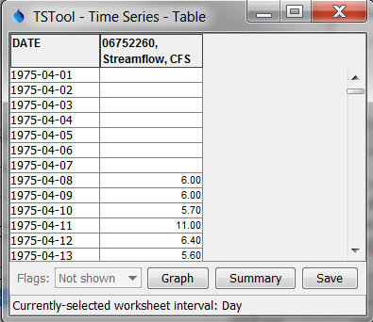

WriteTimeSeriesToExcelBlock_DataTable

Data Table used with WriteTimeSeriesToExcelBlock() Command Style Formatting

To configure style-based formatting, a style table is defined listing properties for formatting cells. This table can be defined as a CSV file, Excel worksheet or other format and read into TSTool using a suitable command. The following figure illustrates a basic style table, which can be shared among commands.

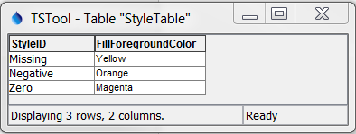

WriteTableToExcel_StyleTable

Style Table used with WriteTimeSeriesToExcelBlock() Command for Specific Checks and Formatting

The following style table column names are recognized. The default values for cell style properties not listed in the table are those provided by Excel.

Recognized Style Table Column Names

| Column Name | Description | Default |
| --- | --- | --- |
| StyleID | An identifier for the style, which is used in the format table below. | None – must be specified. |
| FillForegroundColor | The foreground fill color as a named color (e.g., “Red”), RGB triplet (255,255,255), or hex color 0xFFFFFF. The following named colors are recognized: black, blue, cyan, darkgray, gray, green, lightgray, magenta, none, orange, pink, red, white, yellow. | No fill color. |
| FillPattern | Fill pattern for cells using FillForegroundColor and FillBackgroundColor. | **Currently always defaults to solid.** |

The condition table indicates how the styles are used for time series data. The following example indicates that any time series with identifier (or alias) starting with “ts” should be processed to evaluate for missing, negative, and zero values.

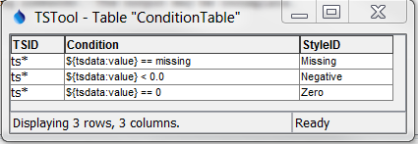

WriteTimeSeriesToExcel_ConditionTable

Condition Table used with WriteTimeSeriesToExcelBlock() Command for Specific Checks and Formatting

The column names for the condition table must be specified as shown. The Condition column recognizes the following time series data specifiers:

* ${tsdata:value} – the time series data value, used to evaluate numerical conditions
* ${tsdata:flag} – the time series flag, used to evaluate string conditions

Values on the left and right of the operator must be separated with spaces to facilitate parsing the condition. The Condition column recognizes the following operators:

Condition Table Operators

| Operator | Description |
| --- | --- |
| < | Less than. |
| <= | Less than or equal to. |
| == | Equal to. Specify the right-side value as missing to check for missing. |
| != | Not equal to. Specify the right-side value as missing to check for missing. |
| > | Greater than. |
| >= | Greater than or equal to. |
| contains | Specify for string values to check for substring (case-independent). |

Multiple conditions can be specified by using AND (surrounded by a single space) between conditions. The Display column in the condition table is optional and provides test to use in the legend. If the Display column is not provided, the Condition column contents will be used for the legend.

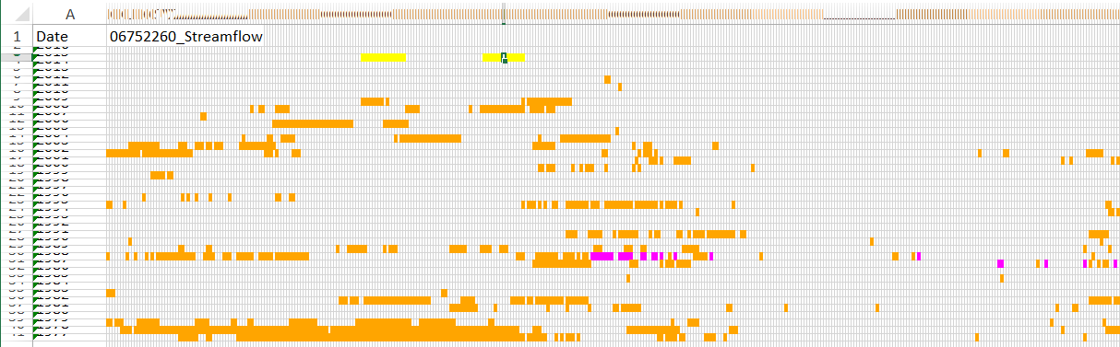

WriteTimeSeriesToExcelBlock_Output

WriteTimeSeriesToExcelBlock() Command Example Output for Specific Checks and Formatting

The following example illustrates using multiple conditions to implement a color scale.

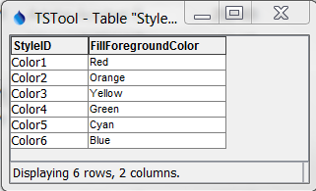

WriteTimeSeriesToExcel_StyleTable2

Style Table used with WriteTimeSeriesToExcelBlock() Command for a Color Scale

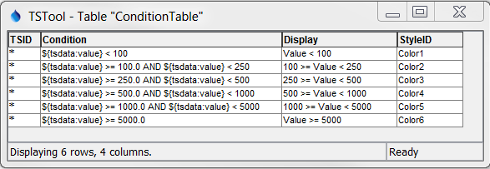

WriteTimeSeriesToExcelBlock_ConditionTable2

Condition Table used with WriteTimeSeriesToExcelBlock() Command for a Color Scale

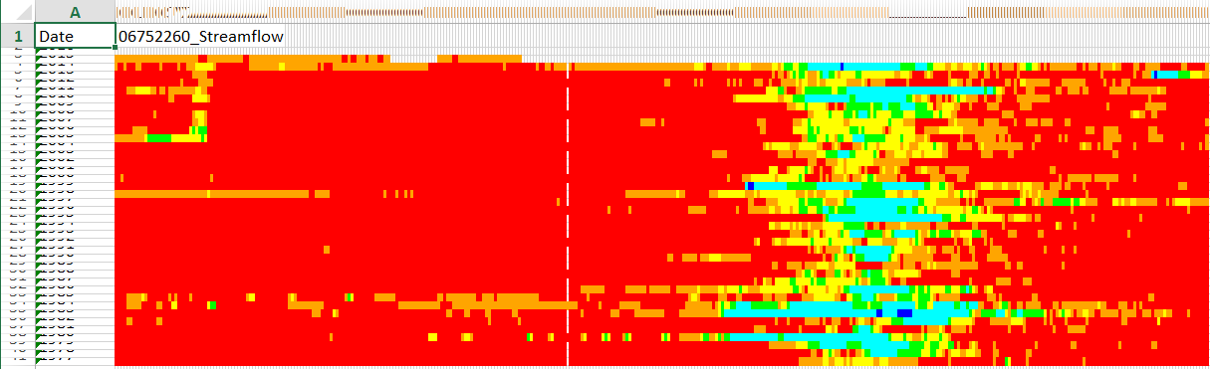

WriteTimeSeriesToExcelBlock_Output2

WriteTimeSeriesToExcelBlock() Command Example Output for Style Formatting